Risk Taking Behaviours 1 HIV Negative
VISIT MONTH:
Screening ID:  Site Study Screening Number | Participant ID:  Site Study Couple I/P Chk | Visit Date:  dd mm yy
1 | Are you generally a respondent who is fully prepared to take risks or do you try to avoid taking risks on a scale out of 10, where 0 means “not at all willing to take risks” and 10 means “very willing to take risks”  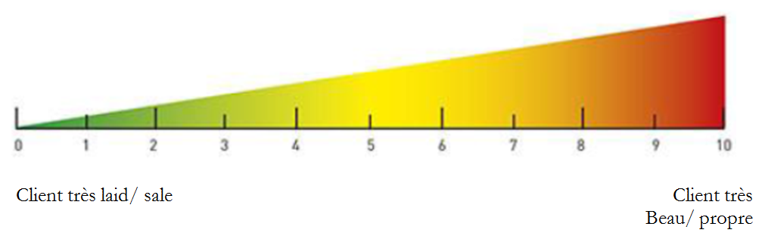  Not willing to take risks Slightly willing to take risks Neutral Willing to take risks Highly willing to take risks
 | a. in general |  | b. with financial matters |  | c. with your health |  |  | d. In sexual behaviours
2 | Would you prefer having 5000 Nairas for sure or to play a game with a 50% chance of having 15000 Nairas and a 50% of having nothing?
 | 1= I prefer N5000 for sure  2=I have no preference, the two are identical  3= I prefer to play the lottery |  |  |  |  | Answer:
3 | In this game, we will present you 6 businesses and we will ask you to choose your prefered business i.e. the one you would like to invest in if you were using real money. Every business has a 50% chance of yielding to a high payoff and a 50% chance of yielding a low payoff. This probability is now the same for every business, however the amount of the low and high payoff vary across businesses. For instance, if you chose business 1, the low and high payoff are similar so you are sure that with business 1 you will earn N5600. However, if you choose Business 6, you have 50% chance of earning N14000 but also a 50% chance of earning N400. You can only invest in one business. Make your choice by writing X on the far right hand column of the table.  Investment choices Probability Low pay off High payoff Preferred Business  Business 1 50%-50% N5,600 N5,600  Business 2 50%-50% N4,800 N7,200  Business 3 50%-50% N4,000 N8,800  Business 4 50%-50% N3,200 N10,400  Business 5 50%-50% N2,400 N12,000  Business 6 50%-50% N400 N14,000

Completed by: (initials/date) _________________________________________
Forms Instruction
The Risk taking behaviours 1 CRF is completed at Enrollment and annually (Months 12 and 24) by both the PrEP user AND the partner.
The same form is used for male and female partner participants.

Item-specific Instructions:
Screening ID | Screening IDs will be assigned from the site list and are unique to the individual. They are numeric and should be assigned sequentially. The Index Screening ID is assigned to the HIV-positive participant, and the Partner Screening ID is assigned to the HIV-negative participant.
Participant ID | Participant IDs are assigned from a list provided by the PROJECT. They are assigned once eligibility has been determined and the subject has been enrolled. The Participant ID should be left blank until the eligibility status of the participant is known. If eligible, the Participant ID should be entered and initialed and dated (if being added on a different date). If the participant is not eligible, then the Participant ID should be left blank.
Item 1a-1d | For those items please enter a number comprised between 0 and 10, 0 being “not at all willing to take risks” and 10 means “very willing to take risks” in the response section. We recommend you show a visual aid to the respondent so the respondent can show you on the scale her/his level of risk taking.  -Item 1a “in general” means in all confounded fields (this includes risks with money, travel, health, sexual behaviours, sports, driving, social activities, etc.)  Item 1b “with financial matters” means with money.  -Item 1c “with your health” means with any type of behaviours that may affect your health (smoking, drinking, health diet, practicing sport, demand for prevention services, demand for treatment when sick, etc.)  -Item 1d “with your sexual behaviours” means with any type of behaviours that may affect your sexual health (using condoms, having multiple partners, having sex with sex workers or with respondents who are at high-risk of infection, demand for preventive services such as HIV testing, STI testing, etc.)
Item 2 | The questions examines how much the respondent is willing to take risk with money. Tick the appropriate response to know if the respondent prefers a certain amount of money or if the respondent prefers playing the game
Item 3 | Please carefully read the game script and make sure that the respondent understands that one business needs to be chosen. Write a X for the business chosen.

