Guidelines for Daily Oral Pre-Exposure Prophylaxis: TEMPLATE LANGUAGE
The intent of this document is to provide adaptable guidelines that align with World Health Organization (WHO) daily oral pre-exposure prophylaxis (PrEP) guidance and recommendations. The document includes prompts for national-level consideration during the guideline adaptation process. Areas specifically requiring national update are indicated in red font.

This document was developed by CHOICE in close collaboration with USAID. CHOICE is a collaboration between the USAID-funded EpiC and RISE projects. The content of this document was sourced largely from the WHO PrEP Implementation Toolkit. Countries should use this document as appropriate for their needs and setting; CHOICE branding or acknowledgement is optional.
Table of Contents

Pre-Exposure Prophylaxis 2
Guidance for Offering Oral PrEP 2
Oral PrEP Effectiveness 3
Approved Drugs for Oral PrEP 3
Optimal Oral PrEP Service Delivery Package 4
Oral PrEP Initiation 4
Indications for Oral PrEP 4
Identifying Clients at Substantial Risk 4
Contraindications for Oral PrEP 7
Initiation Visit Schedule and Readiness Assessment 7
Oral PrEP and Other Drug Interactions 11
Client Follow-Up 11
Management of Clients in Specific Situations 15
Management of Creatinine Elevation 15
Management of HIV Seroconversion 15
Management of Side Effects and Adverse Drug Reactions (ADRs) 16
Education and Counseling for Oral PrEP 16
Risk Reduction Counseling 16
Who Can Deliver Oral PrEP and Where 19

Pre-Exposure Prophylaxis
Pre-exposure prophylaxis (PrEP) is the preemptive use of antiretroviral (ARV) drugs to reduce the probability of HIV-negative individuals acquiring HIV infection, especially in persons who are deemed at substantial risk of acquiring HIV or who present requesting PrEP, even for reasons they do not wish to disclose. Some individuals in monogamous relationships may be at substantial risk due to their partners’ risk behaviors, about which the person seeking PrEP may not have any actual details; special consideration may be warranted in these cases. PrEP is not effective in preventing pregnancy or sexually transmitted infections (STIs) other than HIV. Existing safety data also support the use of daily oral PrEP in pregnant and breastfeeding women (PBFW) who are at continuing substantial risk of HIV infection.
These guidelines focus on daily oral PrEP, which is approved for use in [country]. Other forms of PrEP are being developed, tested, and reviewed, such as the dapivirine vaginal ring. Guidance on other approved forms of PrEP will be made available as appropriate. A systematic review and meta-analysis of oral PrEP trials using Tenofovir Disoproxil Fumarate (TDF)-containing ARV drug combinations demonstrated that oral PrEP is effective in reducing the risk of acquiring HIV infection. The level of protection did not differ by age, sex, regimen (TDF or TDF + Emtricitabine [FTC]) and mode of acquiring HIV (rectal, penile, or vaginal exposure). Event-driven PrEP (ED-PrEP), also called on-demand PrEP or 2+1+1, is also effective in reducing the risk of acquiring HIV infection for men who have sex with men (MSM). ED-PrEP may be appropriate for MSM who find it more convenient, have infrequent sex (for example, less than two times per week on average), and are able to plan for sex at least two hours in advance, or who can delay sex for at least two hours. Where offered, MSM should have an option to decide which regimen works for them.
For consideration:
- Many people who consider themselves to be in monogamous relationships or to have no risk themselves are at heightened risk for HIV due to their partner’s risk; thus, assessing risk for many adolescent girls and young women (AGYW) and people whose partners are members of key populations (KPs) is about gauging the risk of their partners, even if their own behavior does not seem to put them at a high likelihood of HIV acquisition.
- Requesting PrEP should be enough to get it (without a client having to “qualify” or explain their request in detail).
- Injection drug use is mentioned in this guidance; however, first-line prevention strategies for people who inject drugs (PWID) are needle exchange and/or drug use harm reduction and treatment. There are some protective effects of daily oral PrEP for this population, and it should be a part of a larger prevention package.
- Template language for ED-PrEP guidelines can be found on PrEPWatch in both English and French and should be adopted together with guidelines for daily oral PrEP.

Guidance for Offering Oral PrEP
For consideration: We have purposefully not mentioned PrEP as a long-term therapy. There is currently no agreement on what is meant by “long-term” and how long someone “should” be on PrEP. Even though WHO has an indicator for continued oral PrEP at 90 days, they agree that people can use oral PrEP effectively for shorter durations, and that oral PrEP provision should not be contingent upon anticipated risk of greater than three months. It is good to avoid framing PrEP as only a long-term product, since indefinite, continuous use is not the reality for most, and many may use oral PrEP effectively episodically. Applying an antiretroviral therapy (ART) model—i.e., start and stay on—limits implementation strategies and ignores the realities of clients’ needs and preferences.
It is recommended that oral PrEP be offered as an additional prevention choice for HIV-negative persons who are considered to be at substantial risk of acquiring HIV infection as a part of a combination of other available HIV prevention methods (including condom and lubricant use, or other options as they become available). Oral PrEP should be used during periods of substantial risk of HIV acquisition, which are likely to vary greatly by individual and at varying times of life for different lengths of time according to risk. Oral PrEP can be stopped at any time during periods of low or no risk, or per a client’s request.
For everyone other than men whose only exposure to HIV is through sex with men, oral PrEP must be taken daily and should be used daily for at least seven days before it is considered effective and continued for 28 days after the last potential exposure.
For men whose only exposure to HIV is through sex with other men, start daily oral PrEP with a loading dose of two pills at PrEP initiation and delay sex for at least two hours, at which time drug levels will be sufficient to provide protection. Continue taking one pill of PrEP at the same time daily. To discontinue daily oral PrEP safely, one pill of PrEP should be taken daily until two days after the last potential exposure.

Oral PrEP Effectiveness
When used as directed, oral PrEP can reduce the risk of HIV through sexual transmission among at-risk individuals by more than 90%. Oral PrEP can be even more effective if it is combined with other HIV prevention tools such as condom and lubricant use, drug use harm reduction and treatment, and treatment for people living with HIV.

Approved Drugs for Oral PrEP
For consideration:
- Countries may consider including both TDF/FTC and TDF + Lamivudine (3TC) in the guidelines, as both are approved for daily and ED-PrEP use. Having the option of using either set of approved drugs may be beneficial if there are Tenofovir Lamivudine Dolutegravir (TLD) transitions that free up Tenofovir Lamivudine, or if there are supply chain challenges that affect availability of one of the recommended drugs.
- Clarify current options in the section below (TDF/FTC and TDF/3TC)). TDF monotherapy is approved by WHO for daily oral PrEP use; however, there are no countries where TDF monotherapy is used as daily oral PrEP. If TDF monotherapy is included in guidelines, it should be noted that it is not a preferred option for MSM.
- TAF/FTC is not currently recommended by WHO for PrEP, while the U.S. Food and Drug Administration has approved its use among MSM only and as a daily regimen. There are currently no international guidelines for TAF/FTC. This document focuses only on the use of TDF/FTC and TDF/3TC for daily oral PrEP.

In [country], the current preferred oral dose regimen for oral PrEP is [TDF/FTC or TDF/3TC]. [TDF/FTC or TDF/3TC] can also be used for oral PrEP.

Optimal Oral PrEP Service Delivery Package
Ideally, the following package of services is provided when oral PrEP is offered. Note that the full offer of these services is not required for oral PrEP initiation, though it may support effective use and continuation of oral PrEP. This optimal package of services includes:
- HIV testing and counseling, including index testing and couples testing
- Creatinine clearance screening and monitoring
- Hepatitis B (all populations) and C (MSM and PWID only) screening
- Comprehensive HIV prevention, including risk reduction counseling and condom/lubricant distribution
- Assessment of need for contraceptives and/or pregnancy testing
- STI screening, diagnosis, and treatment
- Screening for noncommunicable diseases, such as diabetes mellitus and hypertension
- Referral for voluntary medical male circumcision services
- Referral for services for gender-based violence (GBV), including intimate partner violence (IPV)
- Referral for substance use and mental health concerns identified during counseling and screening
- Adherence assessment and counseling, including help identifying possible barriers to appropriate adherence

Oral PrEP Initiation

Indications for Oral PrEP
It is recommended that oral PrEP be offered to HIV-negative individuals who are at substantial risk of acquiring HIV and lack contraindications for oral PrEP. Risk assessment questions can aid in assessing individual risk level as part of the pre- or post-HIV test counseling process but should not be used to ration oral PrEP or as the only criteria for determining whether someone should take oral PrEP. Risk assessments are considered tools and should not be required. If someone asks for oral PrEP then they should be given oral PrEP, regardless of whether a risk assessment is completed or what the result of the risk assessment was. Requesting oral PrEP has been shown to be an indicator of substantial risk.

Identifying Clients at Substantial Risk
For consideration: The record form below is taken from the WHO PrEP Implementation Tool and may be used to identify individuals at substantial risk who could be offered oral PrEP, those who might have acute HIV infection (AHI), and those who could be offered post-exposure prophylaxis (PEP). In addition, consider:
- Exploring risk levels of partners with client during the risk assessment (this may be particularly important for AGYW, partners of key populations, and individuals who are pregnant or breastfeeding)
- Asking about experience of STI symptoms (in addition to a specific diagnosis)
Record Form for PrEP and PEP Screening
What was your sex at birth? | Male | Female | Other
What is your current gender? | Male | Female | Other
What is your current age? | ______________years
In the past six months:
With how many people did you have vaginal or anal sex? | 0 1 2* 3+* men  0 1 2* 3+* women
Did you use a condom every time you had sex? | Yes | No* | Don’t know*
Did you have a sexually transmitted infection? | Yes* | No | Don’t know
Do you have a sexual partner who has HIV? | Yes | No | Don’t know*
If “Yes,” has he or she been on antiretroviral therapy for 6 or more months? | Yes | No* | Don’t know*
If “Yes,” has the therapy suppressed viral load? | Yes | No* | Don’t know*
In the past three days:
Have you had sex without a condom with someone with HIV who is not on treatment? | Yes** | No | Don’t know**
Have you had a “cold” or “flu” such as sore throat, fevers, sweats, swollen glands, mouth ulcers, headache, or rash? | Yes*** | No | Don’t know
*Consider offering PrEP; **Consider offering PEP; ***Consider AHI.

All clients testing HIV-negative per the national testing algorithm and who are at substantial risk should be counselled on oral PrEP and assessed for clinical eligibility. The first steps in determining whether someone is clinically able to take oral PrEP are to determine whether there has been HIV exposure in the past 72 hours and to rule out AHI. See Diagram 1 below.

Diagram 1: Oral PrEP Initiation – HIV Exposure and AHI Assessment
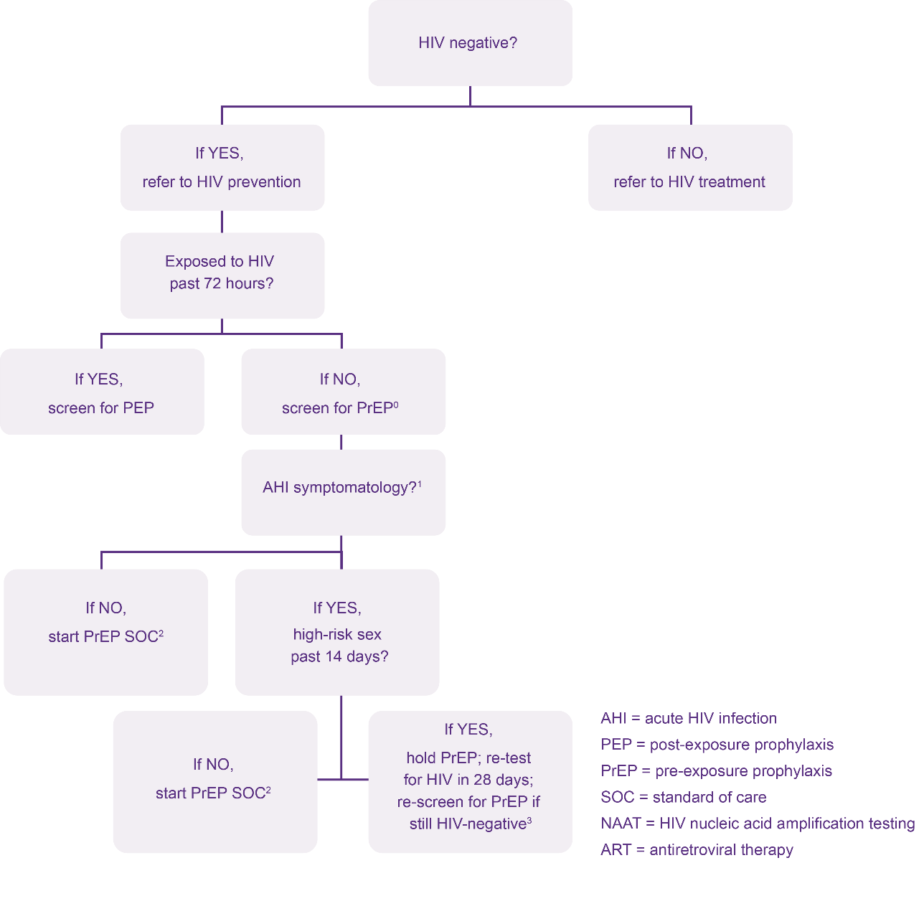
⁰ An answer of “NO” to question “Exposed to HIV past 72 hours?” means no known past exposure to HIV at all or known HIV exposure that was 73+ hours ago.
¹ Signs/symptoms mimicking acute HIV infection (sore throat, fever, sweats, swollen glands, mouth ulcers, headache, rash, muscle aches) are commonly due to illnesses other than HIV; providers need to use discretion in determining whether the symptomatology is consistent with HIV, or whether an alternative cause may explain them.
² PrEP Standard of Care: clinical eligibility screening and risk assessment per WHO/national guidelines, e.g., creatinine clearance, medical history, hepatitis screening, etc.
³ If NAAT available, PrEP may be started earlier than 28 days, if NAAT negative; clinician may consider fully suppressive ART in 28-day interim if waiting 28 days to re-test for HIV.
Developed by Jhpiego in collaboration with Jared Baeten (University of Washington) and Rachel Baggaley (World Health Organization [WHO]).
If the client is determined to be at risk for HIV and AHI is ruled out, clinical eligibility for oral PrEP should be assessed.

Contraindications for Oral PrEP
Box 1. Signs and symptoms of AHI
Fever
Swollen lymph glands
Skin rash
Headache
Sore throat
Aches and pains
Mouth sores

Oral PrEP should NOT be provided to people with:
- HIV-positive test result using the national HIV testing algorithm
- Known exposure to HIV in the past 72 hours
- Signs of AHI (Box 1) AND potential exposure or risk within the past 14 days. (Defer oral PrEP and consider PEP counseling for clients with a history of unprotected sex in the past three days, even in the absence of symptoms of AHI.)
- Inability to commit to adhere to oral PrEP and to attend scheduled oral PrEP visits
- Drug allergy to any component of the drugs being used for oral PrEP
- Creatinine clearance less than 60 mL/min, if known
- Concurrent nephrotoxic medication

Initiation Visit Schedule and Readiness Assessment
For most clients, oral PrEP can be initiated the same day. However, in some scenarios as outlined in Table 1, it is recommended to defer oral PrEP initiation.
Table 1. Oral PrEP Initiation
Required Initiation Steps | Action
HIV test  (per national HIV testing guidelines) | - Same-day HIV testing is suggested.  - If positive, client must not be initiated on oral PrEP, but should be immediately initiated on/referred for ART.  - If the test result is inconclusive, defer oral PrEP and follow the national algorithm until a definite HIV test result has been obtained for all clients who are not pregnant or breastfeeding. Provide risk reduction counseling.  - For PBFW with inconclusive HIV test results, refer to prevention of mother-to-child transmission (PMTCT) guidelines that advise putting women on ART until the results are received. If the results come back positive, continue on ART, and if the results are negative, switch from ART to oral PrEP drugs, if clients are still interested. Provide risk reduction counseling.  For consideration: Same day HIV testing is aligned with WHO guidance. However, some programs accept results of tests conducted within the last 3-7 days if there has been no exposure since then. In some places, it may be difficult to link clients to oral PrEP on the same day they tested negative.
Counseling | - Assess whether the client is at substantial risk of HIV.  - Discuss prevention needs and provide condoms and lubricants.  - Discuss desire for oral PrEP and willingness to take oral PrEP.  - Develop a plan for effective oral PrEP use.  - Assess client’s experience of GBV, including IPV.  - Assess substance use and mental health issues.  - Assess fertility intentions and offer contraception or safer conception counseling; discuss oral PrEP safety in pregnancy and while breastfeeding, if the client wishes to conceive or is or intends to breastfeed.  For consideration: While not part of the WHO counseling messages at oral PrEP initiation, it is important for clients to be counselled on the possibility of side effects, what these side effects may be, and what to do if side effects occur.
Clients exposed to HIV in the past 72 hours | If a client reports an exposure to HIV in the past 72 hours, screen for possible eligibility for PEP instead of oral PrEP.  - [Add national PEP regimen here. WHO recommends a fully suppressive 3-drug PEP regimen].  - Educate clients on the difference between PEP, PrEP, and ART and offer risk reduction counseling.  - After 28 days of PEP, a client may be transitioned from PEP to oral PrEP without a gap to oral PrEP, if still HIV-negative and still at risk of acquiring HIV.
Clients at risk of AHI | If client presents with signs and symptoms of HIV infection and possible exposure to HIV in the previous two weeks:  - Defer oral PrEP. Provide risk reduction counseling as well as STI screening, diagnosis, and management.  - Repeat HIV testing after four weeks.  - If negative, initiate oral PrEP.
Oral PrEP contraindications | - Assess for contraindications of oral PrEP. If no contraindications, provide oral PrEP for one month (consider multi-month dispensing on a case-by-case basis).
Recommended Initiation Steps | Action
Serum creatinine | - If available, conduct baseline serum creatinine before starting oral PrEP to ensure normal renal function (creatinine clearance ≥ 60 mL/min).  - Given the low rates of creatinine abnormalities, creatinine should not be a barrier to oral PrEP initiation. If needed, a focused medical history screening could be used to identify potential kidney issues if creatinine test is not readily available to identify those who must have a test as part of eligibility determination.  - For clients with pre-existing risk factors for renal impairment, every effort should be made to obtain a serum creatinine prior to initiation of oral PrEP. Risk factors include: age >50, hypertension, diabetes mellitus, body weight $≤$55kg, other nephrotoxic medication, any symptoms or signs suggestive of renal impairment.  For consideration: While urinalysis is not in the WHO guidance, some countries are using this as a proxy if creatinine testing is not available or results are delayed. If urinalysis is not normal, oral PrEP initiation would be delayed until creatinine results come back. This section could be updated based on national preferences.  Note that albuminuria is better than proteinuria for detection of early disease/impairment (they are not the same thing). Proteinuria indicates an elevated presence of protein in the urine (normal excretion should be < 150 mg/d), while albuminuria is defined as an “abnormal loss of albumin in the urine.” Albumin is a type of plasma protein normally found in the urine in very small quantities. Albuminuria is a very common (though not universal) finding in chronic kidney disease patients; is the earliest indicator of glomerular diseases, such as diabetic glomerulosclerosis; and is typically present even before a decrease in the glomerular filtration rate (GFR) or a rise in the serum creatinine. Albuminuria, without or with a reduction in estimated GFR (eGFR), lasting > 3 months is considered a marker of kidney damage.  - The serum creatinine should be used to estimate creatinine clearance using the following Cockcroft-Gault formula:  Est. Creatinine Clearance =  [[140 - age(yr)]*weight(kg)]/[72*serum Cr(umol/L)]  (multiply by 0.85 for women)  For consideration: The WHO/Jhpiego mobile app has a very convenient CrCl calculator. It is free and allows calculation with results reported in either mg/dL or umol/L. This can be downloaded from the Google Play and iOS app stores.  - If creatinine clearance < 60 mL/min see management of creatinine elevation (page 15).
Hepatitis B surface antigen (HBsAg)  (for more information see “special considerations” below) | - HBsAg negative: offer hepatitis B vaccination (as per national hepatitis guidelines, if available).  - HBsAg positive: see section below on clients with a hepatitis B infection.
Hepatitis C antibody test (for MSM and PWID) | - If positive: consider referral for assessment and treatment for hepatitis C.
Syndromic screening for STIs | - If syndromic, manage STIs as per STI standard treatment guidelines.
Pregnancy testing | - Determine last normal menstrual period; do pregnancy test if indicated and requested by client.  (Remember, neither pregnancy nor breastfeeding are contraindications to oral PrEP use.)
Mental health status assessment | - Screen for mental health concerns including depression and alcohol/other substance abuse, which might increase risk or affect adherence to oral PrEP.  - Link to follow-up mental health care.  (Clients with mental health concerns should not be prohibited from receiving oral PrEP if they can effectively use oral PrEP.)
IPV routine inquiry and response | - Conduct GBV, including IPV, routine inquiry with clients.  - Identify clients who are experiencing GBV/IPV.  - Provide appropriate GBV and IPV response, including first-line support and referral where necessary, and support clients to identify ways to effectively use and continue oral PrEP.  (Clients experiencing GBV, including IPV, should not be prohibited from receiving oral PrEP if they can effectively use oral PrEP.)
Special considerations related to hepatitis B | Clients with hepatitis B infection wanting PrEP:  - Daily oral PrEP is not contraindicated in clients with hepatitis B infection; if the HBsAg result is positive, the client can initiate daily PrEP.  - Additional assessment can be considered for people with hepatitis B infection who are considering oral PrEP.  - Clients with hepatitis B infection who are not interested in oral PrEP or stopping oral PrEP should be referred to relevant management/treatment services.  For consideration: Clients starting oral PrEP who have hepatitis B infection may benefit from additional counseling to ensure they are aware of the need for ongoing treatment should they wish to stop taking oral PrEP for HIV prevention.

For consideration: The following readiness assessment (adapted from Eswatini national guidelines) can be used to determine if oral PrEP is appropriate for the client.

READINESS ASSESSMENT PRIOR TO ORAL PREP INITIATION
- HIV test is nonreactive on oral PrEP initiation day | [__] Yes | [__] No
- Client is at substantial risk for HIV infection (or client has requested to use oral PrEP as an HIV prevention method) | [__] Yes | [__] No
- Client was not exposed to HIV in the prior 72 hours | [__] Yes | [__] No
- Client is not suspected to have AHI | [__] Yes | [__] No
- Client is willing/able to come to follow-up appointments | [__] Yes | [__] No
- Client has no contraindications to oral PrEP medicines (add specific PrEP drugs here as appropriate: TDF, FTC, 3TC) | [__] Yes | [__] No
IF “YES” TO ALL SIX QUESTIONS ABOVE INITIATE PrEP

Oral PrEP and Other Drug Interactions
ARV drugs used for oral PrEP (add specific regimens – TDF/FTC and/or TDF/3TC) do not have any known interactions with contraceptive hormones or gender-affirming hormones used by transgender individuals.
There are no known interactions between oral PrEP medications and alcohol or recreational drugs. However, if a oral PrEP user thinks that his or her use of alcohol or other substances is interfering with taking oral PrEP regularly, the PrEP provider should discuss and support behavior change and offer additional prevention options, including condoms and lubricants.

Client Follow-Up
It is recommended that once on oral PrEP, clients return after one month to assess and confirm HIV-negative test status, assess for early side effects, discuss any difficulties with medication adherence, and any other client concerns. After the one-month follow-up visit, clients may return for follow-up visits every three months. Some clients may be candidates for dispensing multiple months of oral PrEP at once to avoid having to return to pick up a bottle each month. This should be discussed with clients on a case-by-case basis and could be started at the initiation visit, if appropriate. At each follow-up visit, review of oral PrEP adherence, recent HIV exposure, and signs/symptoms of AHI should continue. The flow diagram shown below (Diagram 2) can be used to assist with this process.

Diagram 2: Oral PrEP Follow-Up – HIV Exposure, AHI, and Adherence Assessment
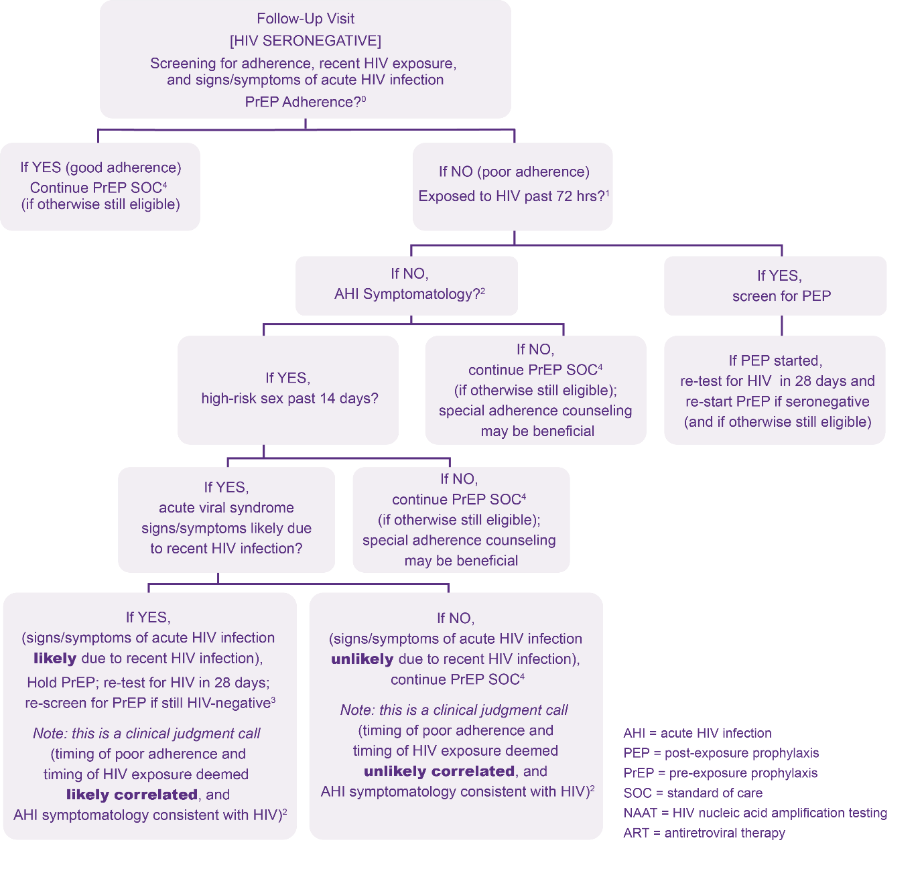

⁰ If adherence was so poor as to constitute PrEP discontinuation, then refer back to page 1, Initiation Visit.
¹ An answer of “NO” to question “Exposed to HIV past 72 hours?” means no known past exposure to HIV at all or known HIV exposure that was 73+ hours ago.
² Signs/symptoms mimicking acute HIV infection (sore throat, fever, sweats, swollen glands, mouth ulcers, headache, rash, muscle aches) are commonly due to illnesses other than HIV; providers need to use discretion in determining whether the symptomatology is consistent with HIV, or whether an alternative cause may explain them.
³ If NAAT available, PrEP may be started earlier than 28 days, if NAAT negative; clinician may consider fully suppressive ART in 28-day interim if waiting 28 days to re-test for HIV.
⁴ PrEP Standard of Care: clinical eligibility screening and risk assessment per WHO/national guidelines, e.g., creatinine clearance, medical history, hepatitis screening, etc.
Developed by Jhpiego in collaboration with Jared Baeten (University of Washington) and Rachel Baggaley (World Health Organization [WHO]).
Table 2 outlines the procedures for each of the follow-up visits. These visits are the minimum number of visits an oral PrEP client will require. However, visits can be more frequent (and refills shorter) if oral PrEP is integrated with another service (e.g., antenatal care [ANC] or family planning), so visits should be aligned as much as possible.

Table 2. Follow-up Visit Procedures

Visit | Visit procedure
Every visit (one month after initiation and quarterly thereafter) | - HIV testing and counseling  - Review of oral PrEP adherence and risk reduction counseling  - Review of recent HIV exposure and signs/symptoms of AHI  - Assess for adverse drug reactions (management as needed)  - Provide counseling on prevention of STIs and recognition of STI symptoms, issues related to mental health, GBV/IPV, and substance use  - Remind oral PrEP users on the dosage of oral PrEP needed to achieve adequate ARV levels in tissues to be effective. Until adequate ARV levels are achieved as outlined below, safer sex practices should be encouraged (including abstinence and condoms/lubricants)  - For everyone other than men whose only exposure to HIV is through sex with men: one pill of oral PrEP must be taken daily for seven consecutive days prior to exposure to have maximum efficacy and then one pill of oral PrEP must be taken daily at approximately the same time. To discontinue oral PrEP safely, one pill of oral PrEP must be continued daily for 28 days after the last potential exposure.  - For men whose only exposure to HIV is through sex with other men:  For those taking a daily regimen: two pills of oral PrEP must be taken at least two hours before sex to have maximum efficacy. One pill should be taken daily at approximately the same time thereafter. To discontinue oral PrEP safely, one pill of oral PrEP should be taken daily until two days after last potential exposure.
Semi-annually | - Creatinine and creatinine clearance  For consideration: WHO recommends creatinine testing every six months, although some programs conduct this annually with clients when there is no suspicion of renal impairment.
Annually | - Hepatitis C antibody test for MSM and people who inject drugs

For consideration:
- While not in the WHO visit schedule, unscheduled visit procedures could be added to the table above. These procedures might include:
  - Determining if the reason for the visit is oral PrEP-related or not, e.g., adverse drug reactions
  - Assessing and manage the reason for the unscheduled visit according to national guidelines, e.g., acute or chronic illnesses, worsening existing condition(s)
  - Providing HIV risk reduction and oral PrEP adherence counseling
  - Agreeing on follow-up schedule

Stopping Oral PrEP
Ideally, clients should inform their service provider when they want to discontinue oral PrEP. The duration of oral PrEP use may vary, and individuals are likely to start and stop oral PrEP depending on their individual risk assessment at different periods in their lives, including changes in sexual relationship status, behaviors, and ability to adhere to a oral PrEP maintenance program.

For everyone other than men whose only exposure to HIV is through sex with men:
- One pill of oral PrEP must be continued daily for 28 days after the last potential exposure.

For men whose only exposure to HIV is through sex with other men taking a daily regimen:

- One pill of PrEP must be taken daily until two days after last potential exposure.

For consideration: Health care workers should discuss the options of when to discontinue oral PrEP with their clients. Oral PrEP may be stopped for the following reasons:
- Client request
- Positive HIV test (clients who seroconvert while on oral PrEP should be immediately linked to care and initiated on ART in line with national guidelines)
- Safety concerns, such as persistent creatinine clearance <60mL/min
- No longer at substantial risk
- Decision to switch from oral PrEP to a different HIV prevention method(s)
- Persistent side effects.

In addition, be sure to:
- Explore risks and alternative prevention/risk reduction strategies
- Advise the client that an HIV test is required to re-start oral PrEP
- Remind the client of oral PrEP use that is required after the last potential exposure (at least two days for men whose only potential exposure to HIV is through sex with other men and at least 28 days for other clients)
- Encourage ongoing links to appropriate HIV prevention and contraceptive services, as well as the use of other HIV prevention strategies, as needed
- Reference national guidance on hepatitis B infection, as appropriate.

Restarting Oral PrEP
Individuals restarting oral PrEP will need to be tested again for HIV and free of any contraindications for oral PrEP.

For consideration: WHO guidelines do not make recommendations about when a client taking oral PrEP should be considered discontinued or what procedures are required for restarting someone on oral PrEP once they have been considered discontinued. In their guidelines, some countries have chosen to specify when a client should be considered discontinued based on the number of days after a client stops oral PrEP use or the number of days after a missed appointment. Typically, this has been followed by procedures to restart someone on oral PrEP.
If a country decides to do this, restarting procedures which include more than the required initiation steps outlined in Table 1 may become barriers to oral PrEP use by delaying or preventing someone from restarting oral PrEP and increase program costs.

Management of Clients in Specific Situations
This section outlines management of clients in specific situations outside of regular client follow-up.

Management of Creatinine Elevation
Very few clients experience creatinine elevation and approximately 80 percent of creatinine elevations are self-limiting (and can be addressed without stopping oral PrEP) and are caused by dehydration, exercise, diet, diabetes mellitus, hypertension, liver failure, or hepatitis C virus or may be a false-positive test result. Rule out and manage other causes of elevated creatinine.

Serum creatinine is not a good marker of kidney function. Calculate creatinine clearance as per the Cockcroft-Gault formula (or by using the calculator in the WHO oral PrEP eLearning app).

Est. Creatinine Clearance =
[[140 - age(yr)]*weight(kg)]/[72*serum Cr(umol/L)]
(multiply by 0.85 for women)
Most people can remain on oral PrEP and have the creatinine clearance repeated on a different day from a different blood sample. If the second sample result is still <60 mL/min, discontinue oral PrEP and re-test later if the person wants to try again.

For consideration: National guidelines may want to consider stopping oral PrEP if the creatinine clearance is very low on the initial test (< 50 mL/min), but again, this is not per WHO guidance and an area where national guidelines have varied. Example text from other national guidelines:

If the calculated creatinine clearance is:
- < 50 mL/min: Stop oral PrEP and refer to [clinical staff cadre] immediately.
- 50-60 mL/min: Repeat serum creatinine within two weeks. If a repeat sample gives creatinine clearance < 60 mL/min, stop oral PrEP and consult with [clinical staff cadre] for further investigation and management.

For PBFW with an inconclusive HIV test result, refer to your national PMTCT guidelines.

Management of HIV Seroconversion
- If a client seroconverts while on oral PrEP, or after starting oral PrEP (even if not taking oral PrEP or not taking oral PrEP consistently):
- Confirm reactive rapid test results by retesting a second sample (according to the national testing algorithm).
- Immediately link to care and initiate on ART (as per national ART guidelines).
- Document seroconversion and possible reason for seroconversion (non-adherence, stopped taking oral PrEP, or oral PrEP failure, i.e., breakthrough infection while adherent to oral PrEP).

Management of Side Effects and Adverse Drug Reactions (ADRs)
- Minor side effects are relatively common but are mild and self-limiting and often do not require discontinuation of oral PrEP. These include nausea and/or vomiting, diarrhea and/or flatulence, dizziness, headache, and weight loss. Side effects should be managed symptomatically, and counseling should be provided.
- Major toxicities (including renal toxicity and metabolic complications) associated with TDF and FTC are rare in oral PrEP exposure to date. Consult [clinical staff cadre] if these occur.
- Any side effects should be recorded in client records and [relevant forms] regardless of severity.
- Complete the national [adverse drug reaction form] and report as per standard operating procedures.
- If oral PrEP will be discontinued, record the outcome in the oral PrEP register.

Education and Counseling for Oral PrEP
Education and counseling for clients considering oral PrEP, or clients already on oral PrEP, are important to ensure the drugs’ effective use.
Oral PrEP counseling should be based on the following principles:
- Be client-driven, based on their needs, resources, and preferences.
- Be based on a foundation of respect and include an open and honest relationship between provider and client.
- Recognize that behavior change is not easy, and human beings are not perfect.
- Validate and normalize client concerns and seek to affirm and encourage client efforts and not be prescriptive or judgmental.
- Focus on the identification of small wins and achievable next steps in reducing risk and/or making pill-taking easier.
- Include contingency planning when common barriers are encountered.

There are a number of components which should be included in oral PrEP counseling and education. Special populations such as key populations and AGYW will need additional tailored counseling.

Risk Reduction Counseling
Risk reduction counseling is a behavioral intervention that attempts to decrease an individual’s chances of acquiring HIV and other STIs. It includes counseling about HIV and other STI prevention, prevention of unintended pregnancy, GBV/IPV prevention and mitigation, and other sexual and reproductive health issues and should be provided at all follow-up visits for oral PrEP users.
The main objective of risk reduction counseling is for clients to assess individual risk, acknowledge self-risk, and set realistic goals for behavior change that could reduce their risk of acquiring HIV and other STIs, as well as prevent unintended pregnancies. This counseling, which is most effective when non-judgmental and user-centered, can be provided by any trained health care provider and should:
- Explore the context of the client’s specific sexual practices and psychosocial status and help the client recognize any of their behaviors that are associated with higher risks for HIV infection or unintended pregnancy. Health care providers should also be aware that clients might not always perceive their own risk or may be in denial about it.
- If the client discloses that they have experienced or are at risk of GBV, including IPV, provide first-line support and make referrals as appropriate. Discuss how violence and fear of violence affects their risk and prevention behaviors and discuss ways to stay safe and protect themselves in the context of their relationship(s).
- Identify the sexual health protection needs of the potential oral PrEP user and reflect on what his or her main concerns appear to be.
- Strategize with the client about how they can manage these concerns or needs.
- Agree on which strategies the client is willing to explore and provide guidance on how to implement them.

Additional counseling and education messages for clients about oral PrEP are in Table 3.

Table 3. Counseling and Education Messages for Clients about Oral PrEP
Topic | Key Messages
What is oral PrEP? | Oral PrEP is one of several HIV prevention options and, where possible, should be used in combination with condoms and other prevention methods. Oral PrEP does not protect against other STIs or prevent unintended pregnancy.
Oral PrEP works if taken as prescribed | For oral PrEP to be effective, you must take oral PrEP as prescribed, which for most people is every day throughout their time at risk.
Oral PrEP is not for life | You should take oral PrEP for as long as you feel you are at risk of HIV infection.  Some people only need to take oral PrEP during certain times in their lives, while others have an ongoing need.
Starting and stopping oral PrEP | For everyone other than men whose only exposure to HIV is through sex with men:  One pill of oral PrEP must be taken daily for seven consecutive days prior to exposure to have maximum efficacy and then one pill of oral PrEP must be taken daily at approximately the same time. To discontinue oral PrEP safely, one pill of oral PrEP must be continued daily for 28 days after the last potential exposure.  For men whose only exposure to HIV is through sex with other men:  For those taking a daily regimen: Two pills of oral PrEP must be taken at least two hours before sex to have maximum efficacy. One pill should be taken daily at approximately the same time thereafter. To discontinue oral PrEP safely, one pill of oral PrEP should be taken daily until two days after last potential exposure.
Ways to support adherence | Daily oral PrEP can be taken any time of the day, with or without food. If you forget a dose on daily oral PrEP, take it as soon as you remember.  Some people find it easy to remember to take their oral PrEP when they integrate it into a daily routine and take it the same time each day. For example, you could take oral PrEP when you brush your teeth (either in the morning or evening), or when watching a favorite TV show or listening to a favorite radio program. It is helpful to pair taking oral PrEP with a routine that makes you feel good.
Oral PrEP and alcohol or other recreational drugs | Taking oral PrEP while you are using alcohol or other recreational drugs will not hurt you. However, alcohol or other recreational drugs may cause you to forget to take your oral PrEP, so be sure to take it in advance of any substance use.  (Note to provider: emphasize adherence and pill-taking reminders.)
Oral PrEP, pregnancy, and breastfeeding | Oral PrEP does not prevent pregnancy. Be sure to use a modern method of contraception to avoid an unintended pregnancy.  Taking oral PrEP while you are pregnant or breastfeeding will not hurt you or your baby. Since HIV can be transmitted during pregnancy and breastfeeding, taking oral PrEP during this time prevents both you and your baby from acquiring HIV.  You can use oral PrEP throughout pregnancy and breastfeeding.  (Note to provider: assess family planning needs and offer, as appropriate.)  (Note to provider: offer oral PrEP to PBFW at high risk of HIV as a priority after all the risks and benefits have been explained to the client.)
Oral PrEP and other medications | Oral PrEP is safe and effective. It can be taken with hormonal contraceptives, gender-affirming hormones, or non-prescription drugs.
No STI protection other than HIV | Oral PrEP does not prevent any other STIs. Use a condom correctly whenever you have sex to prevent other STIs.
Side effects | Over 90% of people will not experience any side effects. Those who do experience only mild side effects, including:  - Gastrointestinal symptoms (diarrhea and nausea, decreased appetite, abdominal cramping, and flatulence)  - Dizziness  - Headaches  Most of those side effects disappear within one month. However, your health care provider can help you manage them.
Other ways to lower risk of HIV | To lower your risk of HIV:  - Adopt safer sexual practices, including consistent condom and lubricant use  - Engage in non-penetrative sex, including mutual masturbation  - Receive screening, diagnosis, and treatment for other STIs  - Ensure an HIV-positive partner in a serodiscordant couple has been on effective ART for at least six months, has an undetectable viral load, and remains adherent to ART  - Receive voluntary medical male circumcision  - Reduce number of sexual partners  - Access drug harm reduction and treatment services
Switching between HIV prevention options | It is okay to start oral PrEP and decide later that you want to use another option to prevent HIV infection, like condoms. Many people switch between methods as their needs change. I am here to help you to make the best decision for you.

Who Can Deliver Oral PrEP and Where
Oral PrEP implementation can be integrated in any setting that meets the conditions for initial evaluation and initiation and has an appropriately trained cadre(s) of workers who have been approved to perform clinical assessments and provide prescriptions for ARVs as oral PrEP according to national guidelines. It is important that this cadre also have systems and tools in place for the monitoring, documentation, and reporting of oral PrEP use.
For consideration:
Because the roles and responsibilities of different cadres can change over time, it may be beneficial to not specify which cadres are involved in specific aspects of oral PrEP service delivery. This allows for task-sharing amongst non-clinical (or less specialized) cadres to occur and support further movement of oral PrEP from health facilities and into the community.

Likewise, it may be beneficial not to include an exhaustive list of oral PrEP service delivery locations in guidelines to avoid limiting programmatic expansion and differentiated service delivery. Some service delivery locations may include:
- One-stop-shops
- Drop-in centers (including in community and facility settings)
- HIV clinics (for HIV-negative partners before the HIV-positive partner has a suppressed viral load or when viral suppression is unknown)
- ANC and maternal, newborn, and child health clinics
- Family planning, reproductive health, and STI clinics and mobile health clinics
- Community settings meeting the criteria for initial client assessment and evaluation, e.g., integrated prevention centers and youth-friendly outlets
- Primary care settings
- Virtually

