TITLE: ORAL PRE-EXPOSURE PROPHYLAXIS

INTRODUCTION
Zimbabwe remains one of the countries burdened by the HIV epidemic. 1,3 million people are living with HIV (prevalence~14.9%) and the number of new HIV infections remains high (incidence~ 0.48%). Oral Pre-exposure prophylaxis is now included as additional option for people at substantial risk of HIV infection in the context of combination HIV prevention package in Zimbabwe. This training package will provide information on PrEP so that service providers will be able to know why PrEP is given, which clients should receive it, how to prescribe it, and how to manage clients on it. As the use of PrEP is an evolving area, it is expected that these documents will require updating over time as new information regarding PrEP arises and implementation experiences accumulate.
_____________________________________________________________________________________________________

TRAINING OBJECTIVES

Broad objective
The objective of this module is to provide health workers with information on pre-exposure prophylaxis (PrEP) so that can they can be able to know why PrEP is given, to which clients, prescribe it and manage clients on PrEP.

Specific objectives
By the end of this module, participants will be able to:
- Identify eligible candidates for PrEP.
- Conduct an individualized risk assessment.
- Educate and counsel PrEP candidates and users.
- Conduct clinical and laboratory assessments during the initial PrEP visit.
- Prescribe PrEP.
- Conduct clinical and laboratory assessments during follow-up PrEP visits.
- Use PrEP monitoring and evaluation (M&E) tools effectively.
_____________________________________________________________________________________________________
STRUCTURE OF THE TRAINING

PrEP Basics

PrEP Screening and Eligibility

Initial and Follow up PrEP Visits

Monitoring and managing PrEP Side Effects, Seroconversions and Stigma

Special Considerations for AGYW

Monitoring and Evaluation for PrEP

_____________________________________________________________________________________________________

MODULE 1: PREP BASICS

By the end of this session, participants will be able to:
- Define what PrEP is and differentiate PrEP from PEP and ART.
- Conceptualize PrEP as part of combination HIV prevention
- Understand the evidence for PrEP and why it is given.
- Address the concerns surrounding PrEP implementation
_____________________________________________________________________________________________________

BACKGROUND
Different people have different HIV prevention needs. For a given individual, prevention needs can change over time. No single prevention intervention can fully address all prevention needs. To prevent HIV infection, a combination of structural, behavioral, and biomedical interventions are used. The combination of HIV prevention approaches used are based on both epidemiological and demographic evidence of what is needed in a particular setting. Combining approaches result in synergies with greater impact than single interventions alone
Antiretroviral drugs (ARVs) are now used as additional tools in combination prevention. The use of ARVs for HIV prevention is well established; we have been using ARVs to prevent mother-to-child transmission of HIV (PMTCT) for post-exposure prophylaxis (PEP) for many years.
The combination of HIV prevention approaches used are based on both epidemiological and demographic evidence of what is needed in a particular setting. Combining approaches result in synergies with greater impact than single interventions alone
_____________________________________________________________________________________________________
COMBINATION HIV PREVENTION
Combination prevention refers to a systematic approach to implementing a range of HIV prevention interventions: behavioural and biomedical in synergy with structural interventions. This means that the different interventions are delivered in combination and tailored to the needs of the different individuals and population groups at risk of HIV infection. The combination approach recognizes that an individual’s risk of HIV infection and their HIV prevention needs change over time
.
Structural interventions aim to address social, economic, political, environmental, cultural, and also organizational, community, legal, or policy factors that influence vulnerability and predispose different groups of people to HIV infection.

Behavioural interventions support behaviour change to reduce the risk of HIV infection.
Biomedical interventions are particular tools, commodities, or mechanisms that lower infectiousness of HIV infected persons and/or susceptibility of HIV-negative persons to HIV. Within biomedical interventions is the use of antiretroviral drugs for HIV prevention.
It is critical to include all the combination strategies in reducing te risk of HIV acquisition by HIV negative people
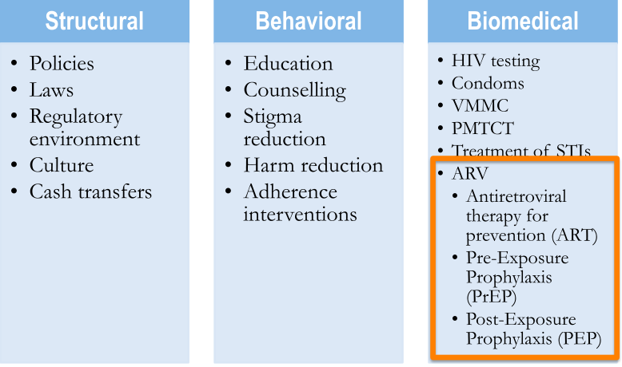
_____________________________________________________________________________________________________

DISCUSSION
What are the policies, laws and regulatory issues that are facilitators and barriers to HIV prevention?

What are the challenges with the different components of the combination HIV prevention package?

DEFINING PRE-EXPOSURE PROPHYLAXIS
PrEP is the use of antiretroviral drugs by HIV-uninfected persons to prevent the acquisition of HIV before exposure to HIV.
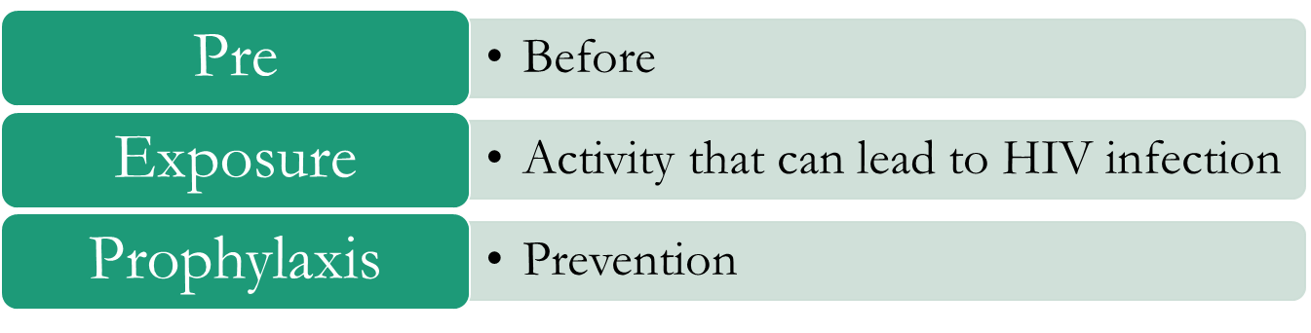
Potential PrEP Agents and Delivery
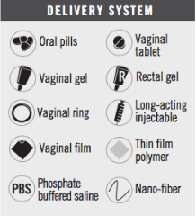
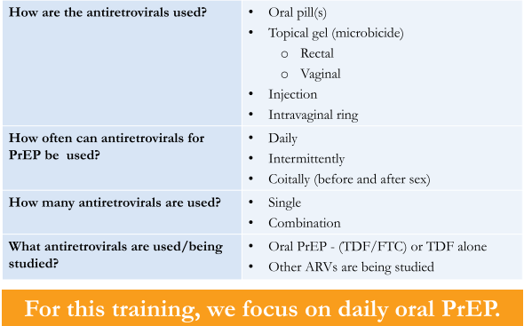

The WHO recommends that oral PrEP containing TDF should be offered as an additional prevention choice for people at substantial risk of HIV infection as part of combination HIV prevention.

Substantial risk of HIV infection is defined as an incidence of HIV infection between 3 per 100 person-years in the absence of oral PrEP. Identifying and offering oral PrEP to those at substantial risk leads to great individual benefit, strong epidemiological impact, and optimal investment in resources.

KEY QUESTION
Who is at substantial risk of HIV infection?

Indicators of substantial risk of HIV infection vary depending on local HIV epidemiology and population group

Inconsistent use of condoms (male or female), including an intention to use condoms during sex with some occasional omissions or accidents, increases HIV risk. Social desirability bias in reporting condom use may occur, so PrEP could be considered for people reporting any intercourse without a condom or concerns about their future use of condoms. For example, someone who reports a desire to stop using condoms may be already having sex without condoms.

Recently diagnosed STIs are often indicators of risk of sexual acquisition of HIV. The predictive value of STI indicators varies by region, the type of STI and a person’s demographic characteristics. A new diagnosis of syphilis or genital herpes is a strong predictor of HIV risk among men who have sex with men in most settings and among heterosexual men and women in areas of high HIV prevalence. PrEP services should be prioritized; local epidemiology will be essential to guide decisions about when to offer PrEP and to which populations.

Requesting PrEP has been shown to be an indicator of substantial risk. HIV incidence among people requesting PrEP has been higher than expected from observational studies in the same locality. People at high risk of acquiring HIV infection who request PrEP tend to have greater PrEP uptake, adherence and retention. Clinicians should consider any request for PrEP seriously, especially for individuals in settings where the local epidemiology indicates likely substantial HIV risk in their population group.

People who use and/or inject drugs are often at substantial HIV risk. WHO recommends a package of effective HIV services be provided for all people who inject drugs, including harm reduction (in particular opioid substitution therapy and needle syringe programmes). When these interventions are available, the risk of HIV transmission is significantly reduced. Providing these services should be a priority.

GROUP EXERCISE
What are some similarities and differences between Pre-Exposure Prophylaxis (PrEP) and Post-Exposure Prophylaxis (PEP)?

Are both PEP and PrEP used in children, adolescents, pregnant women?

PEP (post-exposure prophylaxis) means taking antiretroviral medicines (ART) after being potentially exposed to HIV to prevent becoming infected. PEP should be used only in emergency situations and must be started within 72 hours after a recent possible exposure to HIV
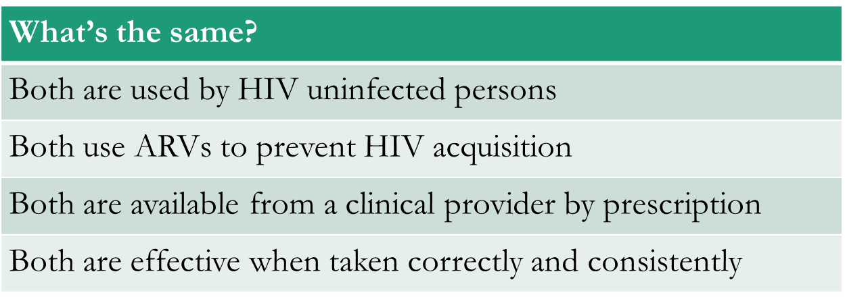

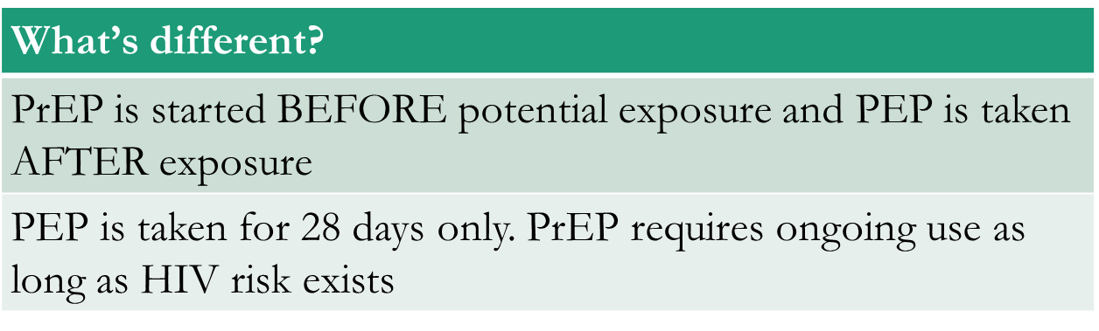
PEP regimens for adults
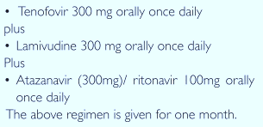
PrEP regimens for children
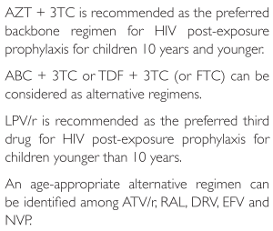
_____________________________________________________________________________________________________

DISCUSSION
What are some similarities and differences between ART and PrEP?

HIV treatment requires adherence to life-long therapy with consistent, fully-suppressive dosing.
PrEP is needed during “periods” of high HIV risk.
Both ART and PrEP require optimal adherence.
Individuals taking PrEP require ongoing risk assessment and PrEP can be discontinued if they:
- acquire HIV infection.
- are no longer at substantial risk for HIV infection.
- decide to use other effective prevention methods.
ART is taken by HIV infected persons for treatment.

PrEP is used by HIV uninfected persons for prevention. There are alternative prevention methods a person can use.
HIV treatment requires life-long therapy with constant dosing.
PrEP is needed during periods of high HIV risk. Clients can discontinue PrEP if they feel they are no longer at risk (e.g. in a mutually monogamous relationship with HIV-negative partner).
Or if they decide to use other effective prevention methods (e.g. consistent use of male or female condoms).

Motivation for adherence is different: ART is taken by HIV infected persons so they can remain healthy, while PrEP is taken by HIV uninfected persons to prevent infection.

HIV treatment regimens
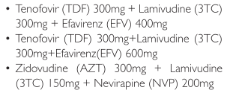

WHY WE NEED PREP
There are several effective HIV prevention interventions already (e.g. condoms, harm reduction for PWID), we need another prevention intervention because…
• New HIV infections still occur despite prevention efforts
• New HIV infections among priority and key populations are quite high

Despite other HIV prevention strategies to prevent HIV infection, new infections still occur. And high among priority and key populations. PrEP provides an additional prevention intervention to be used with existing interventions (such as condoms). It is not meant to replace or be a substitute for existing interventions.

EVIDENCE FOR PREP
There is evidence of efficacy from several clinical trials among MSM, heterosexual men and women, and people who inject drugs. For study participants with Truvada in plasma, efficacy reached 92%.
There were disappointing results in the FEMPreP and VOICE trials which were discontinued for futility.
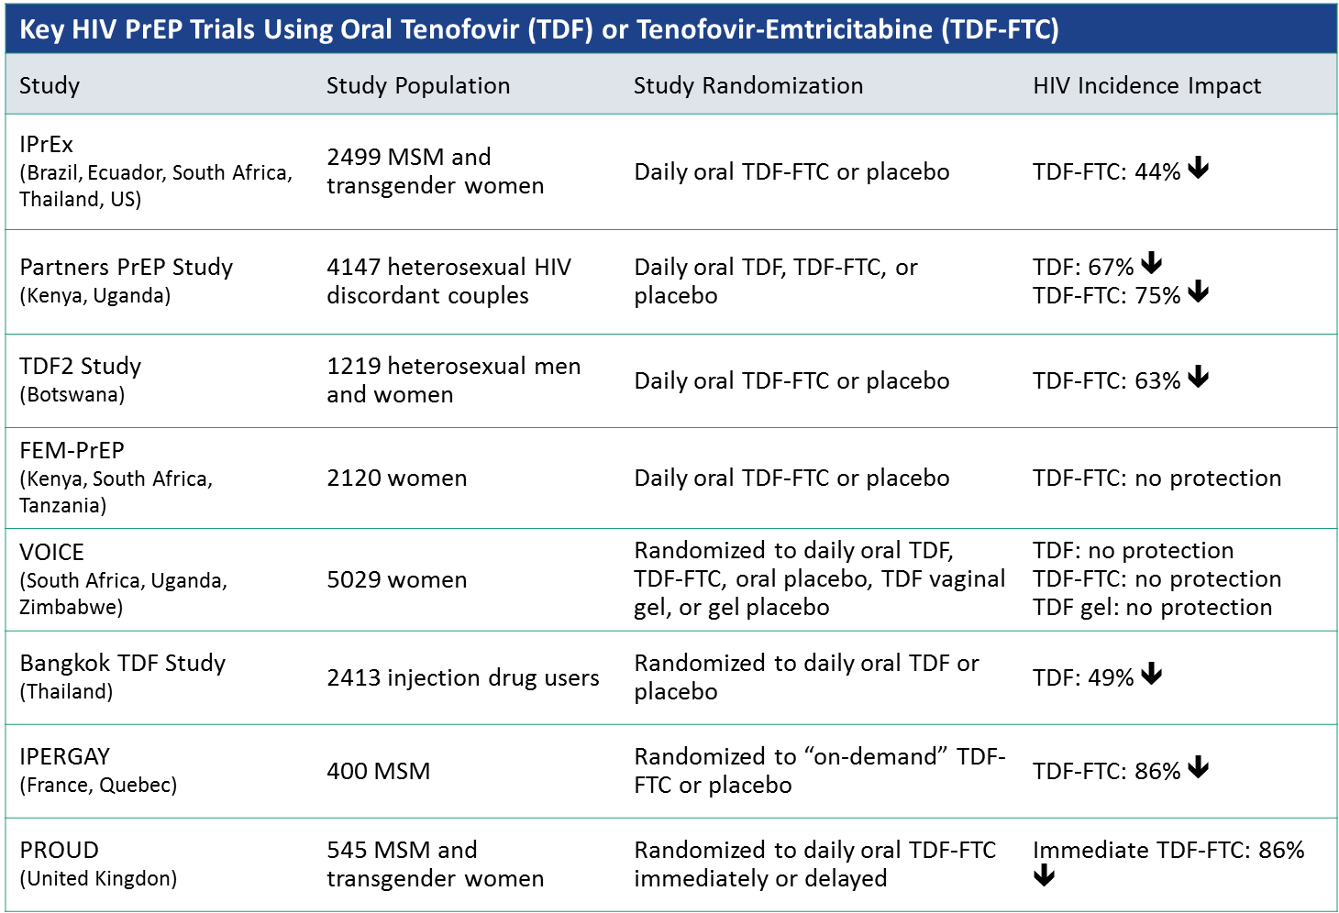
References for some studies
iPrex- Grant RM, et al. N Engl J Med. 2010;363:2587-2599
Partners PrEP - Baeten JM, et al.N. Engl J M.2012 :367 :399-410
TDF 2 - Thigpen MC, et al. N Engl J Med.2012 ; 367 :423-434
FEM PrEP -Van Damme L, et al. N Engl J Med.2012 :357 :411-422
Bangkok TDF study- Choopanya K, et al. Lancet.2013 ;381 :2083-2090
Oral PrEP taken daily during periods of substantial risk of HIV infection, is a highly-effective prevention strategy, and can reduce the risk of acquisition of HIV through sexual intercourse by more than 90%. The level of protection provided by oral PrEP does not differ by age, sex, or mode of acquiring HIV - rectal, penile or vaginal exposure; however, the level of protection is strongly correlated with adherence. High adherence to oral PrEP results in a high level of protection from HIV infection whereas suboptimal adherence does not offer the expected protective benefits.
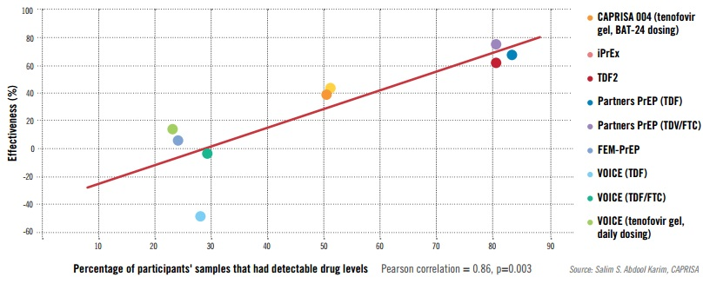

Figure 5Effectiveness and adherence in trials of oral and topical Tenofovir based prevention
_____________________________________________________________________________________________________

FREQUENTLY ASKED QUESTIONS AND ANSWERS

Is PrEP safe?
PrEP showed no evidence of increased proportion of adverse events. Analysis of results of many PrEP studies show that 90% of participants had no side-effects!
PrEP is safe!
Approx. 10% in clinical trials experienced mild, short-term side-effects like nausea, tiredness, gastrointestinal symptoms (flatulence) and headache.

Will PrEP users engage in riskier behaviours? Will PrEP encourage people to use condoms less often or to have more sexual partners – i.e. “risk compensation”?
There was no evidence of this in clinical trials. The PROUD study showed that for participants who were at high risk before initiating PrEP, sexual behaviour remained unchanged whether or not participants received PrEP
Will PrEP lead to more HIV drug resistance (HIVDR)?
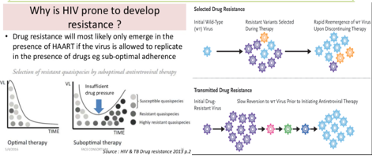

HIVDR in PrEP users was rare in clinical trials; HIVDR occurred mostly in cases where the person had undiagnosed HIV infection at the time of starting PrEP
When adherence to PrEP is high and HIV seroconversion does not occur, HIVDR will not occur.
If adherence is suboptimal and HIV infection occurs while on PrEP, there can be a risk of HIVDR. Optimal adherence to PrEP is crucial. Health providers must support and monitor adherence and teach PrEP users to recognize signs/symptoms of acute HIV infection

Does PrEP protect against other STI?
Only condoms protect against STI and pregnancy. PrEP protects against HIV and also against herpes simplex virus type 2 in heterosexual populations.
PrEP does NOT protect against syphilis, gonorrhoea, chlamydia, or HPV
PrEP should be provided within a package of prevention services, including STI screening and management, risk reduction counselling, condoms, contraceptives, etc.

MODULE 2: SCREENING FOR PREP AND INITIATION

Module objectives
By the end of this session, participants will be able to:
- Recognize the indications for PrEP
- Identify people at risk and at substantial risk for HIV infection; including priority and key populations
- Conduct HIV risk assessment for PrEP
- Know when and how to prescribe PrEP
_____________________________________________________________________________________________________
WHO recommendation for PrEP
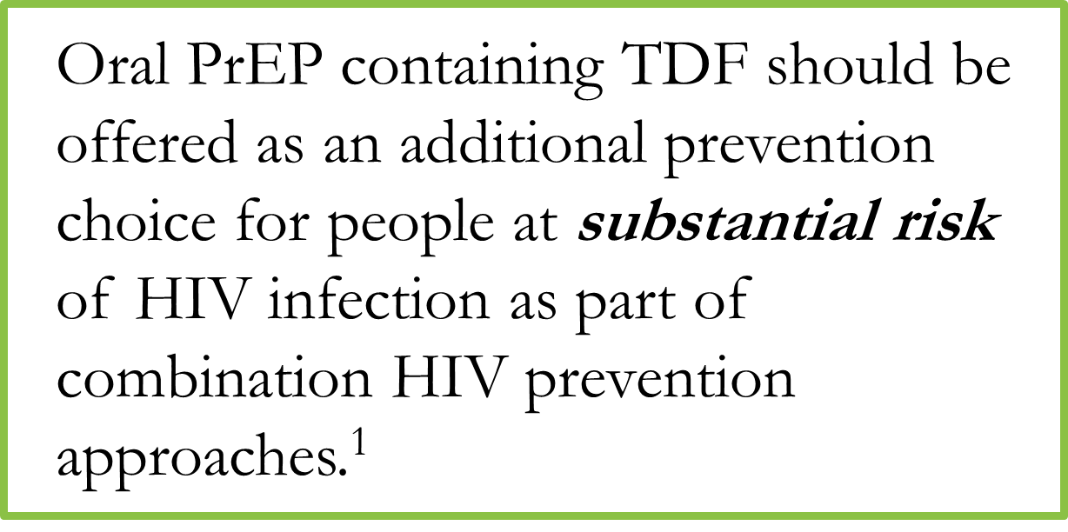
Oral PrEP is an additional prevention choice in addition to the standard combination prevention approaches. PrEP is a choice that ultimately the client should have when accessing health services. Offer as an additional prevention choice
Deliver PrEP with comprehensive support
- Adherence counselling
- Legal and social support
- Mental health and emotional support
- Contraception and reproductive health services

Who should be offered PrEP?
PrEP will be offered to all individuals at substantial risk of HIV infection. The policy on who should be offered PrEP is broad to ensure equitable access and to avoid stigmatizing individuals, groups or the product – even if initial implementation prioritizes high-risk groups
In Zimbabwe, groups that are likely to be at substantial risk of HIV infection include:
- Female and male sex workers;
- Sero-discordant couples (HIV negative partner)
- Adolescent girls and young women;
- Pregnant women in relationships with men of unknown status
- High-risk men (MSMs, prisoners, long distance truck drivers) and
- Transgender people
_____________________________________________________________________________________________________
Indications for PrEP
Indications for PrEP by history over the past 6 months:
- HIV negative and sexual partner with HIV who has not been on effective therapy for the preceding 6 months OR
- HIV negative and sexually active in high HIV prevalence settings AND any of the following….
AND any of the following:
- Vaginal or anal intercourse without condoms with more than one partner, OR
- A sexual partner with one or more HIV risk factors, OR
- A history of an STI by laboratory testing or self-report or syndromic STI treatment, OR
- Any recurrent use of PEP, OR
- Requesting PrEP

Contraindications for PrEP
Contraindications must be ruled out before starting PrEP, these include:
- HIV positive status
- Unknown HIV status
- Allergy to any medicine in the PrEP regimen
- Unwilling/unable to adhere to daily PrEP
- Known renal impairment
- Estimated creatinine clearance <60 cc/min
_____________________________________________________________________________________________________

What is required before PrEP Initiation?
Conduct a rapid HIV test to rule out existing HIV infection preferably on the same day that PrEP is being started.
Take a complete medical history and full physical examination to rule out any signs or symptoms of an acute viral syndrome, including a flu-like illness, then consider the possibility that acute HIV infection could be the cause. In such circumstances testing for HIV RNA or antigen is recommended or retest using rapid HIV test 4 weeks later
Measure blood creatinine before starting PrEP and at every 6 months after PrEP where available. Blood creatinine is mandatory in people with comorbid conditions that can affect renal function, such as diabetes mellitus and uncontrolled hypertension

In addition, conduct:
- HIV risk assessment using a screening tool
- Adherence counselling

What is recommended before PrEP initiation?
- Hepatitis B test
- Blood Creatinine level check
- Pregnancy test
- STI Screening and Treatment

First visit

HIV risk assessment
Review the current risk assessment/ screening tool
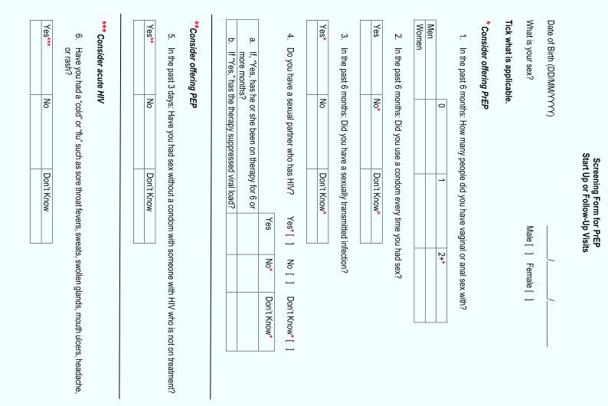
_____________________________________________________________________________________________________
ROLE PLAY
Practice in pairs using different scenarios: AGYW, Sex worker, MSM, sero-discordant
What are the potential challenges with some of these questions?
Are there other questions that should be asked to assess risk?
_____________________________________________________________________________________________________
DISCUSSION
Review PrEP Practical screening questions (Annexe 1)
_____________________________________________________________________________________________________

ACUTE HIV INFECTION
Acute HIV infection (AHI) is the early phase of HIV disease that is characterized by an initial burst of viremia. AHI infection develops within two to four weeks after someone is infected with HIV. Approximately 40% to 90% of patients with AHI will experience “flu-like” symptoms. These symptoms are not specific to HIV, they occur in many other viral infections. Remember that some patients with AHI can be asymptomatic.
The figure below depicts some of the presenting signs and symptoms of AHI.
DO NOT START PREP IN CLIENTS WITH SUSPECTED AHI!!
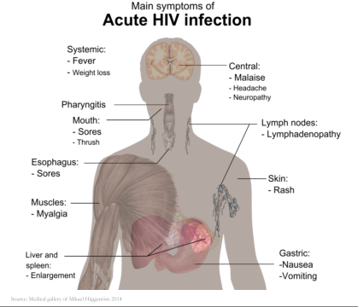
Diagnosis of acute HIV infection
During AHI, antibodies might be absent or be below level of detection: Serological testing using rapid test might be negative. AHI can be diagnosed using “direct” viral tests like HIV RNA or HIV antigen testing.
In the absence of HIV RNA and antigen testing PrEP should be deferred for four weeks if AHI is suspected: Repeat HIV serological test after four weeks to reassess eligibility.
_____________________________________________________________________________________________________
PrEP INITIATION AND REGIMENS
PrEP should be administered by medical doctors and nurses trained in ARV management.

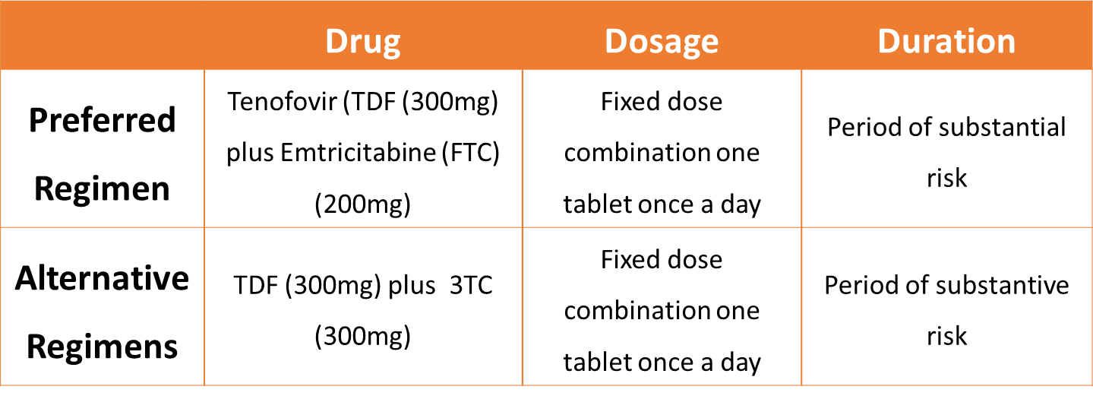
Key points: duration of protection
- Daily dosing in the period of substantial risk
- PrEP reaches maximum effectiveness after 7 doses.
- Full protection may require 4 daily doses for anal sex
- Full protection may occur after 7 daily doses for vaginal sex
- Unlike a patient on lifelong ART, a PrEP client may be discontinued from PrEP when they are no longer at substantial risk of HIV infection
- PrEP medications should be continued for 28 days after the last potential HIV exposure in those wanting to cycle off PrEP
_____________________________________________________________________________________________________
When to stop PrEP
The duration of PrEP use may vary and individuals are likely to start and stop PrEP depending on their risk assessment at different periods in their lives. PrEP can be stopped 28 days after the last possible exposure to HIV if the client is no longer at substantial risk for HIV infection. It can also be stopped if client:
• Has a positive HIV test
• Develops renal disease (Creatinine Clearance
<60ml/Min )
• Has an adverse medicine reaction and
• In sero-discordant couples, when HIV infected partner on ART has achieved viral suppression

Objectives
MODULE 3: CLIENT MONITORING, FOLLOW UP AND ADHERENCE
By the end of this session, participants will be able to:
- How to follow up and monitor clients on PrEP
- Conduct adherence counselling
- Explain the relationship between PrEP effectiveness and adherence
- Know management of PrEP side effects
- Understand when to stop PrEP
- Clinical and laboratory monitoring
- Management of adverse events
_____________________________________________________________________________________________________
PREP CLIENT FOLLOW UP SCHEDULE
Clients on PrEP require regular visits with the health provider. After initiating PrEP the client should be reviewed after 1 month to:
- monitor adherence
- Assess for side effects
- resupply of medicines
Thereafter 3 monthly visits are conducted to monitor client and resupply medicines. Some interventions are mandatory while others are recommended but should not hinder PrEP if not available

Required for follow up
Intervention | Schedule following PrEP initiation
Confirmation of HIV negative status | Every 3 months
Address medicine side effects | Every visit
Provide STI screening, condoms, contraception or safer conception services | As needed
Counselling regarding:  - effective PrEP use (adherence)  - prevention of STIs,  - issues related to mental health,  - intimate partner violence,  - substance use | Every visit
Recognition of symptoms of sexually transmitted infections and management | Every visit
HIV risk assessment | Every visit

Recommended for follow up (should not hinder ongoing access)

Intervention | Schedule following PrEP initiation
Estimated creatinine clearance. | Every 6 months.  - Consider more frequently if there is a history of conditions affecting kidneys (creatinine clearance <60ml/min)  - consider less frequently if age less than 45 yrs, baseline estimated creatinine clearance >90ml/min, and weight >55kg.
Hepatitis C antibody | Consider testing MSM every 12 months. Incident HCV infections have been reported among PrEP users who deny injection drug use.

The main side effect of TDF is renal impairment so close monitoring is required for clients with co morbid conditions like Diabetes Mellitus and uncontrolled Hypertension which affect the kidneys

PrEP COUNSELLING

Initial PrEP Counselling
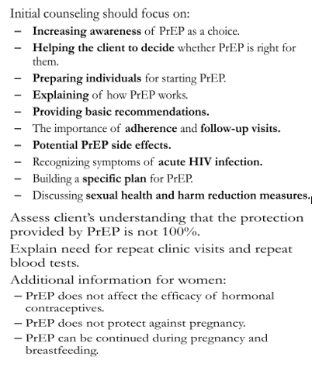

Follow up counselling
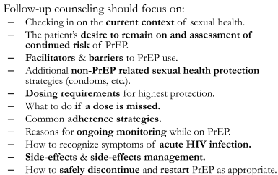
_____________________________________________________________________________________________________

ADHERENCE TO PREP
Adherence to drug(s) means that an individual is taking prescribed medications orrectly and consistently, it involves taking the correct drug:
- in the correct dose,
- at a consistent frequency (number of times per day), and
- at a consistent time of day.
PrEP works when taken as prescribed; correctly and consistently!!!
Adherence with follow–up means patients attend all scheduled clinical visits/procedures, including:
– Clinic and lab assessments.
– Drug collection/repeat prescription.

Truvada for PrEP provides 92%-99% reduction in HIV risk for HIV-negative individuals who take the pills every day as directed. If a daily dose is missed, the level of HIV protection may decrease

According to data analysis from the iPrEx study that found PrEP to be effective:
- For people who take 7 PrEP pills per week, their estimated level of protection is 99%.
- For people who take 4 PrEP pills per week, their estimated level of protection is 96%.
- For people who take 2 PrEP pills per week, their estimated level of protection is 76%.

Trials where PrEP use was more than 70% demonstrated the highest PrEP effectiveness (risk ratio = 0.30, 95% confidence interval: 0.21–0.45, P<0.001) compared with placebo. The figure on the next slide summarizes results from the clinical trials to show that the higher the percentage of participant samples that had detectable PrEP drug levels, the greater the efficacy.

Common reasons for poor adherence

Discussion
What are the common reasons for poor adherence to medication e.g. ART?

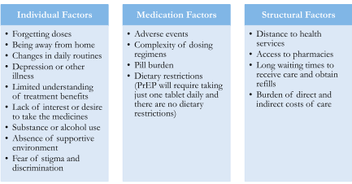

Voluntary and Involuntary Non-Adherence
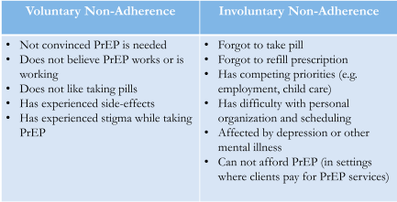

The role of health workers in adherence
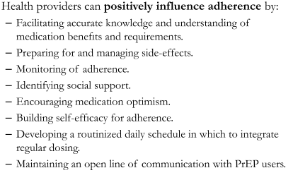
Adherence assessment methods
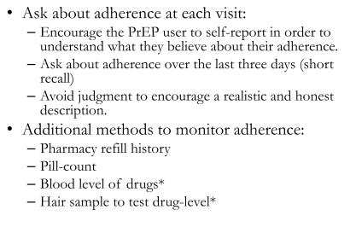

Discussion
What are the advantages and disadvantages of each method?
_____________________________________________________________________________________________________
Approaches to PrEP Medication Adherence Support
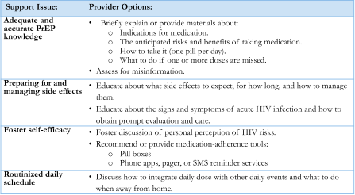
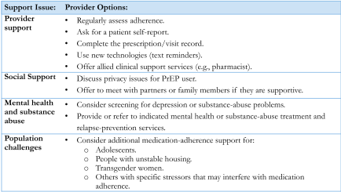
_____________________________________________________________________________________________________

DISCUSSION
Discuss on strategies to support pill taking
- Schedule medication taking time to correspond with the patient’s daily routine activities
- Use reminders e.g. cell phone, alarms, beepers, calendars
- Use of pillboxes like in figure X below
- Join an on-line support group e.g. Facebook: PrEP Rethinking HIV Prevention
- Review disclosure issues to identify those who can support the patient’s intentions to take their pills or barriers to pill-taking due to lack of disclosure/privacy at home
- Use alternative methods of communication: SMS, social networking, mobile applications
- Collect additional contact information for each patient
- Integrate mobile services and outreach into existing services
- Enhance peer support strategies, such as the use of clubs
- Provide alternative clinic hours, if possible
- Provide patients in advance with referral partners in the event that they migrate, or provide with additional stock/prescription

PREP SIDE EFFECTS
Truvada for PrEP is generally safe and well tolerated. Most people on PrEP report experiencing no side effects, however some side effects were reported in clinical trials. Symptoms usually start in the first few days or weeks of PrEP, are usually mild and resolve without stopping PrEP.
Pharmacovigilance is the active surveillance and monitoring of adverse events (for initial roll-out). It should include:
- Creatinine test before initiation and for monitoring
- Random PK testing (to measure adherence)
- Learning from demonstration and funded projects
Frequent adverse events include:
Nausea: 9% of those who received Truvada reported nausea in the first month, compared with 5% of those who received placebo.
Headaches: 4.5% of participants who received Truvada reported headaches, compared with 3.3% of those who received placebo.
Weight loss: 2.2% of those who received Truvada reported unintentional weight loss of more than 5%, compared with 1.1% of placebo users
Small increases in serum creatinine: Truvada is known to cause small increases in serum creatinine, a naturally occurring molecule filtered by the kidneys. In this study, 0.3% of those who received Truvada experienced mild increases in serum creatinine that persisted until the next test. Creatinine levels went back down once these participants stopped taking PrEP. Four of the five participants restarted PrEP without recurrence of the creatinine increase. Investigators monitored kidney function throughout the study and found no serious problems.

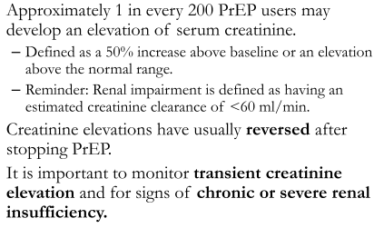
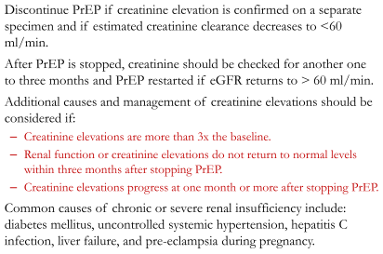
____________________________________________________________________________________________________

MODULE 4; SPECIAL CONSIDERATIONS FOR ADOLESCENT GIRLS AND YOUNG WOMEN
OBJECTIVES
By the end of this training you will be able to:
- Identify the specific HIV and SRH needs of AGYW (ages 15-24)
- Understand key components of youth friendly SRH and combination HIV prevention service delivery, including oral PrEP services
- Understand which AGYW are most likely to benefit from oral PrEP (high risk and able to initiate and adhere)
- Initiate, monitor, and follow up AGYW on oral PrEP in youth friendly ways, responsive to their specific circumstances, and within a rights-based framework
- Provide and/or work with multiple cadres (e.g. CHWs, peers) to provide youth friendly oral PrEP adherence and counselling support

DEVELOPMENTAL CONSIDERATIONS – THE ADOLESCENT BRAIN
Adolescents are not mini adults…
Less developed frontal lobe capacities for executive function, impulse control, and long-term decision-making. More developed limbic lobe favouring emotions, impulsive behaviour, and short-term gratification.
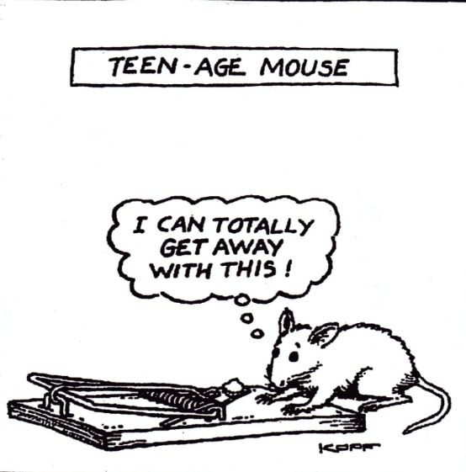
Adolescence is a time of physiological, sexual, and social changes: Changing bodies and hormones create sexual desire and focus on sex; Peer pressure is highly influential; a time of experimentation, testing limits, and questioning authority

AGYW may also be…
- transgender
- with multiple sexual partners
- people who have an STI
- with partners who are HIV-positive or have unknown HIV status
- engaged in sex work
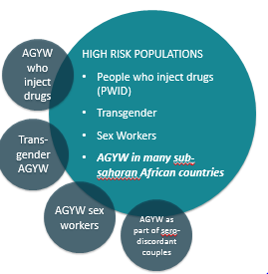
_____________________________________________________________________________________________________

HIV in context – social and structural drivers
HIV among AGYW is fuelled by a combination of factors that create an environment of risk
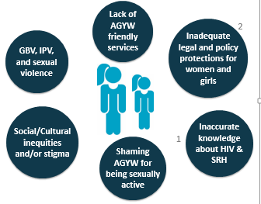

Gender-based violence, particularly intimate partner and sexual violence, is widespread, greatly increasing risk of acquiring HIV. In some settings, up to 45% of adolescent girls report that their first sexual experience was forced. Globally, only 3 in every 10 adolescent girls and young women aged 15-24 years have comprehensive and accurate knowledge about HIV and other sexual and reproductive health issues.
SRH and HIV services are not generally friendly to the concerns and needs of AGYW, particularly for those who are unmarried. Lack of legal rights reinforce the subordinate status of women, including rights to divorce, to own and inherit property, to sue and testify in court, and to open bank accounts. Cultural constraints and/or stigma against AGYW for being sexually active outside of marriage can affect delivery of and access to SRH and HIV services for AGYW

Factors to Consider for AGYW
Risk factors | Protective factors
- Poverty  - Peer pressure  - Sexual coercion  - Transactional sex  - Age-disparate relationships  - Teenage pregnancy  - Physiological vulnerability  - Barriers to using health services  - Dropping out of school  - Being an orphan or in a child-headed household | - Youth-friendly services  - Positive role models  - Guidance and engagement on staying in school from trusted adults  - Access to HIV prevention options

Challenges and barriers to SRH and HIV services for AGYW

DISCUSSION
What are the key barriers for adolescents and youth accessing SRH and HIV services (from a client’s perspective)? | What are the key challenges providing SRH and HIV services  to AGYW (from a provider’s perspective)?

Issues relating to access…
Inflexible and inconvenient clinic opening times
Clinic location, distance from home and availability, and the need for money for transport
Sitting in waiting rooms with adults, some of whom may know them
The attitude of staff – receptionists, clerks and nurses – who may be rude and judgmental
Nurses who may not give enough information or clarity; lack of confidentiality, privacy and sufficient time
The physical environment which looks intimidating, clinical and unattractive
Lack of accessible information developed to address the concerns, language and level of young people, which is easy to read and relevant to their lives

Issues related to quality of care…
Barriers relating to the quality of care which may discourage youth from using the clinic or completing treatment, e.g. drug stock-outs; having to walk through a waiting room with a urine sample; etc.
Anxiety about confidentiality and privacy

Issues related to communication… …
Impatient and unsympathetic staff who do not deal well with the embarrassment or problems young people encounter
Staff with poor listening skills
Embarrassment of provider who cannot discuss issues related to sexuality and safer sex
The language used and how well the health worker explains to the patient the nature of the problem and treatment

Client-related barriers | Community-related barriers | Provider-related barriers | Health system barriers | Product-related barriers
Don’t know where to go  Don’t have resources to get to the service  Staff attitude – judgmental, reprimanding  Don’t feel comfortable, embarrassed, scared to be seen by community  Low self-esteem, stigma, shame, including self-stigma, self-shame  Myths, misconceptions  Lack of sexual partner support | Cultural, religious, moral perspectives  Myths, misconceptions  Community does not support the service | Young people do not use the service  Young people are difficult  Health care providers lack confidence to provide services to adolescents –especially uncomfortable discussing sex and sexuality  Myths and misconceptions  Overwhelming number of clients with special needs! – HIV, TB, elderly, babies, sex workers, MSM, LGBTI, migrants, etc. | Legal, policy frameworks unclear, unsupportive  Time of service: Can’t get to the service because of school/work  Lack of clear guidelines and protocols, not trained in the provision of SRH services  Service unavailable, told to return  Time constraints to provide adolescent friendly care, too many in the queue, over worked  The commodities/supplies are not available  There are no/few/inadequate referral agencies for youth | Unfavourable dosing schedules  Unfavorable packaging, size, color of the product

DISCUSSION
Reflect and share on the list of barriers and think about which of these apply to you and/or your colleagues?
Reflect and share stereotypes about AGYW (hand out #1)

KEY COMPONENTS OF ADOLESCENT AND YOUTH FRIENDLY SERVICES
Services that are:
Friendly: welcoming, respectful, non-judgmental, private
Age appropriate: geared to the appropriate age and development stage of client
Ensure informed consent: counselling and information

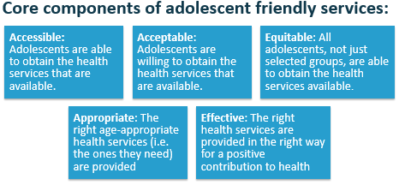

Providing youth sensitive services
- Respectful, non-judgemental
- Very important to listen
- Risk assessment and discussion
- Screening for STIs, TB, HIV, and other NCD needs
- Combination prevention support including: contraception, STIs, sexual violence, and HIV prevention
- Dual protection
- Repeated HIV testing according to exposure and risk (eg. every 3-6 months)

DISCUSSION
You are planning to provide oral PrEP services for AGYW: What are the 5 most important changes you will make to ensure the service is youth friendly?
_____________________________________________________________________________________________________
PREP AND ADOLESCENTS - WHAT DO WE KNOW
Adolescent populations are particularly vulnerable to HIV, and oral PrEP in these populations is likely to have an impact on population-level HIV incidence. The challenges of disseminating an HIV biomedical prevention tool requiring daily usage in adolescents are formidable, but addressing these issues and starting dialogues will lay the groundwork for the many other HIV prevention tools now being developed and tested. - Hosek 2016
Adherence to daily PrEP is a greater challenge for younger populations, and poor adherence associated with decreased efficacy in all PrEP trials.
Individual-level barriers include limited familiarity with antiretroviral-based prevention, stigma, product storage, and social support.
Structural challenges include healthcare financing for PrEP, clinician acceptability and comfort with PrEP delivery, and the limited availability of youth-friendly health services.

Most common reasons for opting out are pill-related (i.e. pill size, taste, remembering it every day)
Side effects (experienced and perceived) are a barrier to uptake and adherence
SMS reminders and setting a regular phone alarm are commonly used/referenced adherence tactics

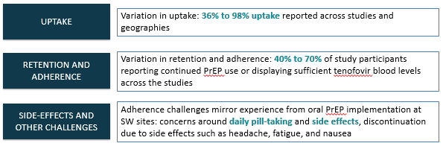

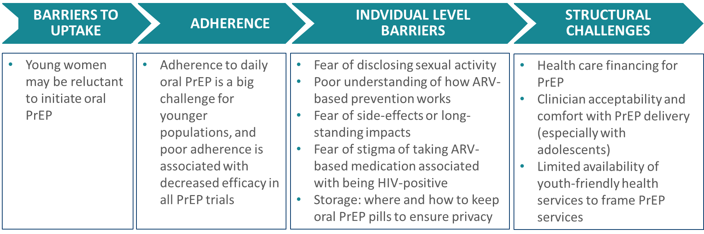
Sensitisation: PrEP involves talking about risk and sex: being aware of our own values, attitudes, prejudices, and moral judgements, including our feelings and attitude about other peoples’ lifestyles, sexual preferences, and behaviours, and how these may impact on our communication – verbal and non-verbal, and the services we render.
Important: Being sensitised paves the way for trust and meaningful engagement

Community education is critical; reduces stigma of AGYW sexual activity, legitimizes PrEP, dispels myths and mis-conceptions, and informs parents/caregivers
National or Ministry of Health logos on IEC materials encourages trust
Caregivers are influential in AGYW’s decision regarding PrEP use – especially HIV+ caregivers
Peer mobilisers, particularly other oral PrEP users, are critical to link AGYWs to services

Interest in PrEP: Capitalize on the view among AGYW that PrEP is a tool for empowerment and control over HIV.
Youth friendly services: Invest in service delivery models where staff offer services without judgment or negative attitudes to sexually active young people.
Accessible services: Mobile clinics offering discreet, consistent, reliable SRH/HIV (including PrEP) services with schedules convenient to young people.
Dual protection: Be clear that PrEP does not provide protection against STIs or pregnancy - condoms and contraception are still necessary.
Identify ways to motivate: Important to promote the immediate emotional benefits of PrEP (e.g., control, empowerment, health, and strength), as they have shown to be the most motivational.

Personal risk and informed decision-making: Young people need to assess whether oral PrEP is good for them before introducing questions of how it will work in their life.
Sensitisation: Relevant people in young women’s lives need to be sensitised and included in the promotion of oral PrEP, including peers, male partners, and family.
Involvement of young people is vital: Promote youth ambassadors and peer educators to provide outreach and education, including young women using oral PrEP successfully.
Personal cost: Young people are concerned about losing close relationships if partners know about their use of oral PrEP or lying about it.
Risk: Young people tend to overestimate the risk of contracting HIV from a single exposure, and underestimate the risk of cumulative exposure – need to build and support accurate risk perception.

QUESTION FOR REFLECTION
Reflect and share - what are some programmatic considerations when delivering oral PrEP to AGYW in your setting?

PROGRAMMATIC CONSIDERATIONS
Engagement of girls and women to identify what works best (settings, combination of services etc) for them in their contexts
Address issues of stigma and discrimination
Address issues related to adherence and effective use of PrEP
Be implemented in an enabling environment, including:
Increasing access to HIV testing and health services for PrEP and other prevention strategies
Fostering community empowerment
Substantial clinical management is needed in the first few months after initiation
Provision in schools will be complex, but tertiary institutions hold promise for reaching older AGYW
Seek opportunities for integration, for example into ANC and family planning services
Mobile services have encouraged strong uptake; in particular mobile SRH services in and around schools

DISCUSSION
Reflect and share - What are some of the services AGYW need alongside oral PrEP?
AGYW should be offered oral PrEP, along-side other prevention options and services, including:
- Comprehensive, adolescent-friendly, SRH and HIV information
- Adolescent friendly and sexuality positive risk reduction counselling
- Peer support to reinforce prevention behaviours
- Contraception, STI management, HIV testing services
- Antenatal and post-natal services
_____________________________________________________________________________________________________
Identification of AGYW who can benefit most from oral PrEP
While all sexually active AGYW in sub-Saharan Africa may be at “substantial risk” for HIV, it is critical to invest in preparing them for oral PrEP and in identifying those who are interested and motivated.
For those that are high-risk but not interested in oral PrEP: counsel on other HIV prevention services AND provide encouragement to return should they wish to discuss further.
PrEP provides the opportunity for AGYW to assess and understand their own risk or vulnerability to HIV
The assessment should be adapted according to the person’s sexual activities, preferences, and overarching context – NON-JUDGMENTAL
It is very important not to make assumptions e.g. AGYW may be choosing to engage in risky behaviours, may be exposed to coercion or violence, or may be engaging in transactional sex out of necessity
Key Point!
PrEP is user driven: An AGYW’s understanding of their own risk and the protection PrEP offers will contribute to their decision to use Prep, their commitment to use PrEP effectively, and allow them to explore other risk reduction options.

Exploring risk in a conversation: key question
In the last six months how many times did you have vaginal or anal sex without a condom?
Do you know your partner’s HIV status? Are any of your partners HIV-positive or of unknown HIV status? If your partner is HIV-negative, do you know when they last tested?
Discuss condom use? What are the challenges?
Have you had a STI in the last year? How did you treat it?
At this point in time, are you planning to get pregnant/wanting to prevent getting pregnant? How do you prevent getting pregnant? If you are planning to get pregnant, do you know your partner’s HIV status?
Have you recently experienced sexual or physical violence that might put you at risk for HIV?
Exercise
How do you respond to the following myths and misconceptions about PrEP?
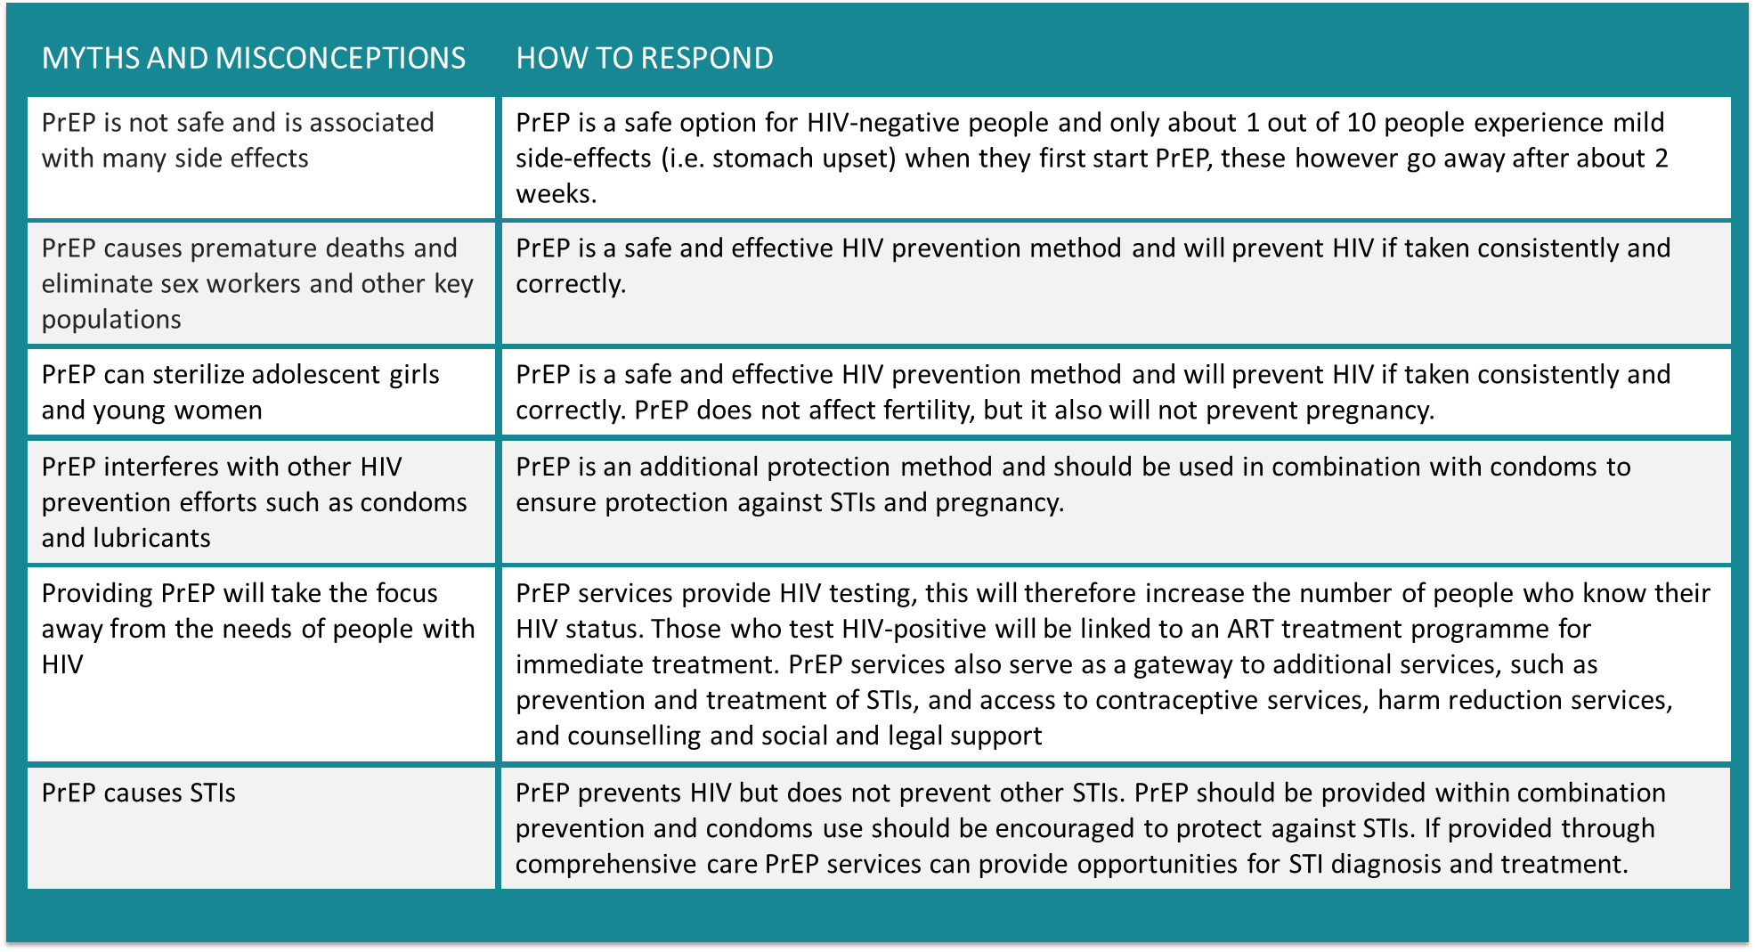
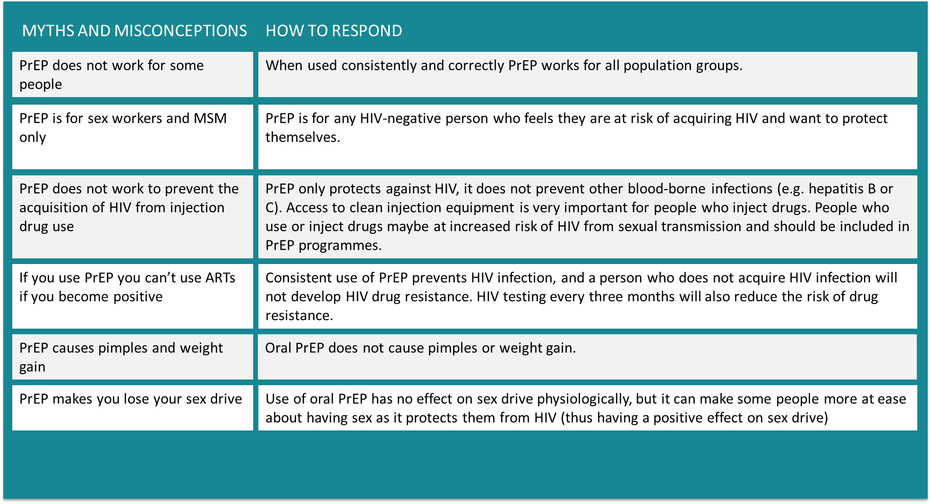
_____________________________________________________________________________________________________
IMPORTANT TOPICS TO DISCUSS WITH PREP CLIENTS
This is a list of important topics to discuss with clients when explaining oral PrEP and helping them decide if it might be right for them. It is not comprehensive. Please ensure you use your organisation’s available counselling tools for each of these topics
What to discuss: | How to discuss it:
Assess the client’s risk profile | Develop a clear picture of the client’s risk profile and lifestyle; make sure they understand how their lifestyle impacts their risk profile. IMPORTANT: use your organisation’s risk assessment tools.
Combination prevention | Taken daily, oral PrEP is an additional prevention option. It should be used in combination with other prevention tools, like condoms, PEP, healthy lifestyles, treatment for STIs, male medical circumcision, and ART for partners living with HIV. REMEMBER: counselling should highlight that ideally oral PrEP should be used with condoms.
Condom negotiation | Some clients, especially sex workers, may not be able to enforce condom use. Provide guidance on how to safely advocate for condom use by the partner. IMPORTANT: does your organisation have a tool that can help you?
STIs | PrEP does not protect against STIs. Regular testing for STIs is encouraged, regardless of PrEP use. REMEMBER: STIs may increase the risk of HIV acquisition.
Contraception / Fertility goals | PrEP is not a contraceptive. Oral PrEP is safe to use with all contraceptive methods. Consult with a physician to provide guidance on how to proceed if the client becomes pregnant.

What to discuss: | How to discuss it:
Adherence (daily) | For oral PrEP to be effective, the pill must be taken every day. Adherence counselling is critical for full HIV protection.
Side effects | Some people get mild side effects when they start oral PrEP, but they generally go away after a few weeks. The most common side effects include: nausea, headache, tiredness, diarrhea, depression, abnormal dreams, vomiting, rash, problems sleeping, and changes in appetite. Clients may need extra support and encouragement to manage side effects in the first few weeks.
Intimate partner violence (IPV) | People who have abusive or controlling partners may find it more difficult to take care of their sexual health and to adhere to PrEP. Ask about the client’s relationships, and for clients experiencing abuse, provide counselling and referrals, when possible.
Talking to your partner, family, friends, etc. | Deciding whether to tell anyone about your PrEP use is a completely personal decision. Some people find it helpful to tell friends or family for support and to provide reminders to take the pill daily. Discuss with the client whether and how they would like to discuss PrEP with loved ones and how to overcome any potential barriers to gaining their support.
Visit schedule | Explain the visit schedule for oral PrEP use. The client must return for follow-up visits at the first month, and then every three months. * (as per national guidelines)

MODULE 5: MONITORING AND EVALUATION
Refer to participant folder for a:
– PREP Client form (facility held)
– PrEP register
– PrEP monthly report form
– Substantial Risk and Eligibility Assessment

EXERCISE
Review the data points on each of these tools
Practice completing the tools using the case studies in ANNEXE 3

PREP CASCADE

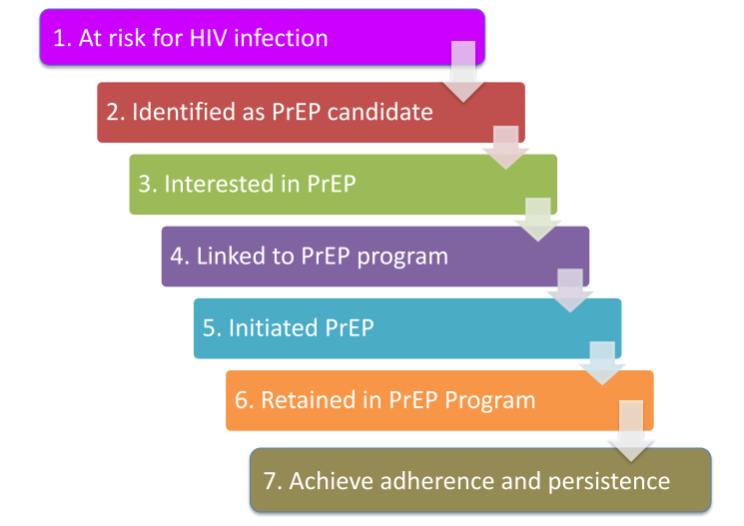

REFERENCE MATERIALS
- ICAP: PrEP Training for Providers in Clinical Settings
- Southern African HIV Clinicians Society
- http://www.who.int/hiv/pub/arv/arv-2016/en/
- http://www.who.int/hiv/topics/prep/en/
- http://www.unaids.org/sites/default/files/media_asset/UNAIDS_JC2764_en.pdf
- http://www.prepwatch.org/
- http://www.cdc.gov/hiv/risk/prep/
- Glidden, DV, Amico, KR, Liu AY, et al. Symptoms, side effects and adherence in the iPrEx open-label extension. Clin Infect Dis. 2016;62(9):1172-7.
- Fonner, VA, Dalglish, SL, Kennedy, CE, et al. Effectiveness and safety of oral HIV pre-exposure prophylaxis for all populations. AIDS 2016;30(12):1973-1983.
- The Fenway Institute. Pre-exposure prophylaxis clinical study data sheet. http://www.projectinform.org/pdf/prepstudydata.pdf Accessed October 5, 2016.
- World Health Organization. Review: Safety of tenofovir PrEP in pregnant and breastfeeding HIV-uninfected women and their infants. http://emtct-iatt.org/wpcontent/uploads/2016/08/WHO-TDF-pregnancy-Lynne-Mofenson.August-212016.pdf Accessed October 5, 2016.

