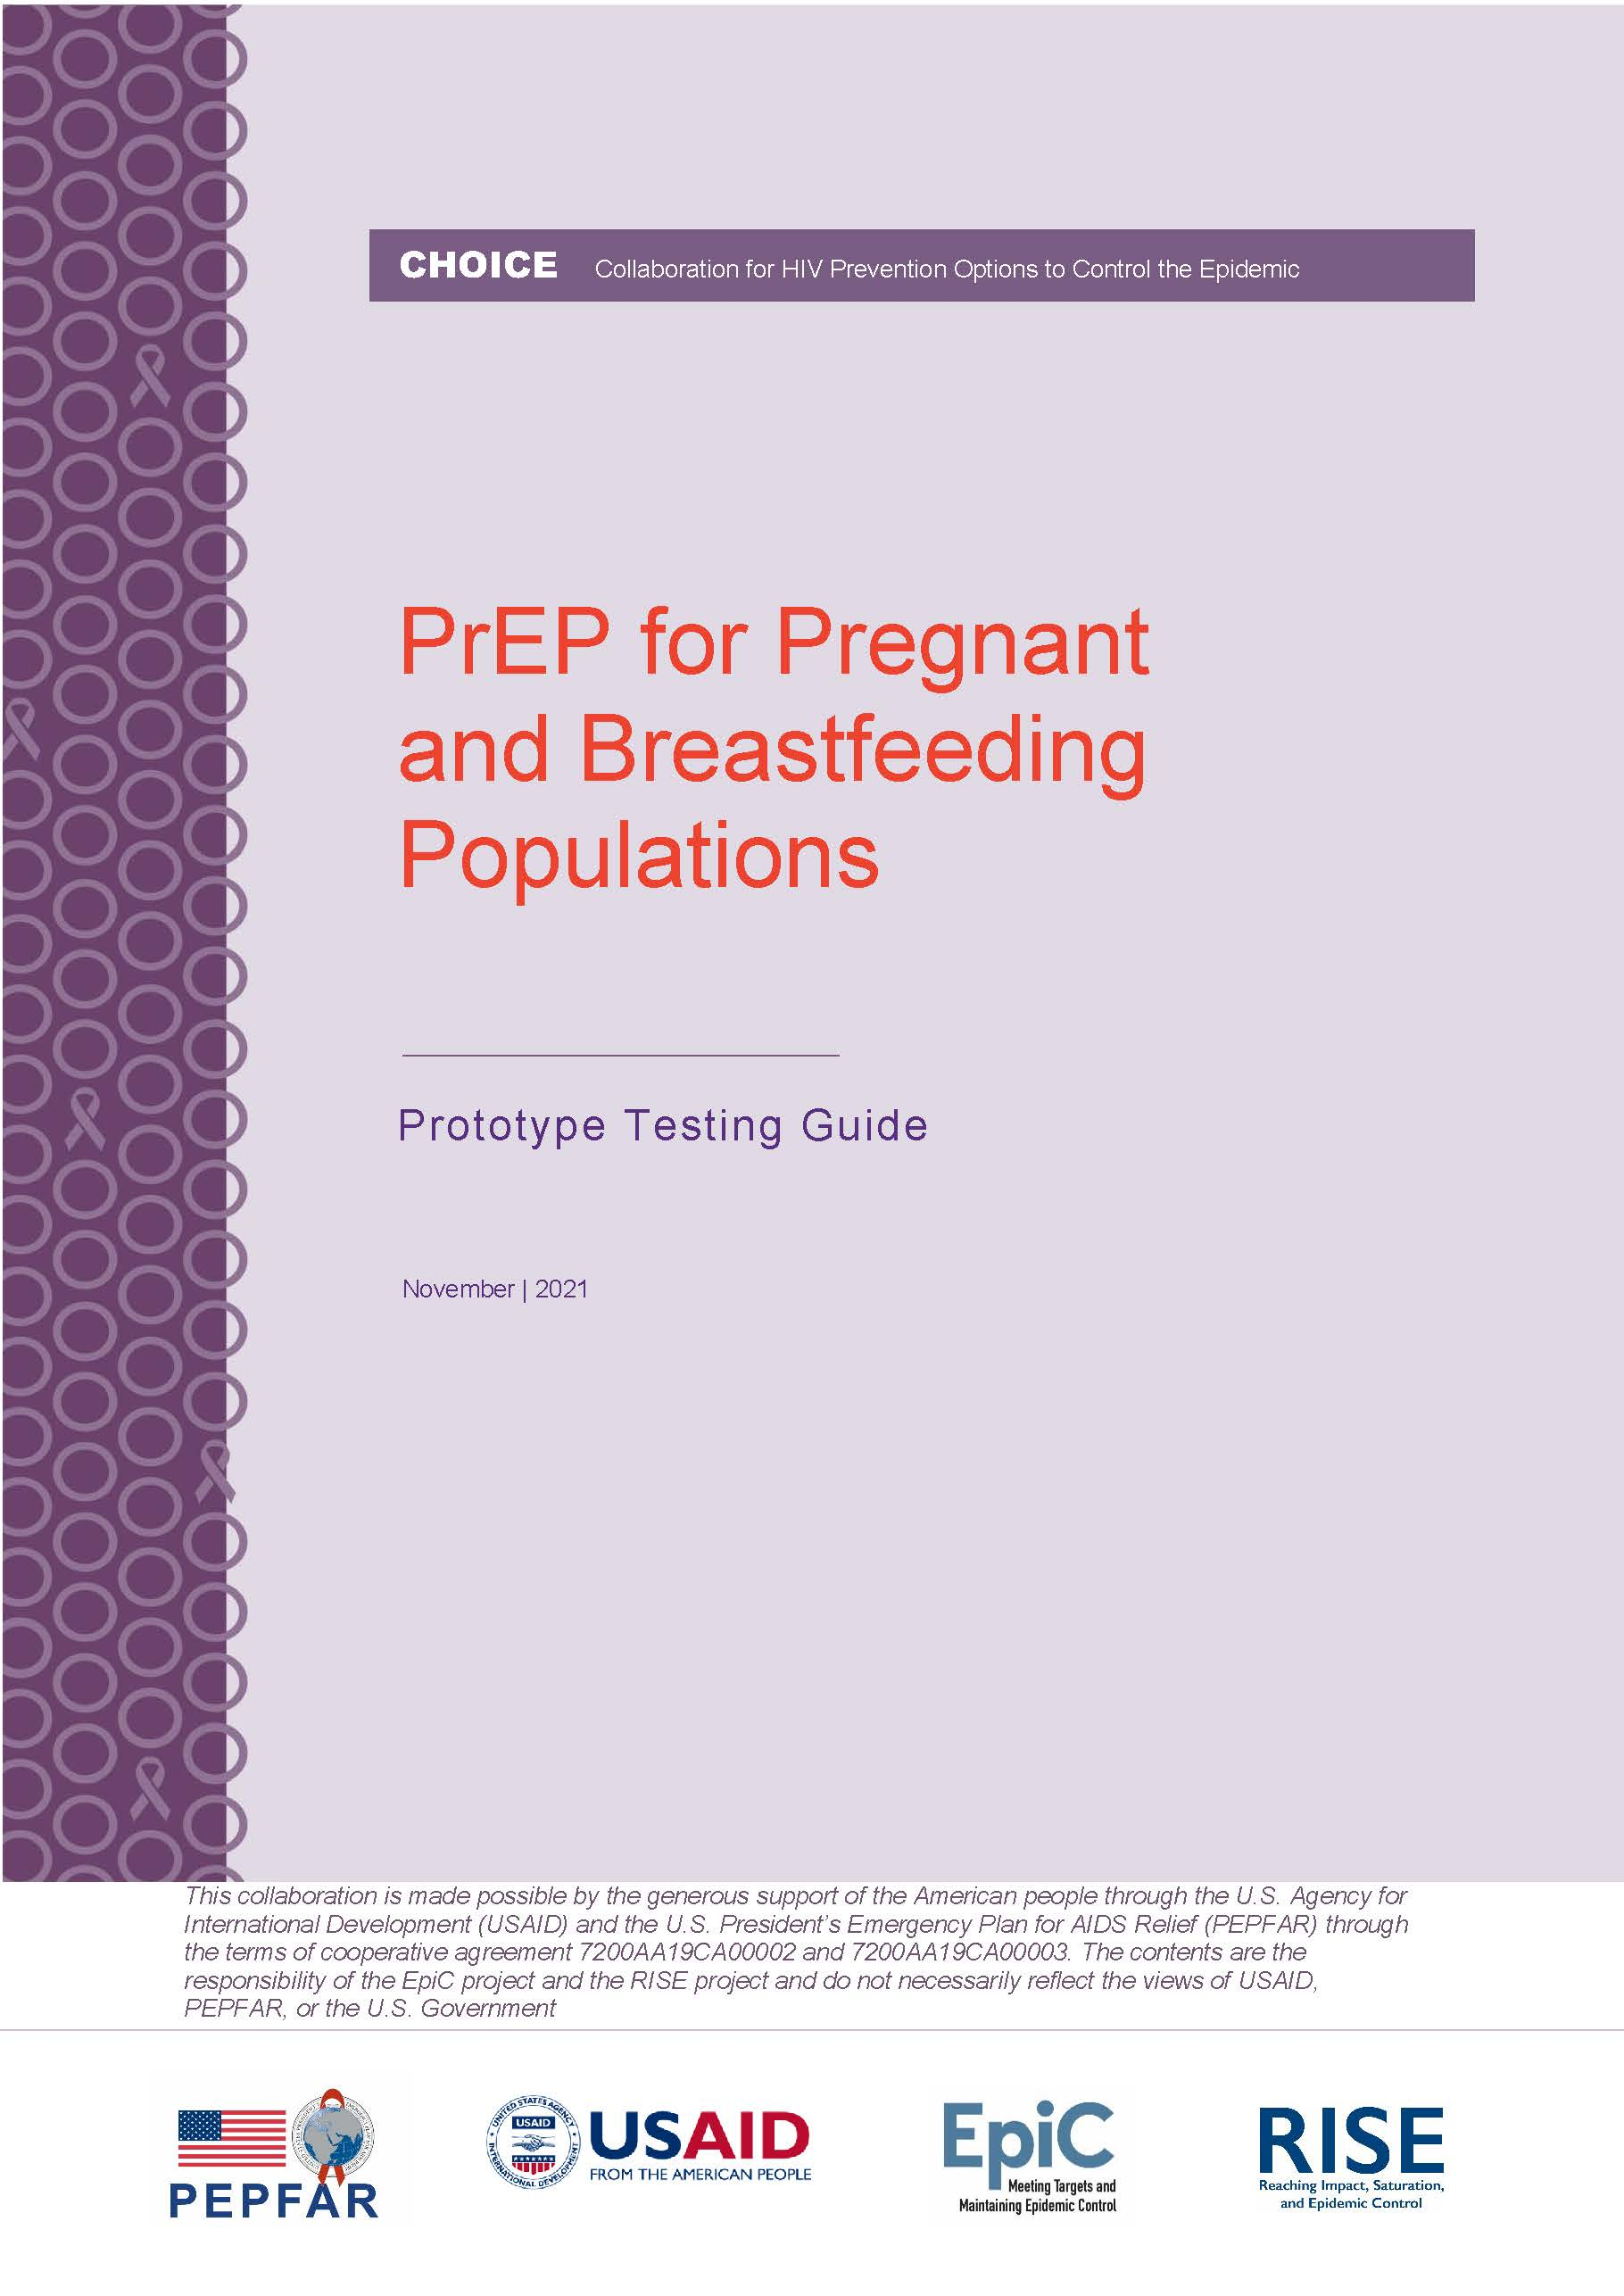
CHOICE Collaboration for HIV Prevention Options to Control the Epidemic

CHOICE Collaboration for HIV Prevention Options to Control the Epidemic

CHOICE Collaboration for HIV Prevention Options to Control the Epidemic

CHOICE Collaboration for HIV Prevention Options to Control the Epidemic
Table of Contents
Acronym List 3
Section 1: Background 4
Section 2: Prototype Testing: Definition, Objectives, Methodology 5
Section 3: Conducting a Prototype Testing Session 6
A Note on Unique Program Needs 10
Conclusion 11
Annex A: Prototypes 12
Annex B: Facilitator Pocket Guides: 27

Acronym List
ANC Antenatal Care
CHOICE Collaboration for HIV Prevention Options to Control the Epidemic
FAQ Frequently Asked Question
HCD Human Centered Design
HIV Human Immunodeficiency Virus
IEC Information, Education, Communication
PEPFAR U.S. President’s Plan for Emergency AIDS Relief
PNC Postnatal Care
PBFP Pregnant and Breastfeeding Populations
PrEP Pre-Exposure Prophylaxis
USAID US Agency for International Development
WHO World Health Organization

Section 1: Background
Guidance from the World Health Organization (WHO) supports provision of pre-exposure prophylaxis (PrEP) to pregnant and breastfeeding populations (PBFP) who are at continued substantial risk of HIV infection. As countries work to expand availability of PrEP for PBFP through policy, advocacy, capacity building, and service delivery efforts, it is also critical to consider this population in national and sub-national PrEP demand generation campaigns. Countries around the world have made great strides in introducing PrEP as a key element of a combined HIV prevention strategy. Many countries have engaged in extensive design processes which have led to innovative programmatic approaches to increase demand for PrEP and support adherence and persistent use among key and priority populations.

This Prototype Testing Guide is intended to help countries and implementing partners adapt or develop demand generation print materials that address the needs of PBFP and providers caring for this population during the introductory phase of service roll out. It includes a series of demand generation print and IEC material “prototypes” and this facilitation guide to help teams learn from and adapt the prototypes for implementation. Please refer to the CHOICE PrEP for Pregnant and Breastfeeding Women – Clinical Guidelines and Training Package for technical information about providing PrEP to PBFP.
Prototypes
High resolution adaptable prototypes can be found on PrEPWatch, and in Annex A. This package includes three types of prototypes: 1) wall posters, 2) flyer, and 3) take home plans / brochures. The initial prototypes were developed using Canva (www.canva.com), and address the existing PrEP evidence base. Details on how they were developed are also available in a PowerPoint deck on PrEPWatch. Programs may choose to use Canva or any other free or low-cost design platform or graphic design service to adapt or refine materials. You may also decide to take what you learn from prototype testing and create new materials

Images: Examples of prototypes available for testing and adaptation
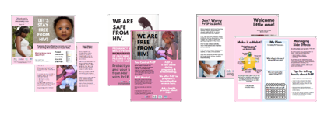

Section 2: Prototype Testing: Definition, Objectives, and Methodology
Definition:
Prototype testing is a way to gather qualitative feedback on programmatic approaches or materials early in the design process with the goal of learning client preferences and desires and subsequently adapting the approaches/materials based on feedback. The technique consists of showing a draft, but realistic, intervention (in this case print materials) to beneficiaries in a representative context without a great deal of contextualization, and then collecting their unfiltered reactions, questions, critiques, and recommendations. At the concept exploration / prototype testing stage, the goal is to discover which ideas resonate with people, which ones spark strong reactions (either positive or negative), and to understand preferences among a variety of concepts. In contrast to academic qualitative research, prototype feedback sessions are informal, unscripted, and conducted by the people who are responsible for developing the content.

Consistent with a human-centered design (HCD) approach, it is important for those making decisions about the materials to experience end-user reactions and to notice body language, tone of voice, and context, in contrast to receiving information second-hand in a research report. These sessions can both educate and inspire programmers, as well as spark empathy for end-users, which is an essential ingredient for the development of materials and activities that will resonate with their intended audience. Discussions about prototypes may also inspire and inform complementary activities (e.g., if most clients want to know how PrEP might impact fertility, it could be important to train providers to respond to these queries).

Objectives:
- Observe what happens when materials are placed in a realistic context
- Determine whether the form, language, writing, images, look and feel, and expressions used are appropriate and understood by the target audience
- Establish whether the content (including images and font), is appealing, relatable, and believable, both overall, and in pieces and parts (which could be recombined)
- Indicate whether the material could motivate the audience to desire PrEP
- Compare reactions when the same messages are presented in different ways
- Build empathy and foster deeper understanding of end-users and their needs

Methodology:
We recommend that prototypes be tested through small discussion sessions with 5-10 people, at service delivery points where PBFP would encounter the materials naturally. The sessions will take about 1 to 1.5 hours and should be facilitated by the program team responsible for designing and implementing the materials.

Note: As described here, the purpose of the prototype testing sessions is not to formulate or test hypotheses or generalize findings, but rather inform media content and design; therefore, as presented, the activities should not constitute research. However, each organization should consult their internal processes for such a determination

Section 3: Conducting a Prototype Testing Session

The instructions in this section will help you to plan, prepare materials, and conduct sessions with PBFP. You could also adapt this process to test materials with health care providers (particularly those providing Maternal, Newborn and Child Health (MNCH) services, including antenatal care (ANC) and postnatal care (PNC) services. The principle is the same: ask people to interact with the examples in this package as they would in real life, and give feedback on the experience.
Step 1: Plan
The first step is to prioritize target audiences, identify facilities where feedback sessions will be held, and decide how many tests to run based on the time, person-hours and financial resources you have. While adapting an existing prototype (like those included in this package) can be a “shortcut,” getting feedback from a diverse group of end-users at the beginning will increase the likelihood that materials will achieve their intended results when used at scale.

- Target audiences: Pregnant and breastfeeding women (posters, flyer, take home plan) healthcare providers (take home plan)
- Facilities: Include a diverse set of facilities such as: private and public health facilities, community-based services, and drop-in centers. Look for sites that will represent different types of clients (i.e., young mothers, sex workers, military spouses, etc.).
- Stakeholders: Consider inviting key stakeholders to participate in a prototype feedback session. This helps to hasten any necessary Ministry of Health or other approvals when materials are ready to use.

Step 2: Prepare and collect materials
Materials
- Notebooks
- Pens or Markers
- Color print outs of the different campaign concepts or prototypes
- Decide which members of the programmatic team will be best placed to learn from the exercise and drive adaptation.

You will want to have at least two people to facilitate the prototype feedback sessions—one to engage with the target audience, and one to take notes, observe body language, take (consented!) pictures, etc. We recommend having both clinical and demand generation project leads present, as you seek to harmonize messaging across the clients’ experience of care.

- Translate the available prototypes into local language using an online PDF editor or Adobe. NOTE: Pictures may need to be localized, but the stock images used in the materials in this package were perceived to be “local” in several different countries. Try these images first, as they will be free to reproduce.

- Print out several copies of each of the materials using a color printer. This package includes three types of prototypes: 1) wall posters, 2) flyer, and 3) take home plans / brochures.
NOTE: Some of the prototypes are designed to be printed on the front and back of a single sheet of paper (flyer and tri-fold brochures), while posters can be printed on A3 paper
Step 3: Conduct the Session(s):
- Place the flyers and posters in the waiting area of the service delivery point as you imagine that they will be placed in real life, and where PBFP will be sure to see them. i.e. Hang posters on the walls, place flyers on tables or benches. NOTE: Keep additional copies of each of the materials for use during discussion
- OBSERVE how clients interact with the materials. Do they approach the posters? Look at the handouts? Which of the materials seem to attract their attention? What do they reach for first? Do any discussions about the materials occur? What are people saying? What are they talking about? Take 30 minutes just to observe the context. What other materials are these competing with?
- Ask some of the clients in the waiting area if they would be willing to join a discussion to talk about new health materials being used at the facility. Have volunteers sign consent waivers if they are comfortable to allow quotes and photos to be taken. You might hold this conversation in the waiting area itself, or in a separate room in the facility.
Notes on Taking Notes:
Have everyone from the program team sit just outside the group, where they can hear and take notes about everything: anything they are noticing about themes, tone of voice and body language, great quotes, etc.
Take lots of notes!
Take pictures of the environment.
Make sure you write down common and differing opinions
Notice and write down your OWN reactions.
- What is surprising you?
- What are YOU learning?
- What ideas are the discussions inspiring in you?

- Break the ice and set up discussion:
The discussions ought to be informal and fun. Sit at the same level as the participants, to create the feeling that you are discussing among yourselves as equals. If possible, sit in a circle.
Make sure that you have their consent to participate in this discussion and reassure them that they can leave any time, that they only talk about what THEY want to talk about, and that they are free to participate as much or as little as they want.
Begin by welcoming the participants and sharing how happy you are to get to know them. Explain that we are introducing a product in [country], and we need their help figuring out the best way to talk about it and understand the concerns and questions that clients might have.
DO NOT TELL THEM ABOUT PREP—we want to see how they would react if they came across these materials in real life without any introductions!
It could be helpful to do a little icebreaker. Feel free to use any icebreaker you like. One idea is to ask them to introduce themselves using any name they like and share one thing they are looking forward to when the baby is born.
Explain that together we are going to look at some materials, and we want their honest reactions and opinions. Reassure everyone that there are no right or wrong answers here—just their honest thoughts. Encourage them to share anything that comes to mind, even if you don’t ask a specific question about it.

- Test Prototypes in Context:
First, we want to see how the posters and flyers landed in context, and whether they were noticed. Ask the participants what they were thinking about as they were sitting in the facility waiting area:

- What did they do to occupy their minds?
Tips for a great conversation
- Really listen! Repeat back to participants what you are hearing them saying! You can even use the same words they have used.

- Affirm them and validate their perspectives. Say things like: “That makes a lot of sense.”, or, “Oh, that’s an interesting point… tell us more about that?”

- Let their answers drive the next questions. Keep probing…

Example: “I’m noticing that many of you are talking about how your mother in law influences your husband’s ideas on what you need to do when you are pregnant. What helps you to communicate better with your mother-in-law?

- Dig deep: For example, if someone says: “This woman looks like a good mother” ask: “What is it about her that is makes her seem that way?” maybe the answer is: “She just looks so confident!” you could ask: “What is a situation you were in that made you feel confident like that?”
- How are they feeling while they are sitting here?
- What did they notice?
- Which materials caught their attention and why?
- Was there anything that they saw that was new, or made them curious?
- Ask them to point out what they noticed. What made you look at this? What did you think about when you saw it?

- Test Prototypes in Discussion Session:
Lay out all of the different prototypes on the ground, or put them up on a wall and ask the participants to spend some time looking at them. Ask which one they find themselves wanting to look at first. (What draws attention?)

Tell them that they each get to have three votes to “vote” for the poster/images they find to be most appealing or interesting. Give each person three sticky notes or stickers—one sticky is one vote.

They can use their three votes however they like… on three different images, or on one part of a prototype, or they can even put all three on the same thing, if they like it the best!

- Who is this material talking to and why?
- What are you seeing in these materials? How does it make you feel?

Rearrange the materials in order of number of “votes” they got and start discussing each one:

    - What made you vote for this? How much do you like it? A little? A lot?
    - What is it about this that appeals to you?
    - What is it making you think about?
    - What questions is it bringing to mind for you?
    - What do you like about it? Why do you like these things?
    - What parts of it you find particularly interesting? Why?
    - What things do you find to be not at all interesting or demotivating? Why?
    - What information is confusing or unclear?
    - What might get in the way of you deciding to start PrEP today, if it is available?
    - What questions or concerns do you have about PrEP?
    - Where should these materials be placed so that they will be sure to be seen?
Have participants take turns talking about their reactions to the images. Now do the same things for the concepts that were less popular.
    - What about this is not as appealing to you?
    - What concerns do you have about this?
    - What would need to change to make it better?
    - What more do you want to know?
What to look out for: Which positioning worked best for the PBFP: The baby requesting protection? The mom saying PrEP gives her peace? The mom saying PrEP makes her feel powerful? Did they like the testimonials and find them relatable? Which elements were motivating and convincing and which were not?
End the session by telling the women more about PrEP and answering questions they have. Take note of the questions. These can be adapted into FAQs. Ask them what might make them think about taking PrEP and what might hold them back.

C. Test Prototypes with Providers
Print 10 PrEP Plan take-home trifold brochures and give to providers who are prescribing PrEP to PBFP.
Ask the providers to try using the brochures with real clients for several days.

Follow-up after several days and have a conversation about how the provider used the brochures, if they did. Follow-up conversations could be in person or via WhatsApp.

- How did you use the pamphlets during the counselling session?
- What did you like about them? What was helpful?
- What did you not like about them? What was not helpful?
- How did your clients react to the pamphlets? How many wanted to take it home?
- Did anyone decline to take it home? Why?
- How can we make this brochure more helpful for you or for clients?
- Are there different materials for you or for patients that would be helpful? What would those look like? What sort of information would be most helpful, and what format would be the most useful for you?
- Ask the provider if they have any additional questions or ideas.

Step 4: Capture and synthesize feedback
HCD-Lite prototyping sessions bring activity designers into direct contact with end users, which can lead to more empathy and understanding of audience needs and desires.

End-user feedback on the materials is important, and the programmers’ reactions are important too. A post-session discussion should be held to “download” and synthesize the learning from the session. Together discuss the following:

- Note important quotes
- Note any body language you noticed: were participants smiling? Laughing? Serious? Worried? What was their tone of voice?
- Take pictures and quotes where consent is given
- Look for trends in responses and also areas of tension or disagreement
- Consider things you heard that surprised you or that were new to you
- Note any ideas that came to you while observing about how to improve the materials
- Decide if results highlight fundamental flaws with the design, messages, or format

Step 5: Update your materials
Now is your chance to make changes, keeping the women and providers you talked with in mind. Consult with technical experts on any substantive additions, changes, or points of confusion. Consider how you will make these messages most visible and noticeable in the environment where they will be consumed. If the materials change considerably, we recommend running more sessions to make sure that the adapted materials still resonate. When you are confident that the materials will achieve their communication objectives, then proceed with any formal photography and final graphic design.

A Note on Unique Program Needs:
This package is recommended to be used as a starting point. CHOICE recognizes that projects are unique, therefore, teams should adapt the prototypes and facilitation approaches for their context. Different programs will have different levels of financing, time, and personnel to dedicate to materials development. Getting feedback on prototypes can be a “quick and dirty” matter of informally discussing the materials with a few end users in a clinic waiting room, or it can be a more structured endeavor with formal discussion groups with broader geographic and demographic reach. Consider your program needs and resources, but do not allow the “ideal” to keep you from getting feedback from real end-users in the context that they would be seeing the materials. A little is better than none, and more may be better than some--particularly if the contexts are diverse. If you are only able to run a couple of sessions, consider doing so with groups that are very DIFFERENT from one another; if different groups have the same reactions, then the materials are likely to resonate widely.

Conclusion:

Prototype testing sessions to get user feedback are essential because they allow us to consider interventions in context. Even brief conversations can deepen understanding and empathy with the people we want our interventions to reach.

Often, programmers find that what people actually desire, and how they actually use materials, is different than what programmers think they want and need — this process can help close the gap. Moreover, by looking at how an intervention will be consumed, we often learn things we would not otherwise learn by inviting end users into the office to discuss materials without distractions.

Many teams enjoy the exercise so much and find it so valuable that they make prototype testing sessions a routine part of activity design, implementation, and evaluation.

Do not worry about getting it perfect — just get out and do it!

Annex A: Prototypes

Posters-P. 13-19

Seven different versions to test and adapt

To be presented in pairs on A3

Flyer- P. 20-21

To be printed on both sides of a single A4 piece of paper

Page 20 – Front

Page 21 – Back

Take home PrEP Plan trifold brochures- P. 22-24

Two different versions to test and adapt

To be printed double-sided on a single A4 piece of paper and folded

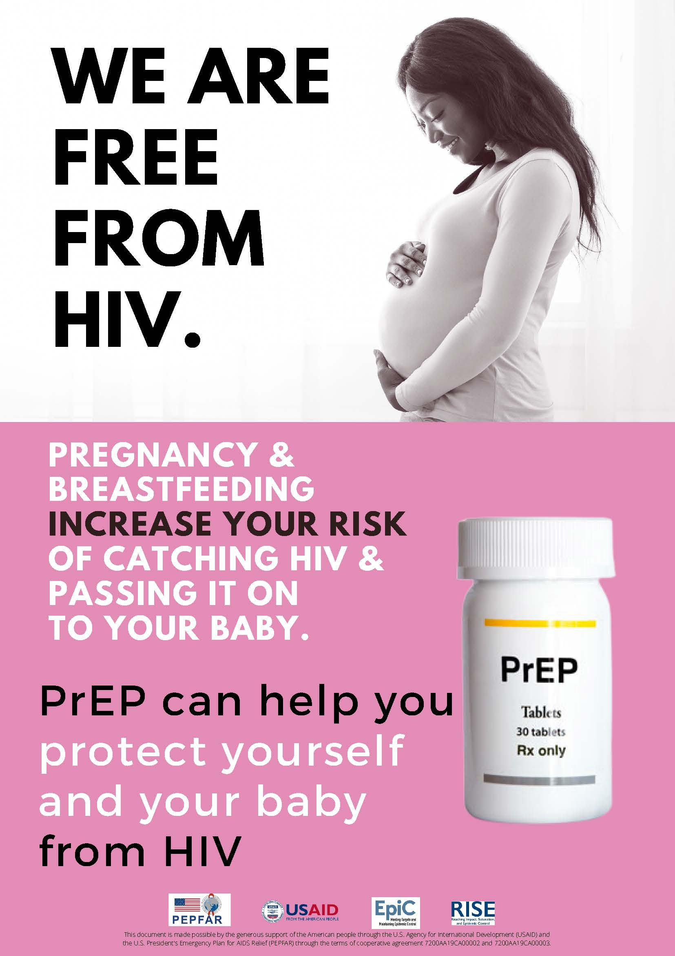

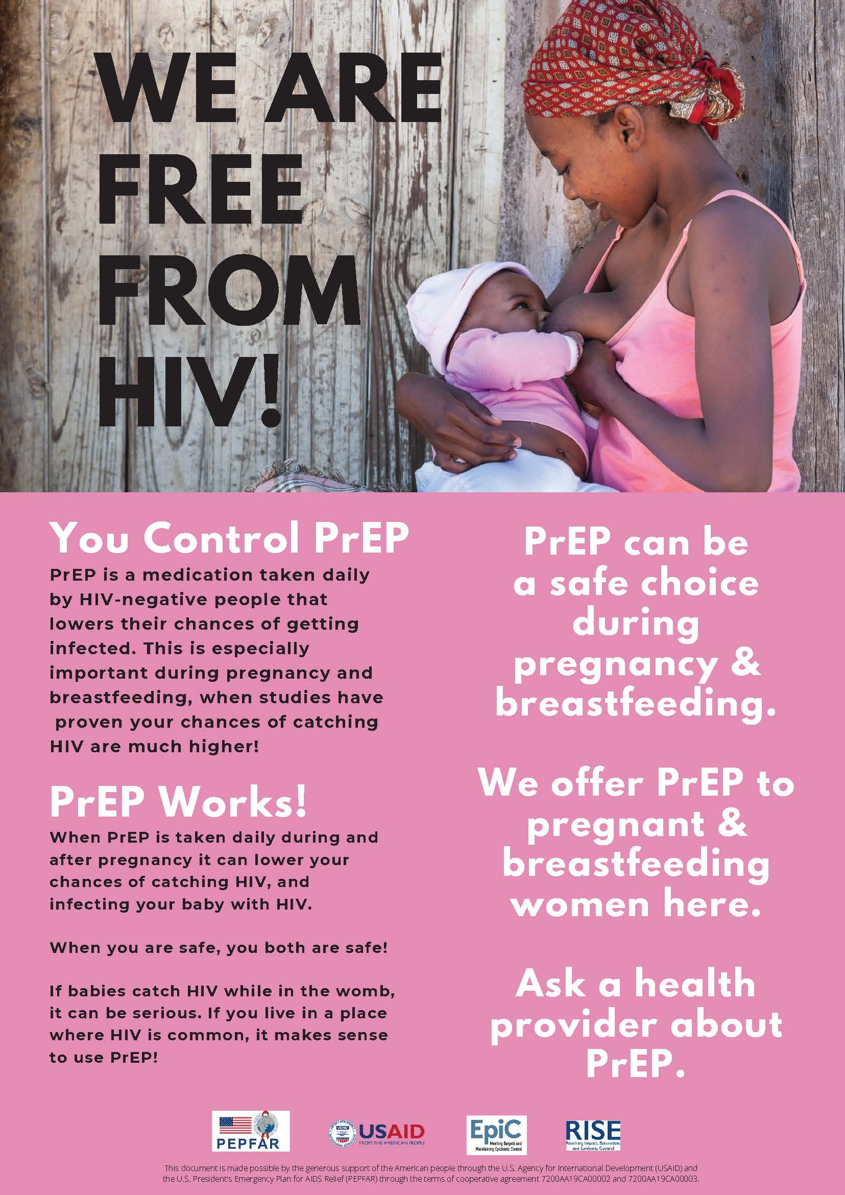
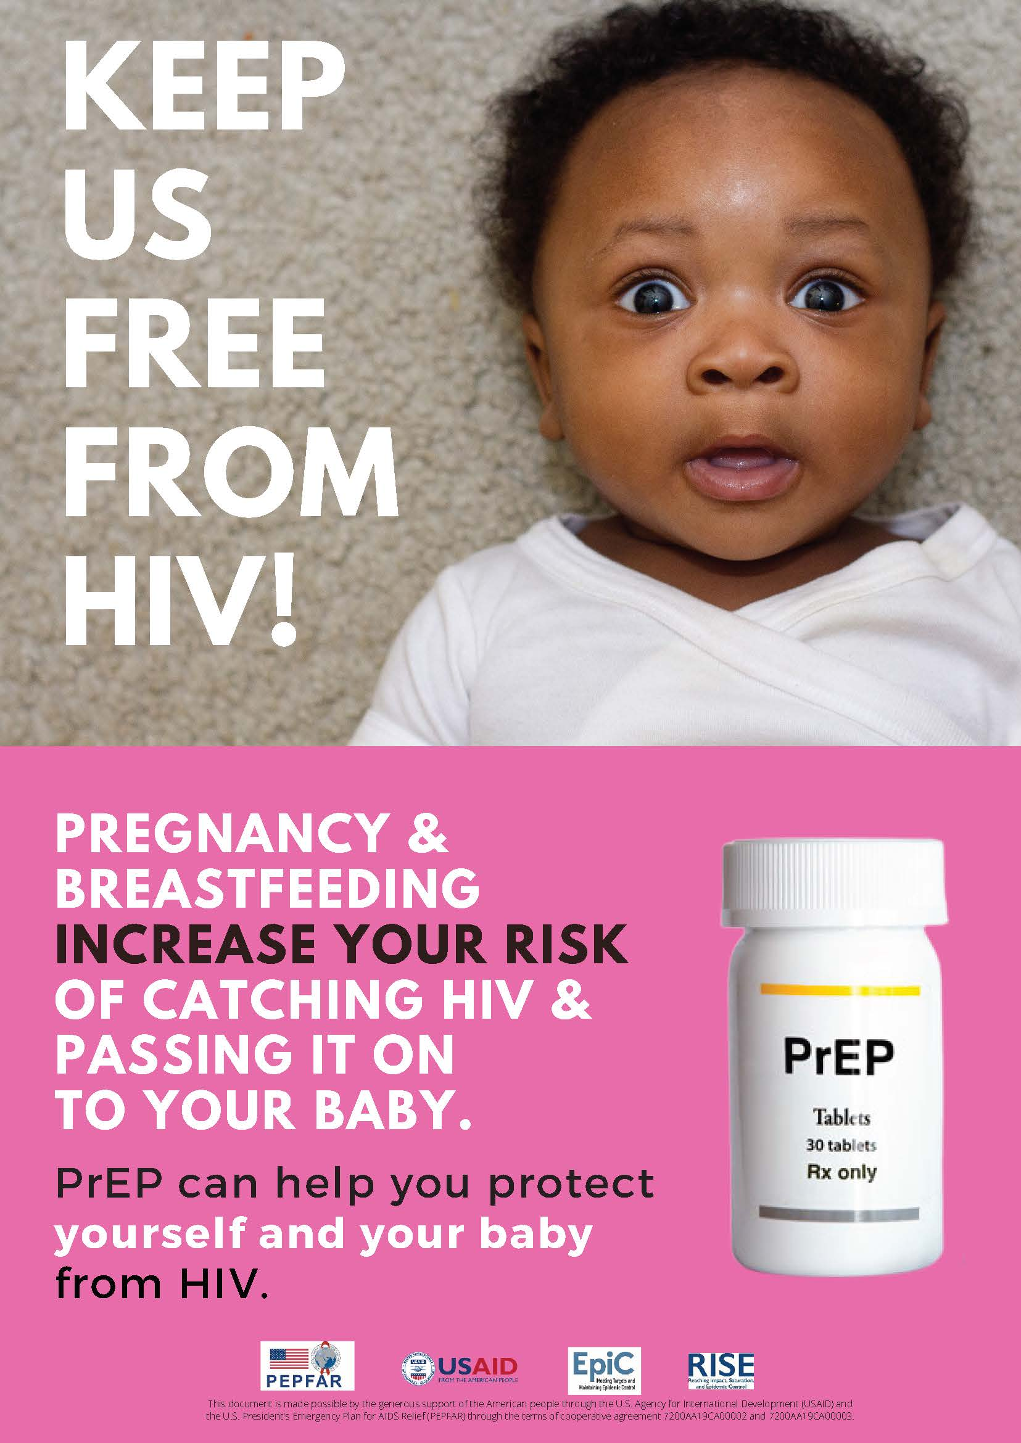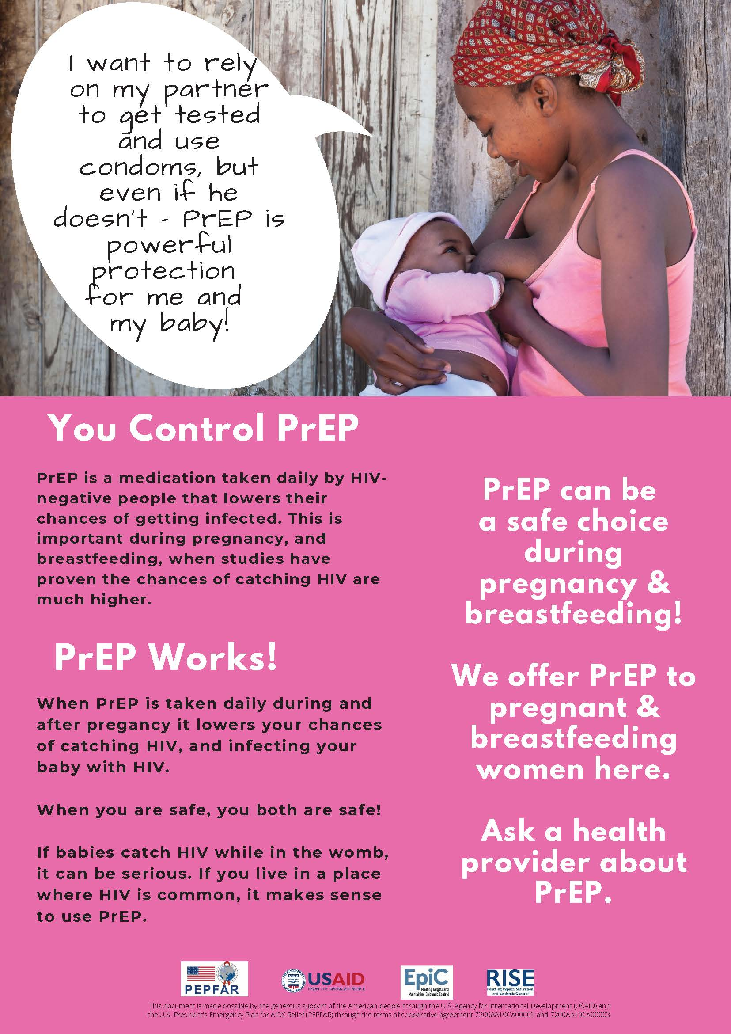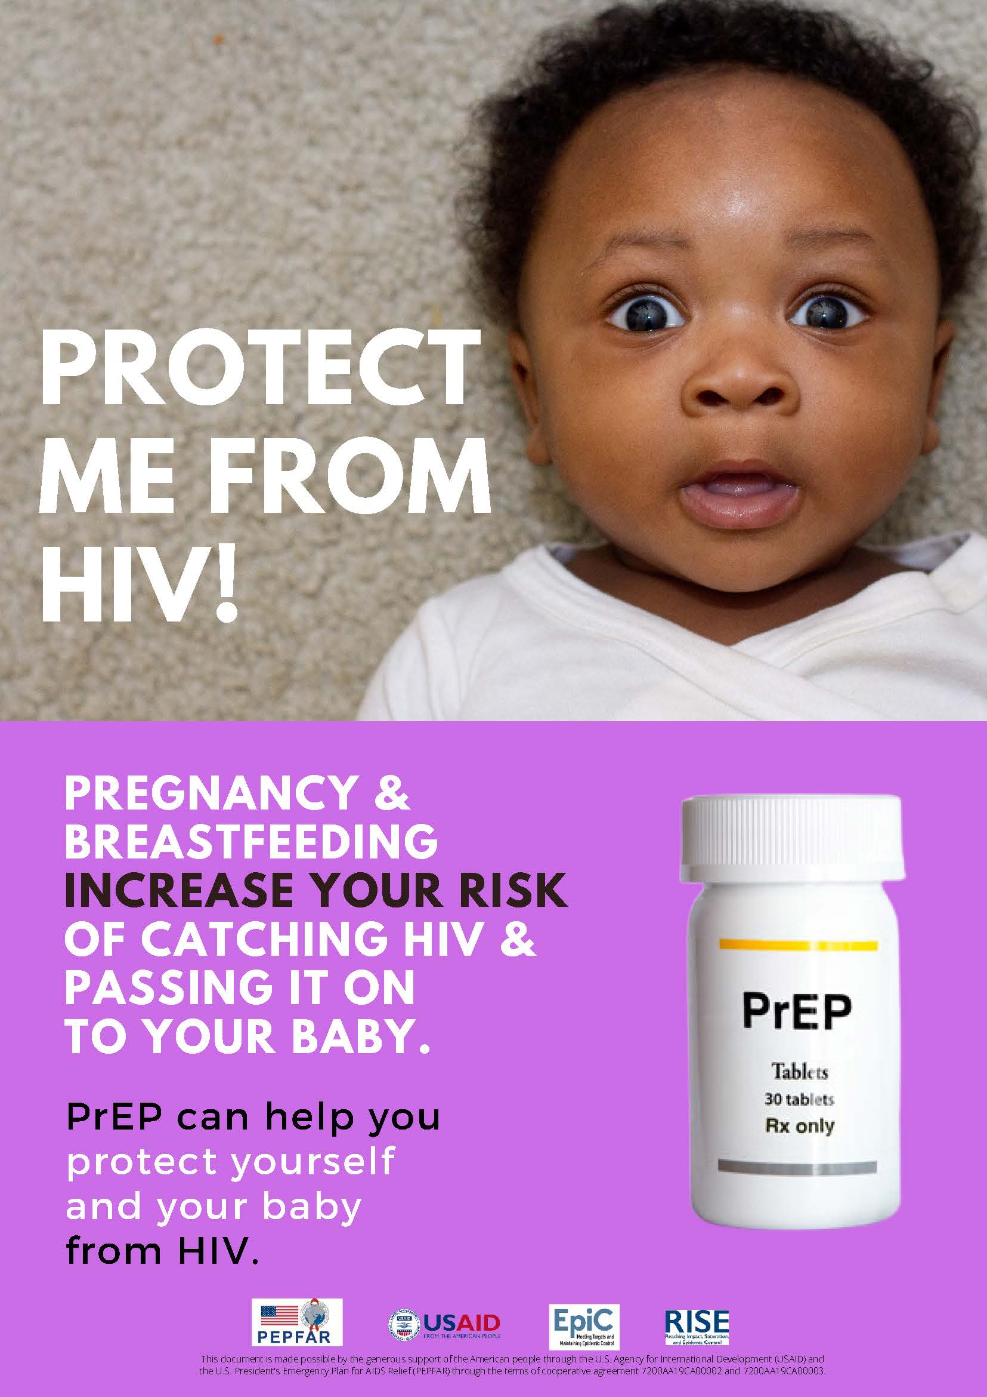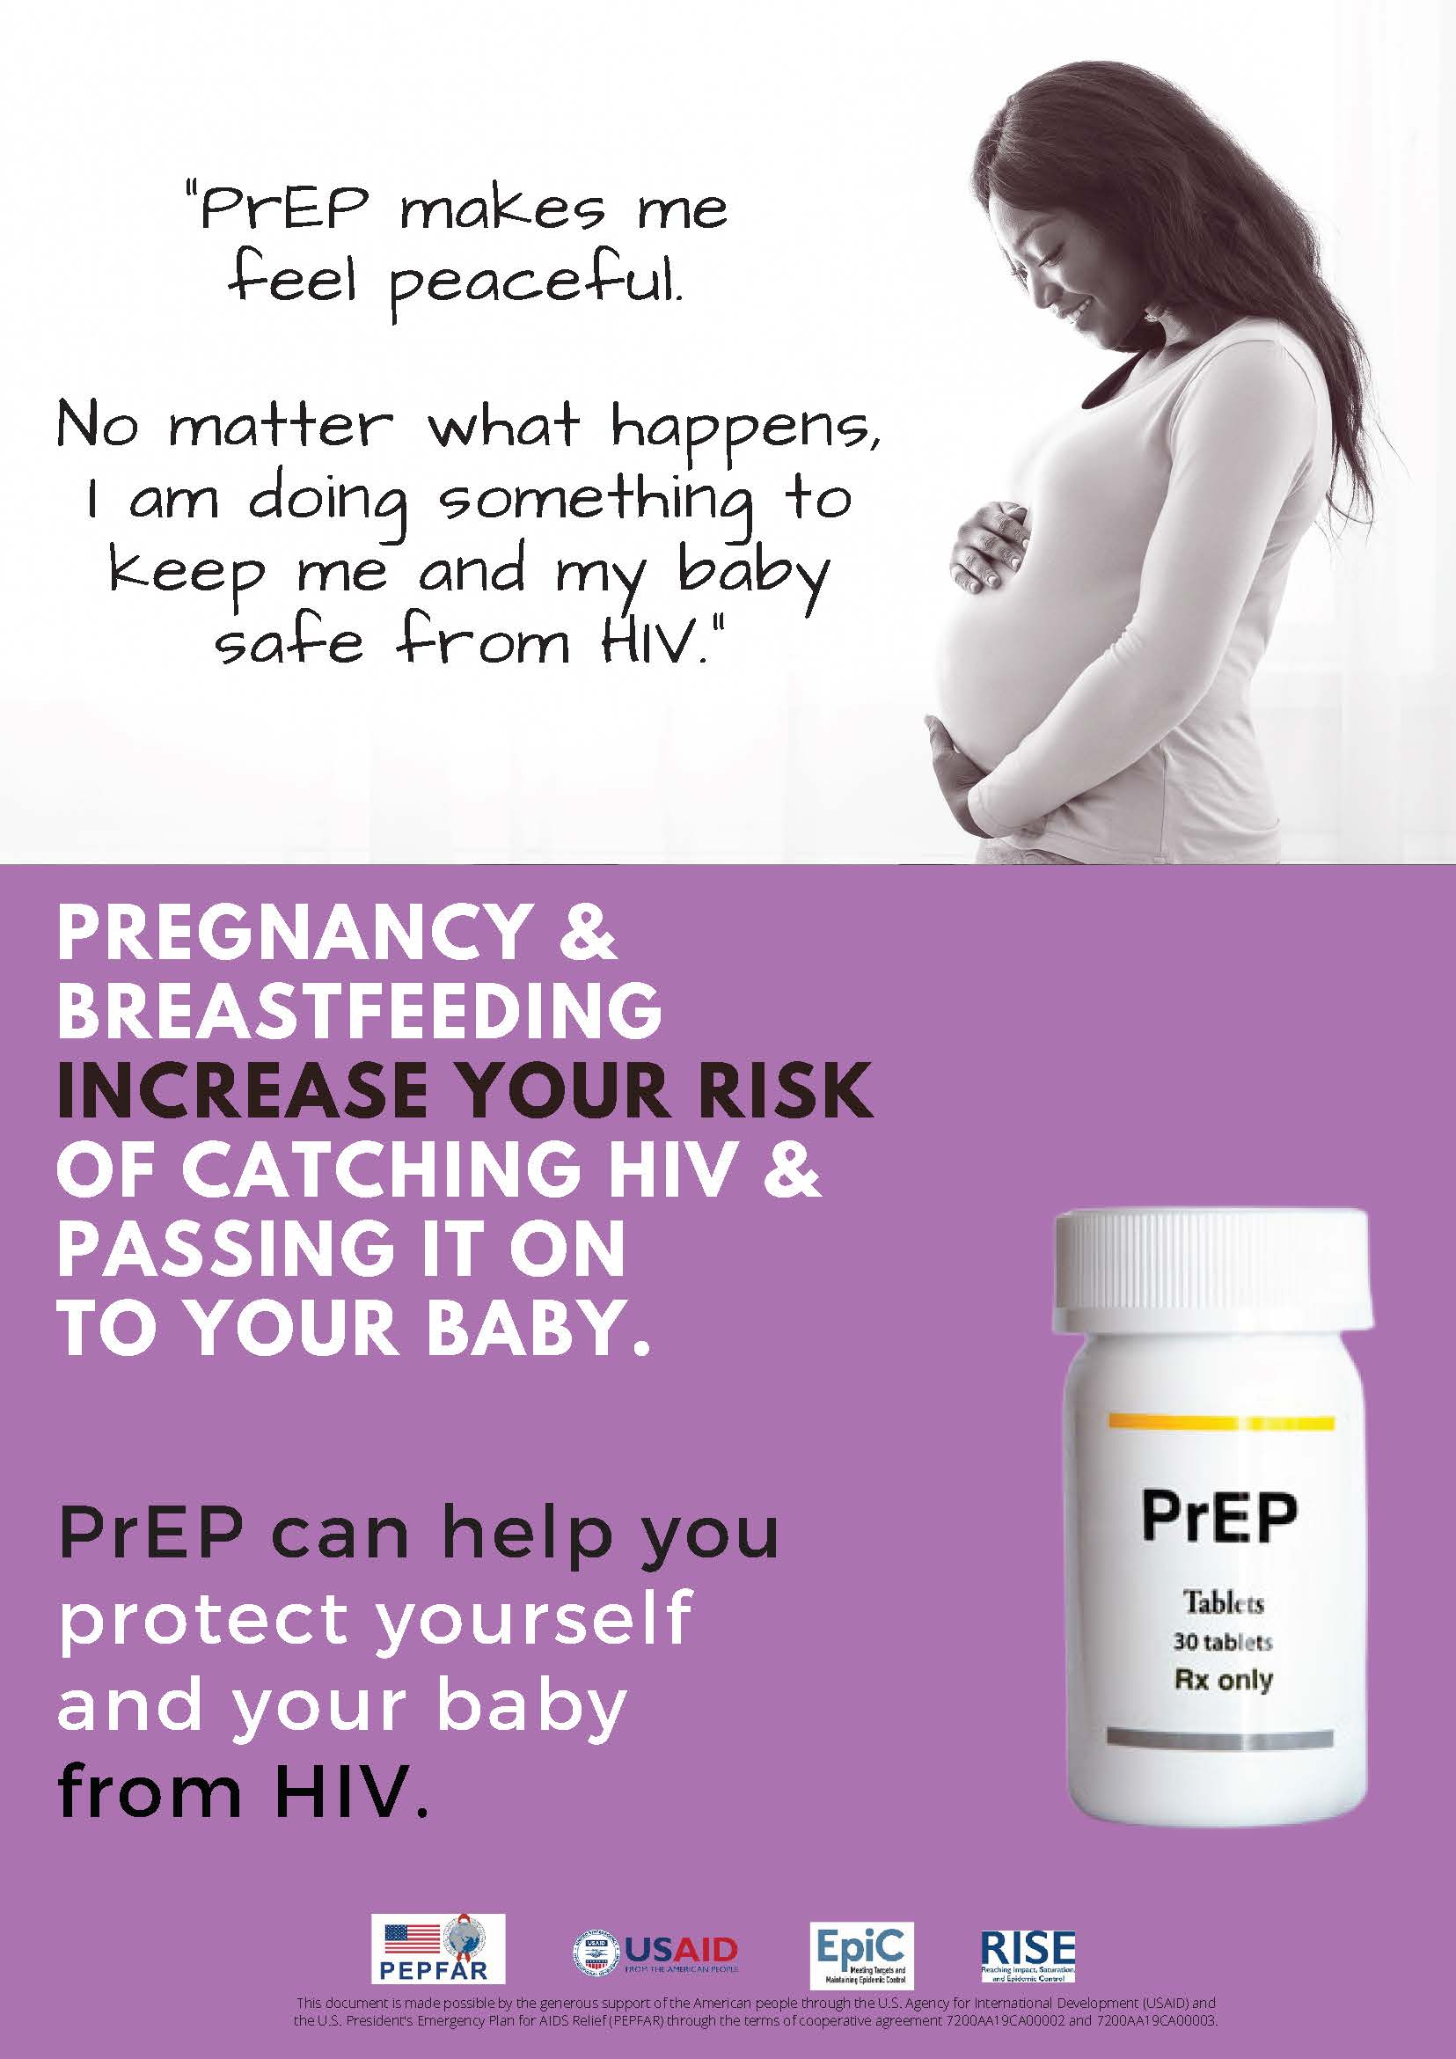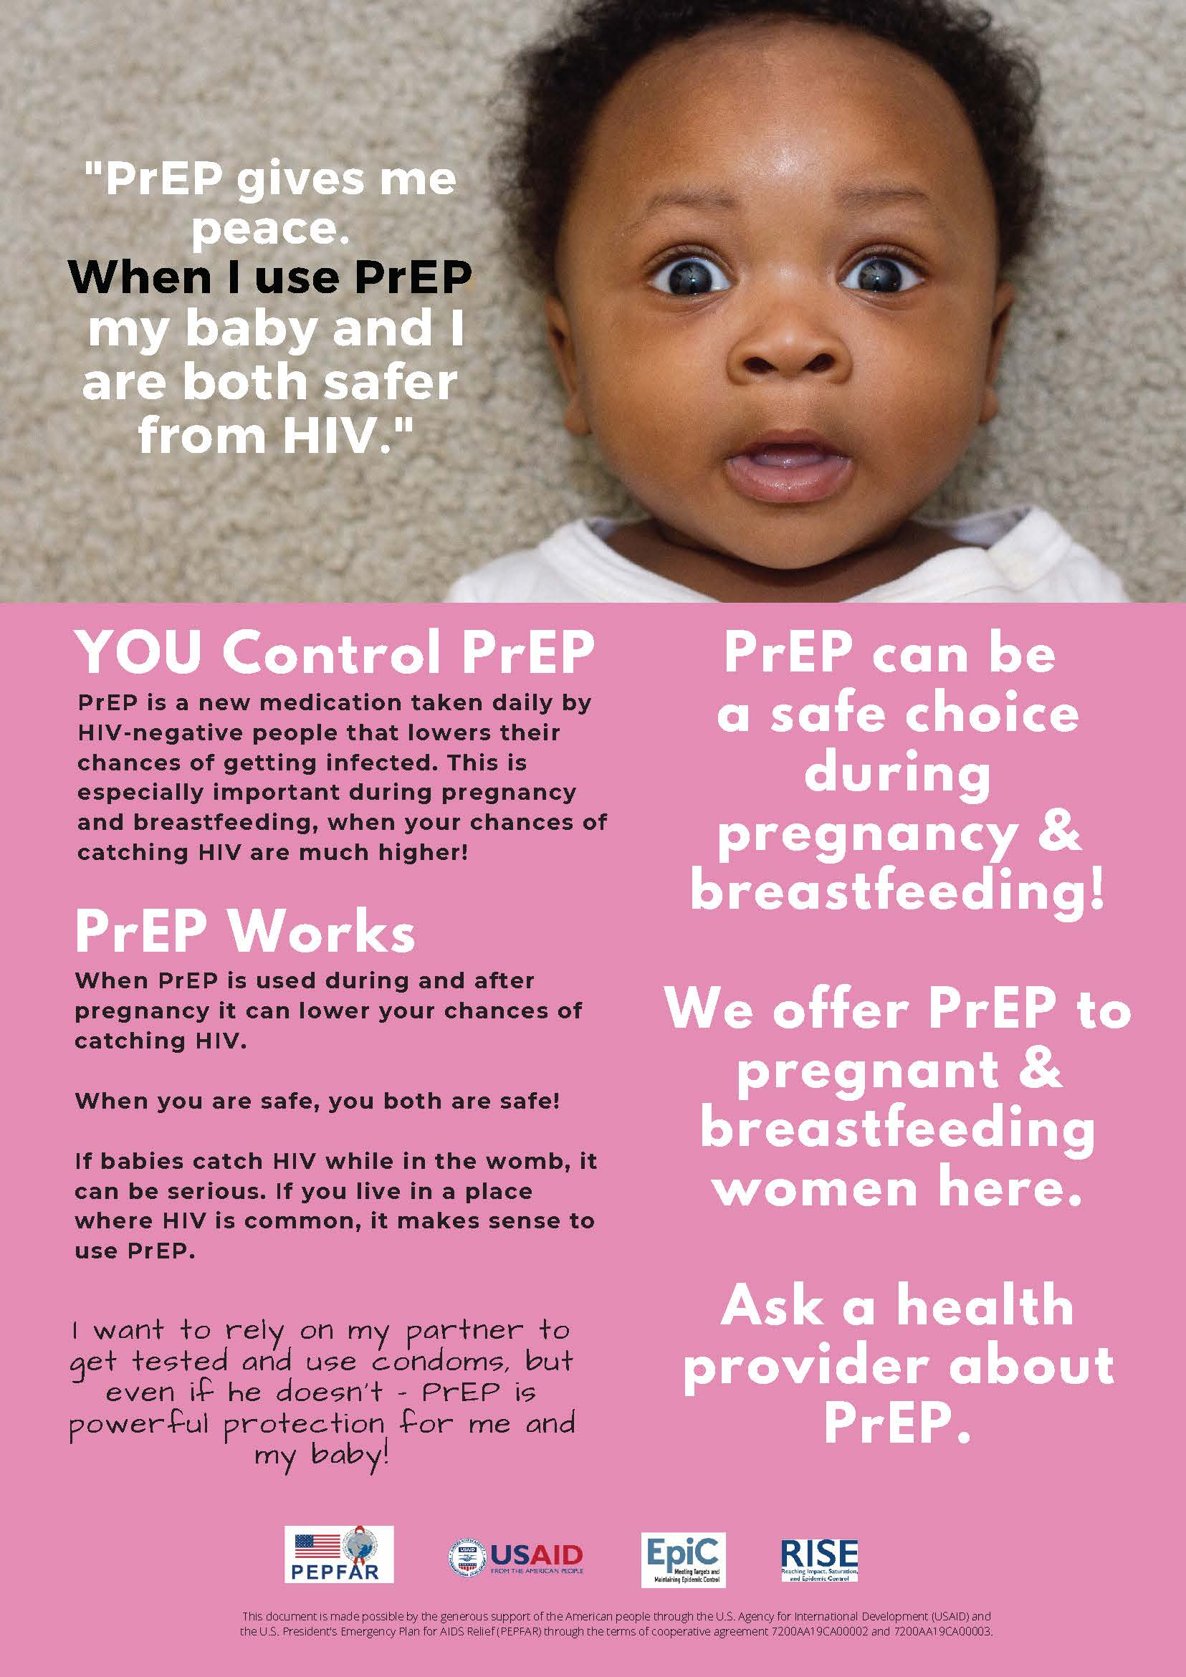
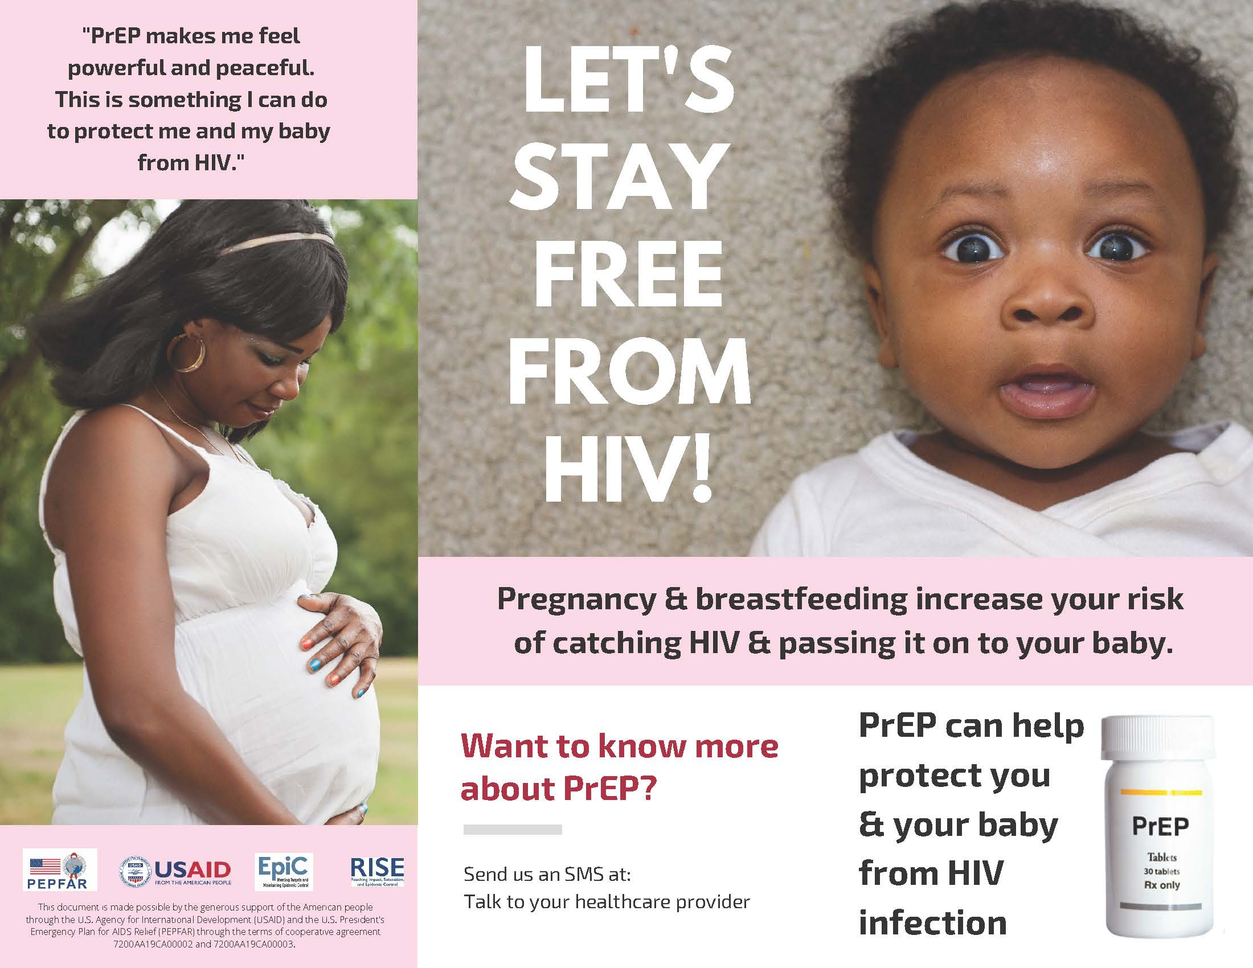
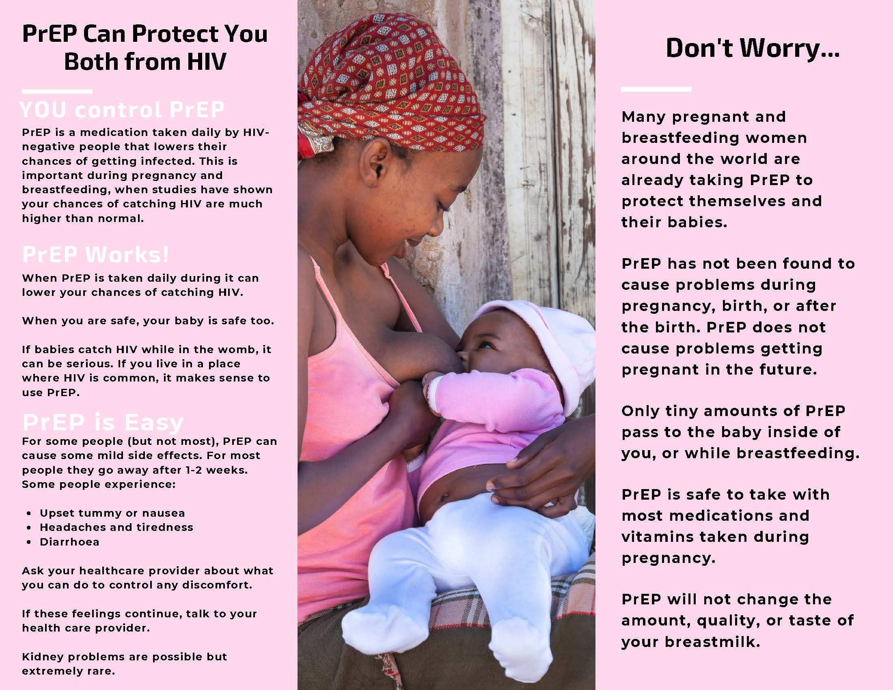

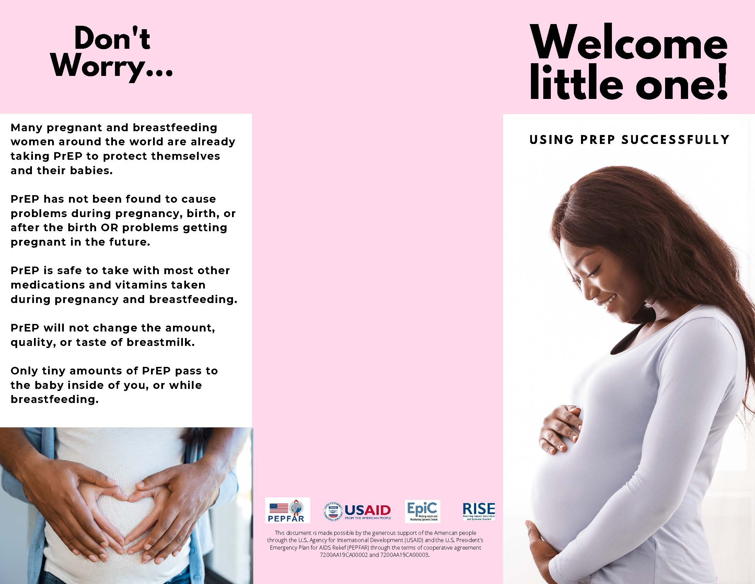
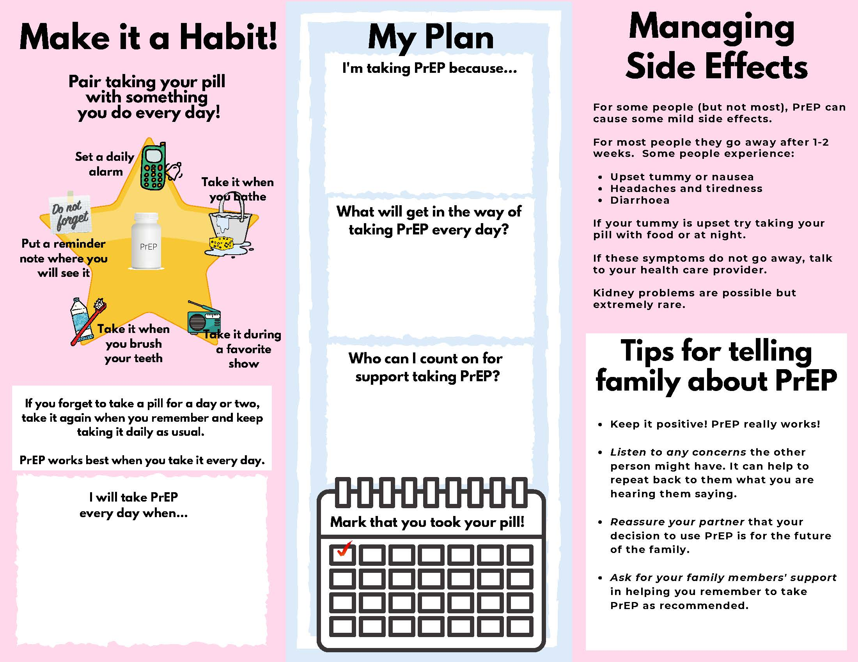

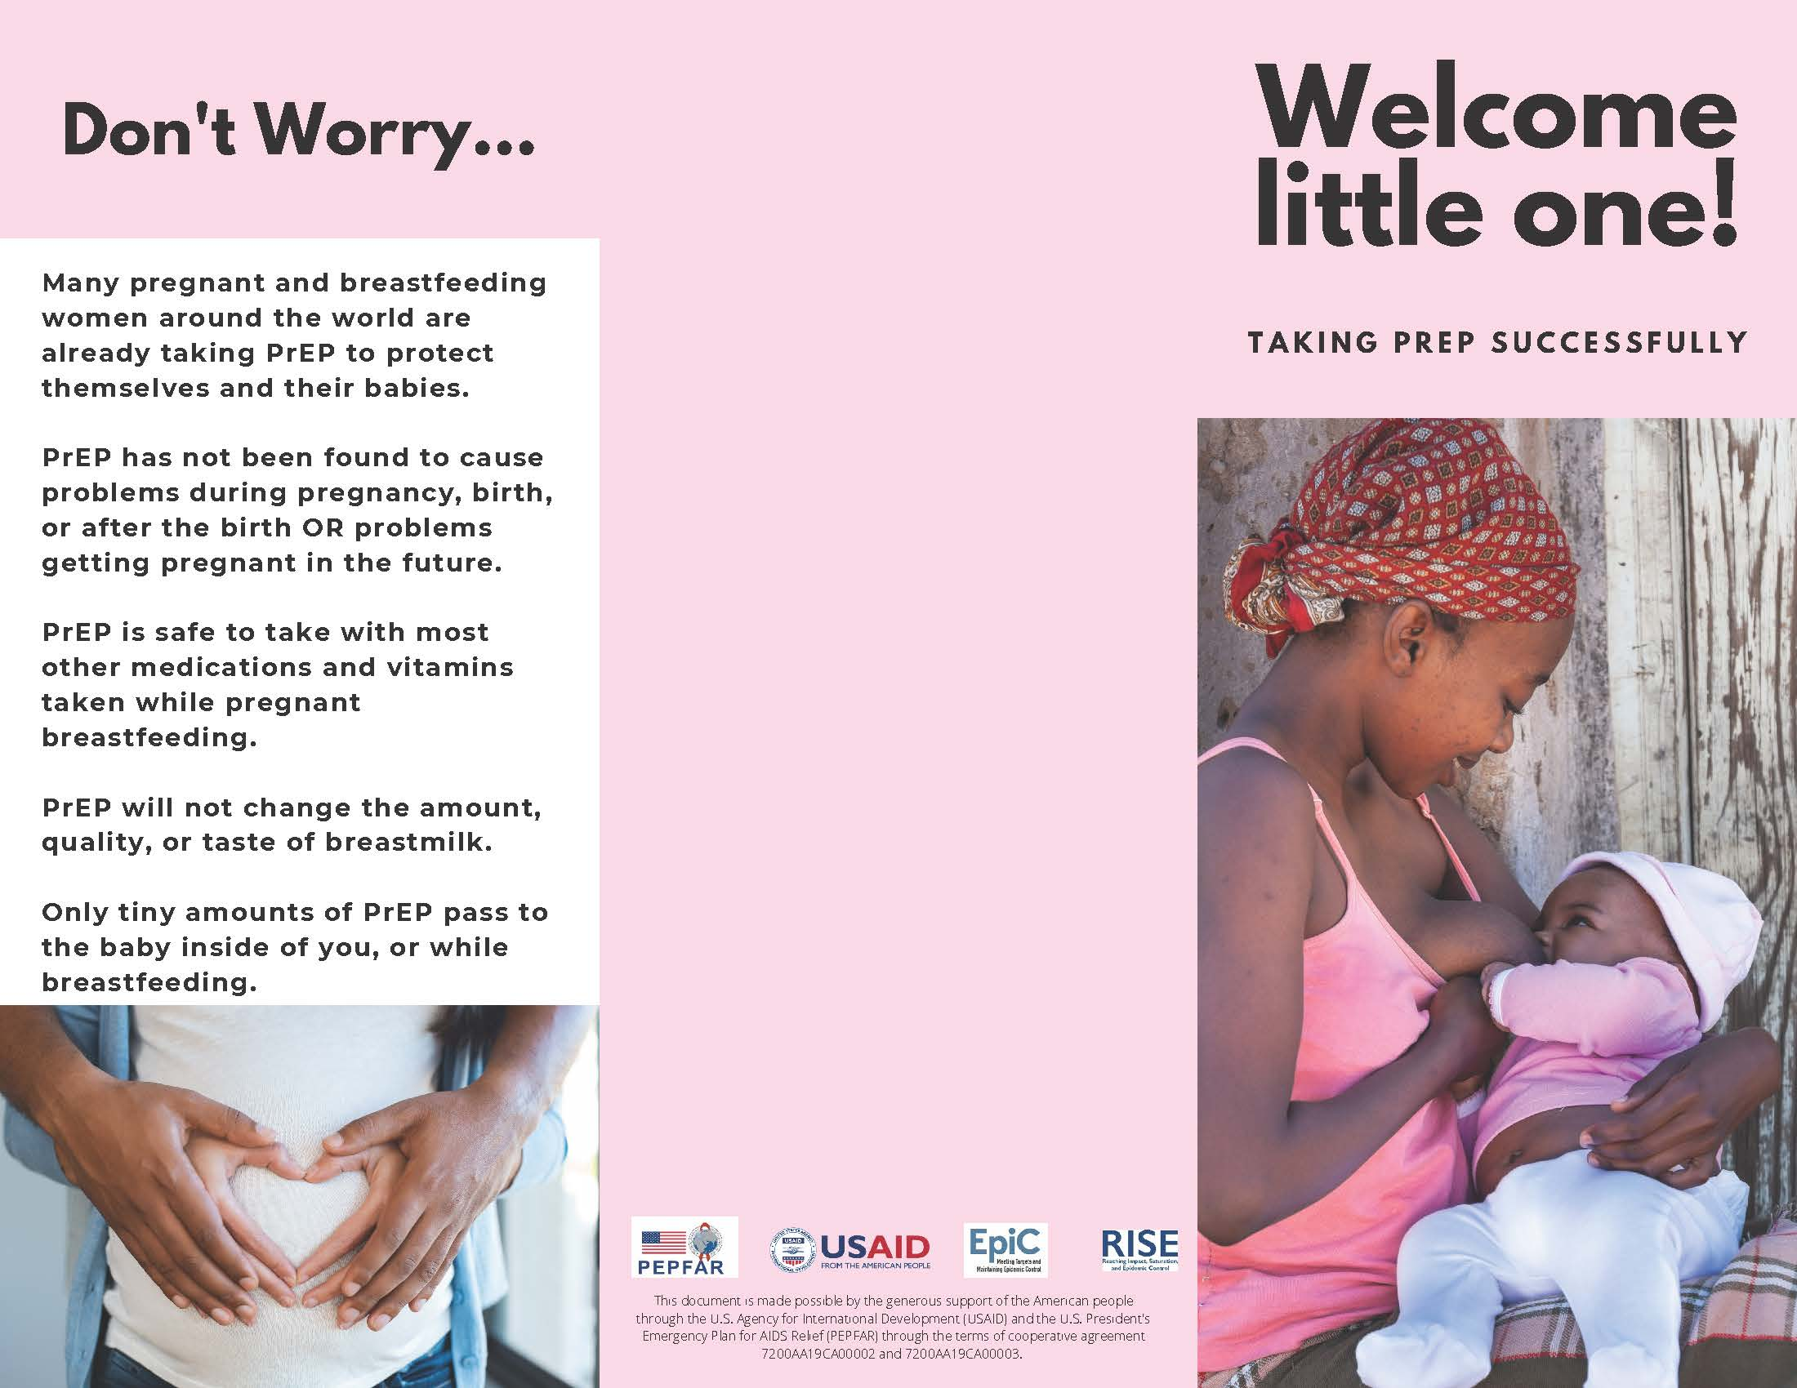

Annex B: Facilitator Pocket Guides
1) Test Materials in Context: (e.g. ANC/PNC Waiting Area)

What to do | What to ask
Hang posters on the walls where you would hang them for real  Place flyers on tables/benches  Sit in the waiting room and quietly observe/take notes  Discussion group:  - Gather volunteers  - Sit together at same level  - Consent  - Icebreaker  - Questions/Discussion | - What did you do to occupy your mind as you were waiting?  - How are you feeling while you are sitting here?  - What did you notice in the waiting room? Why?  - Was there anything that they saw that was new, or made them curious?  - Ask them to point out what they noticed. What made you look at this? What did you think about when you saw it?

2) Test Materials in Discussion Session:
What to do | What to ask?
Lay out all of the print prototypes where they can be easily seen:  - Poster concepts  - Flyer concepts  - Take-home brochures  Sit around the materials at the same level as participants | - Who are these materials talking to and why?  - What are you seeing in these materials? How does it make you feel?  - Ask probing questions  - Examples:  - What is it about the photo that makes you feel this way?  - What would make you feel better about it?
Give each participant 3 stickers or sticky note “votes”  Ask participants to use their stickers to vote for their favorite material  Ask questions and discuss prototypes that got no votes  Ask participants if they have any questions about PrEP or the program  Take note of questions for possible FAQ | - What made you vote for this? How much do you like it? A little? A lot?  - What is it about this that appeals to you?  - What is it making you think about?  - What questions is it bringing to mind for you?  - What do you like about it? Why do you like these things?  - What parts of it you find particularly interesting? Why?  - What things do you find to be not at all interesting or demotivating? Why?  - What information is confusing or unclear?  - What might get in the way of you deciding to start PrEP today, if it is available?  - What questions/concerns do you have about PrEP?  - Where should these materials be placed so that they will be sure to be seen?  For prototypes that got no votes:  - What about this is not as appealing to you?  - What concerns do you have about this?  - What would need to change to make it better?  - What more do you want to know?

3) Test provider experience with take-home pamphlets:
What to do | What to ask
Give several PrEP Plan brochures to providers who are or will be prescribing PrEP to PBFP  Ask them to use the brochures with real clients for several days  Follow-up after several days and ask questions | - How did you use the pamphlets during the counselling session?  - What did you like about them? What was helpful?  - What did you not like about them? What was not helpful?  - How did your clients react to the pamphlets? How many wanted to take it home?  - Did anyone decline to take it home? Why?  - How can we make this brochure more helpful for you or for clients?

WHO. 2015. Guideline on when to start antiretroviral therapy and on pre-exposure prophylaxis for HIV. https://apps.who.int/iris/bitstream/handle/10665/186275/9789241509565_eng.pdf.
PrEP for Pregnant and Breastfeeding Women: Clinical Guidelines and Training Package, available at https://www.prepwatch.org/resource/prep-for-pregnant-and-breastfeeding-women/
Refer to the clinical guidelines, counseling messages, and other information in the CHOICE PrEP for PBFP Clinical Guidelines and Training Package. Available at https://www.prepwatch.org/resource/prep-for-pregnant-and-breastfeeding-women/

