Guidelines for the PrEP Ring: TEMPLATE LANGUAGE

The intent of this document is to provide adaptable guidelines that align with the World Health Organization (WHO) guidance and recommendations for implementation of the monthly dapivirine vaginal ring as HIV pre-exposure prophylaxis (PrEP). Hereafter, the monthly dapivirine vaginal ring will be referred to as the “PrEP ring” or “the ring”.
This document was developed by the Collaboration for HIV Prevention Options to Control the Epidemic (CHOICE) and the Preparing for Ring Opportunities through Market Introduction Support and Knowledge Exchange (PROMISE) Collaboration in close collaboration with USAID. PROMISE and CHOICE are activities within larger USAID-funded awards: Envision FP, Meeting Targets and Maintaining Epidemic Control (EpiC) and Reaching Impact, Saturation, and Epidemic Control (RISE) projects. The content for this document was sourced largely from clinical trial results, including those used in the development of WHO recommendations released March 17, 2021, Updated Recommendations on HIV Prevention, Infant Diagnosis, Antiretroviral Initiation and Monitoring Guidelines and July 16, 2021, Consolidated Guidelines on HIV Prevention, Testing, Treatment, Service Delivery, and Monitoring: Recommendations for a Public Health Approach, and the Summary of Product Characteristics from the European Medicines Agency. Countries should use this document as appropriate for their needs and setting; use of PROMISE/CHOICE branding or acknowledgement is optional.

Table of Contents

Overview of the PrEP Ring for HIV Prevention 3
Guidance for Offering the PrEP Ring 3
PrEP Ring Effectiveness 3
Formulation of the PrEP Ring 4
Optimal PrEP Ring Service Delivery Package 4
PrEP Ring Initiation 4
Identifying Clients Who May Benefit from the PrEP Ring 4
Contraindications for the PrEP Ring 6
Possible Side Effects of the PrEP Ring 6
PrEP Ring Initiation Visit Schedule and Readiness Assessment 6
The PrEP Ring and Other Drug Interactions 10
Follow-Up Visits for Clients Using the PrEP Ring 10
Stopping and Restarting PrEP Ring Use 12
Switching Between the PrEP Ring and Oral PrEP 12
Supporting Current or Potential PrEP Ring Users in Specific Situations 13
Management of HIV Seroconversion 13
Management of Side Effects and Adverse Drug Reactions (ADRs) 13
Pregnancy and Breastfeeding 13
Education and Counseling for the PrEP Ring 14

Overview of the PrEP Ring for HIV Prevention

Pre-exposure prophylaxis (PrEP) is the preemptive use of antiretroviral (ARV) drugs to reduce the likelihood of HIV acquisition among HIV negative individuals, especially in persons who are deemed at substantial risk of acquiring HIV or who present requesting PrEP, even for reasons they do not wish to disclose. Some individuals may be at substantial risk due to their partners’ possible exposures to HIV, about which the person seeking PrEP may not have any actual details; special consideration may be warranted in these cases. PrEP is not effective in preventing pregnancy or other sexually transmitted infections (STIs).
The monthly dapivirine vaginal ring (hereafter referred to as the “PrEP ring” or “the ring”) is a long-acting HIV prevention product developed specifically for clients who are unable or do not want to take oral PrEP or when oral PrEP is not available. The ring has only been studied for prevention of HIV by those assigned female sex at birth during receptive vaginal intercourse and does not prevent HIV acquisition through any other mode of transmission. The ring is made of a flexible silicone material containing 25mg of an antiretroviral (ARV) drug called dapivirine. It is inserted into the vagina and should remain in place for one month. Dapivirine belongs to a class of ARVs called non-nucleoside reverse transcriptase inhibitors (NNRTI) that reduce the ability of HIV to replicate itself inside a healthy cell. The ring delivers the drug directly to the site of potential infection over the course of one month, with low absorption elsewhere in the body, lowering the likelihood of systemic side effects. Clients can insert, remove, and replace the ring themselves each month, or with the assistance of a healthcare provider if desired.

Guidance for Offering the PrEP Ring

The ring may be offered as an option for individuals who wish to prevent HIV acquisition through receptive vaginal intercourse and are unable or do not want to take oral PrEP, or when oral PrEP is not available, in combination with other HIV prevention practices.

The ring must be inserted correctly into the vagina and worn for one month without removing. The ring must be in place for at least 24 hours before it is maximally effective.

PrEP Ring Effectiveness

The ring was clinically shown to reduce the risk of HIV-1 acquisition through vaginal intercourse in two randomized controlled trials: by 35% in IPM-027/The Ring Study and 27% in MTN-020/ASPIRE. The subgroup analysis by age of The Ring Study and ASPIRE data did not show efficacy among women 18-21 years old, who were also shown to have low adherence to the ring during the trials. These trials reported no notable difference in the treatment and placebo arms of reproductive health outcomes, including STIs and adverse events related to pregnancy, fetal outcomes and/or infant outcomes. Results from two subsequent open-label extension studies – DREAM and HOPE – found increases in ring adherence and similar safety profiles, and modeling data suggest even greater risk reduction across both studies. Results from one of the open-label extension studies indicated a 62% reduction in HIV transmission, comparing study results to a simulated control. Further studies are underway or planned to explore safety and acceptability, and to identify ways to support adherence for younger women who choose the ring for HIV prevention. However, since the number of pregnancies was small, trials are ongoing to further assess safety during pregnancy and breastfeeding (see Supporting Current and Potential Ring Users in Specific Situations).

As with other HIV PrEP, the ring should be combined with other HIV prevention methods such as condoms and lubricant use and treatment for the partner living with HIV in the case of people in serodifferent partnerships.

Formulation of the PrEP Ring

The ring is a flexible white silicone ring for vaginal insertion. The ring, which is only available in only one size, contains approximately 25mg of the NNRTI dapivirine.

Optimal PrEP Ring Service Delivery Package

The optimal service package for clients prescribed the ring is the same as that for those prescribed oral PrEP, excluding creatinine clearance and hepatitis B screening. Screening for hepatitis B may still be a component of STI screening, diagnosis, and treatment for clients, however, outcomes of hepatitis B screening have no implications for effective and safe ring use.

PrEP Ring Initiation

Identifying Clients Who May Benefit from the PrEP Ring

PrEP should be offered to HIV-negative individuals who are at substantial risk of acquiring HIV and lack contraindications for their chosen method. The ring should be offered as an option for clients who wish to prevent HIV acquisition through receptive vaginal intercourse and are who are unable or do not wish to take oral PrEP, or when oral PrEP is not available. For example, the ring may be an option for a client who forgets or is unable to take pills regularly, is unable to swallow large tablets or who cannot take oral PrEP due to concurrent use of nephrotoxic medication, or for a client who is not able to access oral PrEP through their preferred provider.

Behavioral assessment questions can aid in assessing an individual’s potential exposures to HIV within a given context as part of the pre- or post-HIV test counseling process but should not be used to ration PrEP or as the only criteria for determining whether someone is eligible for PrEP. Behavioral assessments are considered tools and should not be required. If someone asks for PrEP and lacks contraindications for use, then they should be given the method of their choosing, regardless of whether a behavioral assessment is completed or what the result of the behavioral assessment was. Requesting PrEP has been shown to be an indicator of substantial risk.
All clients testing HIV-negative per the national testing algorithm and who are at substantial risk should be assessed for HIV exposure in the past 72 hours and have AHI ruled out. Clients should be counseled on PrEP options, including assessment for contraindications to those options. See Diagram 1 below.

Diagram 1: PrEP (oral PrEP or the ring) Initiation – HIV Exposure and AHI Assessment
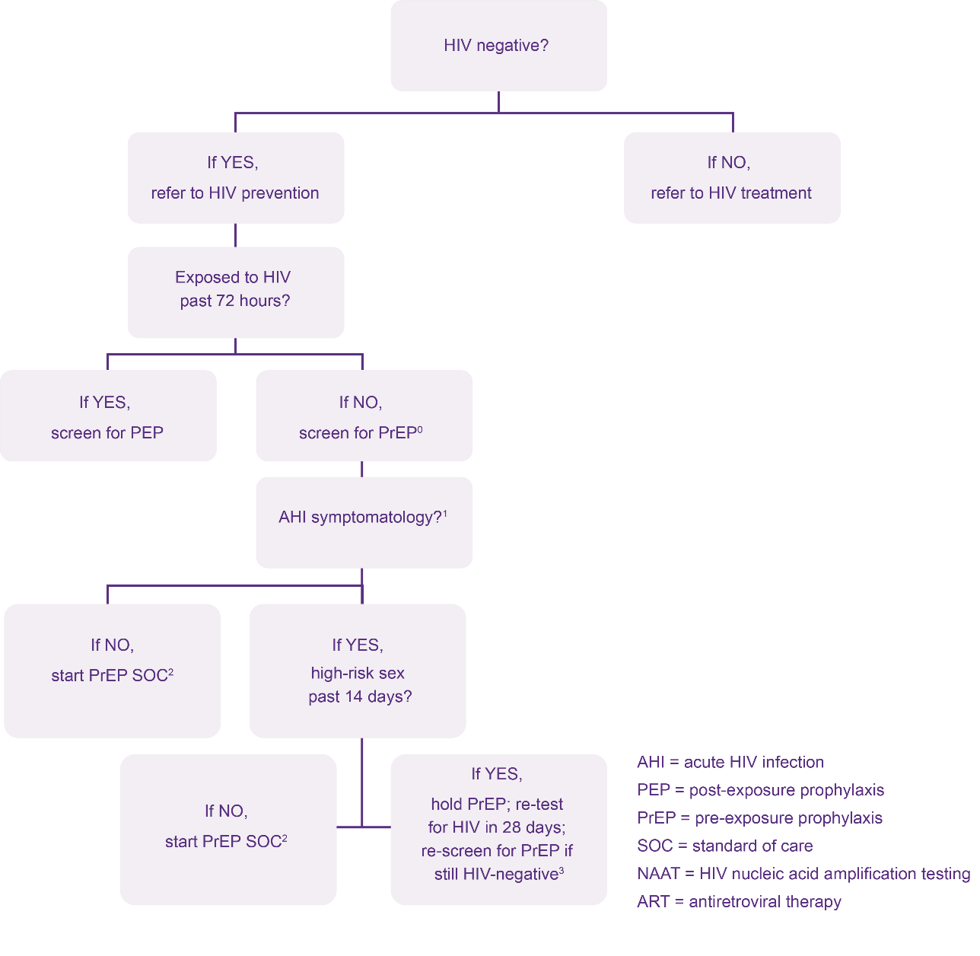
Potentially exposed to HIV in past 72 hours?
If YES, exposure with high likelihood of transmission past 14 days?
AHI = acute HIV infection
ART = antiretroviral therapy
SOC = standard of care
PEP = post-exposure prophylaxis

If NO, start PrEP SOC²
If NO, start PrEP SOC
If YES, hold PrEP; re-test for HIV in 28 days; re-screen for PrEP if still HIV-negative³

⁰ An answer of “NO” to question “Potentially exposed to HIV in past 72 hours?” means no potential past exposure to HIV at all or potential HIV exposure that was 73+ hours ago.
¹Signs/symptoms mimicking acute HIV infection (sore throat, fever, sweats, swollen glands, mouth ulcers, headache, rash, muscle aches) are commonly due to illnesses other than HIV; providers need to use discretion in determining whether the symptomatology is consistent with HIV or may be explained by an alternative cause.
²PrEP Standard of Care: See Table 1 below for ring initiation.
³If HIV testing which can reliably detect HIV given these clients’ potential exposures and timeframes is available, PrEP may be started earlier than 28 days, if results are non-reactive. Clinician may consider fully suppressive ART during 28-day interim if waiting 28 days to retest for HIV.
Developed by Jhpiego in collaboration with Jared Baeten (University of Washington) and Rachel Baggaley (WHO).

Contraindications for the PrEP Ring
Box 1. Signs and symptoms of AHI
Fever
Swollen lymph glands
Skin rash
Headache
Sore throat
Aches and pains
Mouth sores

The ring should not be provided to people with:
- HIV-positive test result using the national HIV testing algorithm
- Known exposure to HIV in the past 72 hours (Defer PrEP and consider PEP counseling for clients, even in the absence of symptoms of AHI)
- Signs of AHI (Box 1) AND potential exposure within the past 14 days
- Inability to commit to effectively using the ring and attend scheduled follow-up visits
- Allergy or hypersensitivity to active substance or other substances listed in the product information sheet

Unlike oral PrEP, low creatinine clearance and concurrent use of nephrotoxic medications are not contraindications of ring use. Note that the ring can only prevent HIV acquisition during receptive vaginal intercourse. Alternative methods of HIV prevention should be used to prevent acquisition through other means.

Possible Side Effects of the PrEP Ring

Possible side effects related to the ring are typically mild and include urinary tract infections (UTI), vaginal discharge, vulvar itching, and pelvic and lower abdominal pain. These side effects usually occur during the first month of use and resolve without the need to remove the ring. Ring users should be counseled to contact their health care provider if they experience any urinary or reproductive tract changes, as these could be a sign of an STI or UTI needing treatment.

PrEP Ring Initiation Visit Schedule and Readiness Assessment

Like oral PrEP, the ring can be initiated the same day for most clients. Initiation visit steps for clients beginning use of the ring are outlined below in Table 1.

Table 1. Ring Initiation
Required Initiation Steps | Action
HIV test  (per national HIV testing guidelines) | - Same-day HIV testing is suggested.  - If positive, client must not be initiated on PrEP and should be immediately initiated on/referred for ART.  - If inconclusive, defer use of PrEP and follow the national algorithm until a definitive HIV test result has been obtained. Provide counseling on how to reduce or minimize potential exposures to HIV.
Assessment for recent exposure to HIV | Clients exposed to HIV in the past 72 hours:  If a client reports an exposure to HIV in the past 72 hours, screen for possible eligibility for PEP instead of PrEP.  - Educate clients on the difference between PEP, biomedical HIV prevention methods, and ART and offer counseling on how to reduce or minimize potential exposures to HIV.  - After 28 days of PEP, client may be transitioned from PEP to PrEP without a gap, if HIV-negative and free of other contraindications.  Clients with possible AHI:  If client presents with signs and symptoms of HIV infection and possible exposure to HIV in the previous two weeks:  - Defer use of PrEP. Provide counseling on how to reduce or minimize potential exposures to HIV as well as STI screening, diagnosis, and management.  - Repeat HIV testing after four weeks. If negative, initiate use of PrEP if free of other contraindications.
Counseling | - Assess whether the client is at substantial risk of HIV.  - Discuss prevention needs and provide condoms/lubricants and provide counseling on how to reduce or minimize potential exposures to HIV.  - Discuss desire for biomedical HIV prevention methods and willingness and preference for oral PrEP or the ring using education and counseling messages for these methods (see Table 3 below). The provider and client should determine together whether oral PrEP or the ring may be appropriate for the client by discussing the client’s potential exposures to HIV and their willingness and ability to use either method effectively.  - If the client wants to use the ring, deliver and discuss any remaining education and counseling messages about the ring (see Table 3 below).  - Explain ring insertion and removal  - Assess if the client may be pregnant, breastfeeding or intends to become pregnant or breastfeed (see Supporting Current and Potential Ring Users in Specific Situations below).
GBV/IPV inquiry and response | Assess client’s experience of GBV, including IPV. Provide appropriate GBV/IPV response, including first-line support and referral where necessary, and support clients to identify ways to effectively initiate and continue with ring use.  Although the ring may be an option for clients concerned about IPV due to its discreet nature, clients who wish to keep their ring use private from their sexual partner(s) should be counseled on the possibility that a partner may feel the ring during sex and assisted with a plan to implement should this occur.  Clients experiencing GBV or IPV should not be prohibited from receiving the ring if they can effectively use it.
Assessment for contraindications for ring use | Assess for contraindications of the ring. If no contraindications, provide a single or multi-month supply of the ring per client preference.
Recommended Initiation Steps (if possible) | Action
Screening, testing, and treatment of other STIs | - If possible, clients initiating the ring should receive screening, testing and treatment for other STIs per national guidelines. The ring should remain in place while the client undergoes STI treatment.  - If testing is not possible, symptomatically manage STIs as per STI standard treatment guidelines.
Pregnancy testing | - Regular pregnancy testing is recommended for clients who are using the ring.  - If pregnant, link to antenatal care, pregnancy options counseling (see Supporting Current and Potential Ring Users in Specific Situations below for more information).
Mental health status assessment | - Screen for mental health concerns including depression and alcohol/other substance abuse, which might increase exposure to HIV or affect adherence to the ring.  - Link to follow-up mental health care.  Clients with mental health concerns should not be prohibited from receiving the ring if they can effectively use it.

Inserting the PrEP Ring
Clients may need initial guidance and support to learn how to use the ring and, once confident, can continue to use the ring on their own. Some clients are comfortable to use the ring on their own with minimal support. However, for clients who prefer, a healthcare provider can help to insert the ring or confirm placement. Understandable visual instructions should be offered alongside ring provision.
Ring insertion steps for the client:
- Get into a position that is comfortable for inserting the ring, such as squatting, one leg lifted up, or lying down. If a client is being assisted by a healthcare provider, the client should be in a reclining position.
- With clean hands, squeeze the ring between the thumb and forefinger, pressing both sides of the ring together so that the ring forms a “figure 8” shape.
- Using the other hand to open the folds of skin around the vagina.
- Place the tip of the ring into the vaginal opening and use fingers to push the folded ring gently up into the vagina.
- Push the ring as far toward the lower back as possible. If the ring feels uncomfortable, it is probably not inserted far enough into the vagina. Use a finger to push it as far up into the vagina as is comfortable.

*Ring insertion should be painless. If a client has any bleeding or discomfort upon insertion, they should contact their healthcare provider.
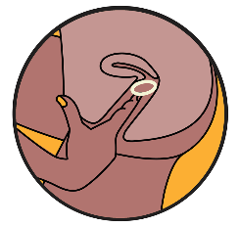
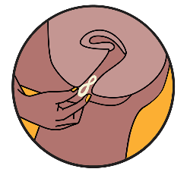
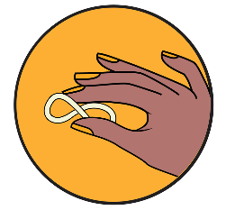

1 2 3 4

Removing the PrEP Ring
Clients can remove the ring without the help of a healthcare provider. However, for clients who prefer, a healthcare provider can help to remove the ring.
Ring removal steps:
- If a client is removing the ring herself, they should get into a position that is comfortable for removing the ring, such as squatting, one leg lifted up, or lying down. If they are being assisted by a healthcare provider, they should be in a reclining position.
- With clean hands, insert one finger into the vagina and hook it around the edge of the ring.
- Gently pull the ring out of the vagina.

*Ring removal should be painless. If a client has any bleeding or discomfort upon removal, they should contact their healthcare provider.

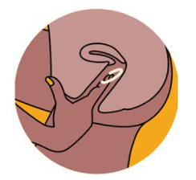

1 2 3

The PrEP Ring and Other Drug Interactions

There are no known interactions between dapivirine and contraceptive hormones, alcohol, or recreational drugs. If a ring user thinks that their use of alcohol or other substances may interfere with their effective use of the ring, the provider should discuss and support behavior change and offer additional prevention options, including condoms/lubricants.

There is currently no data on concurrent use of vaginally administered antimicrobial products for vulvovaginal infections and the ring so concomitant use is not recommended.
Evaluations of co-administered use of miconazole and the ring are not fully resolved and clients should be advised to use additional preventative measure for HIV when co-treated with vaginal miconazole.
Co-administered clotrimazole as a water-based vaginal cream with the ring showed to be well-tolerated but given methodological issues that limited reliability of the pharmacokinetic results of both clotrimazole and dapivirine, concurrent use should be undertaken with caution.
There is no data on concomitant use of the ring and metronidazole or clindamycin, and no current data on concomitant use of other the ring and other vaginal ring (contraceptive rings or diaphragms) so concomitant use is not recommended.

Follow-Up Visits for Clients Using the PrEP Ring

Like clients taking oral PrEP, clients new to the ring may wish to return after one month to receive support and reassurance to address side effects, discuss any difficulties with ring adherence, and talk over any other concerns. However, new clients who do not wish to return after one month can begin a quarterly visit schedule at their initial visit. Some ring users may prefer to return used rings to the healthcare provider/service provision point. Returned rings should be disposed of in accordance with local requirements. When possible, follow-up visits should be coordinated with visits for other services to reduce the number times a client must return to receive services.

Diagram 2: PrEP (oral PrEP or the ring) Follow-Up – HIV Exposure, AHI, and Adherence Assessment
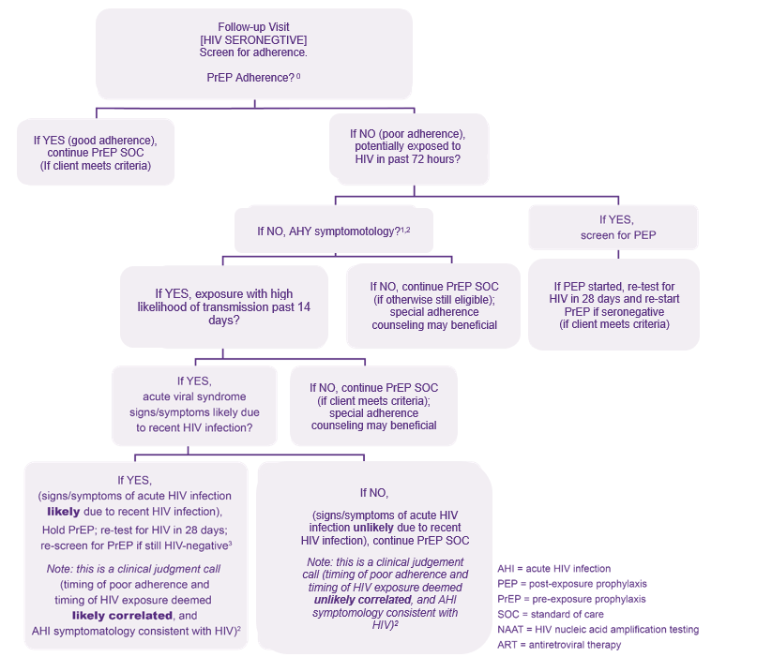
⁰If adherence was so poor as to constitute PrEP discontinuation, refer to initiation visit protocols.
¹An answer of “NO” to question “Potentially exposed to HIV in past 72 hours?” means no potential past exposure to HIV at all or potential HIV exposure that was 73+ hours ago.
²Signs/symptoms mimicking acute HIV infection (sore throat, fever, sweats, swollen glands, mouth ulcers, headache, rash, muscle aches) are commonly due to illnesses other than HIV; providers need to use discretion in determining whether the symptomatology is consistent with HIV or may be explained by an alternative cause.
³If HIV testing which can reliably detect HIV given these clients’ potential exposures and timeframes is available, PrEP may be started earlier than 28 days, if results are non-reactive. Clinician may consider fully suppressive ART during 28-day interim if waiting 28 days to retest for HIV.
⁴ PrEP Standard of Care: See Table 2 below for follow-up visits for the ring.
Developed by Jhpiego in collaboration with Jared Baeten (University of Washington) and Rachel Baggaley (WHO) and adapted.

Table 2. Components of follow-up visits for the ring
 | Procedures
Required | - HIV testing and counseling  - Review of ring adherence and counseling on how to reduce or minimize potential exposures to HIV  - Review of recent HIV exposure and signs/symptoms of AHI  - Counseling on effective use  - Assessment of side effects and adverse drug reactions (management as needed)  - Assessment of contraindications to ring use  - Provide counseling on prevention of STIs and recognition of STI symptoms  - GBV/IPV inquiry and response
Recommended | - Assessment of mental health status and alcohol/other substance use disorder  - Screening, testing, and treatment for other STIs  - Pregnancy testing

Stopping and Restarting PrEP Ring Use

Clients may choose to stop and restart using the ring for a number of reasons which may include changes in relationship status or sexual practice(s) or moving to a new location where different privacy or access concerns are at play, when deciding to attempt pregnancy, or when a client’s preferred HIV prevention option changes.

Clients who have previously used the ring and decide to reinitiate ring use should go through the same procedures for an initiation visit as outlined above.

Switching Between the PrEP Ring and Oral PrEP

Clients may switch between the ring and oral PrEP. Possible patterns of using ARV-based prevention products are not currently known or understood and require careful support and assessment.

Safety data on simultaneous use of oral PrEP and the ring are limited. Although use of both products is not likely to be less well-tolerated than when the drugs are used individually, more data are needed to confirm the safety and efficacy of simultaneous use of oral PrEP and the ring.

Some clients may decide to use both the ring and oral daily PrEP at the same time. However, no evidence indicates that using them together will result in any additive advantage. Whatever the choice, adherence is important to optimize effectiveness of either product. Further, inconsistent use of either or both would be ineffective for HIV prevention. The use of ring in combination with other prevention interventions and intermittent use of ring needs to be studied further.

Supporting Current or Potential PrEP Ring Users in Specific Situations

Management of HIV Seroconversion
If a client seroconverts while using the ring, or after starting the ring:
- Discontinue ring use immediately.
- Confirm reactive rapid test results by retesting a second sample (according to the national testing algorithm).
- Immediately link to care and initiate on ART (as per national ART guidelines).
- Document seroconversion and possible reason for seroconversion (non-adherence, stopped using the ring, or ring failure, i.e., breakthrough infection while adherent to the ring).

Management of Side Effects and Adverse Drug Reactions (ADRs)

- Any side effects should be recorded in client records and relevant forms per national policy regardless of severity.
- Complete the national adverse drug reaction form and report as per standard operating procedures.
- If ring use will be discontinued, record the outcome in the relevant register.

Pregnancy and Breastfeeding

Data are limited (fewer than 300 pregnancy outcomes) on the use of the ring by people who are pregnant, but interim results from an ongoing safety trial of ring use during pregnancy indicate that adverse pregnancy outcomes and complications were uncommon among ring users and generally similar to rates observed in the surrounding study community. Animal studies do not indicate direct or indirect harmful effects with respect to reproductive toxicity that are relevant to use of the ring. Providers and clients should weigh client preferences and ability to effectively use HIV prevention methods when considering whether the ring or another HIV prevention method, such as oral PrEP, should be used during pregnancy.

Dapivirine has been shown to be excreted at very low levels in human milk in one clinical study conducted among 16 HIV-1 negative mothers who were lactating but not breastfeeding. Because milk concentrations remained low (<1420 pg/ml), infant exposure to dapivirine is anticipated to be low (below 1µg/day). Results from a recent trial of ring use during breastfeeding are pending, with results anticipated in 2022. At this time, the potential impact of ring use during breastfeeding is not known. When making decisions about HIV prevention methods, providers and clients should consider the known benefits of breastfeeding for mothers and infants and the risks associated with human milk substitutes. A shared decision-making process should guide selection of HIV prevention options.

One clinical trial to further assess the safety of ring use during pregnancy is ongoing.

Education and Counseling for the PrEP Ring

Counseling about adherence for those using the ring should include efforts to ensure comfort with a vaginally inserted product and understanding of correct and consistent use. Table 3 outlines key education and counseling messages specific to the ring.

Table 3. Education and counseling messages for ring users
Topic | Key Messages
Effective use | The ring should remain in place for one month without removal and should be replaced with a new ring at the end of the month. The ring must be in place for at least 24 hours before it is considered maximally effective. Until adequate drug levels are achieved, safer sex practices should be used, such as abstinence and condoms/lubricants. The ring only prevents HIV acquisition through receptive vaginal intercourse.  Some people only need to use the ring during certain times in their lives, while others may have an ongoing need. You should continue using the ring as long as you feel you have increased likelihood of acquiring HIV or until other methods for HIV prevention work for you and your life.
Sharing the ring | The ring should not be shared with others. If other people you know are interested in using the ring, they can come here.
Ring use during sex | The ring does not interfere with sexual intercourse and should be worn during sex. It can be used with condoms (male and female). Although it is unlikely, it is possible that your partner may feel the ring during sex. If this happens, you may need to confirm ring placement, as it may mean that the ring should be pushed further into the vagina. The ring does not cause harm to your partner, but it does not prevent your partner from acquiring HIV.
Ring use with contraceptives | The ring can be used with most hormonal contraceptives and barrier methods, including condoms (male and female). Using the ring with other vaginal rings, such as contraceptive vaginal rings, or diaphragms is not recommended.
Ring use during pregnancy and breastfeeding | The ring does not prevent pregnancy. Be sure to use a contraception method to avoid unintended pregnancy.  There is limited information about the safety of using the ring during pregnancy or when breastfeeding. If you are pregnant or breastfeeding or intend to be, we should discuss this.
Side effects | Although unusual, there is a possibility of side effects with ring use, such as urinary tract infections, vaginal discharge, vulvar itching, and pelvic and lower abdominal pain. These side effects usually occur during the first month of use and resolve without the need to remove the ring. Urinary or reproductive tract changes may be signs of a urinary tract infection or a sexually transmitted infection, and you should seek medical advice as soon as possible.
The ring and alcohol or other recreational drugs | Using the ring while you are using alcohol or other recreational drugs will not hurt you. If you think your use of alcohol or other substances will or is interfering with using the ring effectively, we should discuss it.
No STI protection other than HIV | The ring does not prevent any STIs other than HIV. When possible, use a condom correctly whenever you have sex to prevent other STIs.
The ring and menses | The ring should be worn for one month, including during menses, to be most effective. The ring does not cover the cervix and does not interrupt the flow of menstrual fluids. There are no safety concerns related to the use of tampons, menstrual pads, menstrual cups, or other menstrual hygiene products while using the ring.  If using a tampon, be careful not to accidentally remove the ring when removing the tampon. Although it is unlikely, it is possible that the ring may fall out. If this happens in a clean location, the ring should be rinsed in clean water and reinserted. If the ring falls out in a dirty location, the ring should be replaced with a new ring.
The ring and douching | It is possible that flushing the vagina with water to clean it (or any form of douching) may dilute the concentration of dapivirine in the vagina. Douching is not recommended at any time, including while using the ring, because it may have a negative impact on the health of the vagina.
Cleaning the ring | The ring does not need to be removed and cleaned for any reason. However, if desired, it is acceptable to remove the ring, rinse it in clean water only, and then reinsert it immediately.
Ring reinsertion | Although it is unlikely, it is possible that the ring may fall out. If this happens, the ring should be rinsed in clean water and reinserted. If the ring falls out in a dirty location, the ring should be replaced with a new ring.
Ring storage | Store rings in their original packaging in a cool, dry place, away from children and direct sunlight, and secured from any pets or animals. The ring does not need to be refrigerated and can be safely stored at or around 25C or 77F for up to 5 years.
Ring disposal | Used rings can be placed inside the original wrapper provided with the ring or wrapped in tissue or toilet paper and disposed of in the trash bin out of reach of children. You can return your used ring to your healthcare provider/service provision point if you prefer.
Other ways to lower chances of getting HIV | To lower your chances of getting HIV:  - Use oral PrEP  - Adopt safer sexual practices, including consistent condom and lubricant use  - Engage in non-penetrative sex, including mutual masturbation  - Receive screening, diagnosis, and treatment for other STIs  - Ensure an HIV-positive partner in a serodifferent partnership has been on effective ART for at least six months, has an undetectable viral load, and remains adherent to ART  - Receive voluntary medical male circumcision  - Reduce number of sexual partners  - Access drug harm reduction and treatment services
Switching between HIV prevention options | It is okay to start the ring and decide later that you want to use another option to prevent HIV infection, like oral PrEP. Many people switch between methods as their needs change. I am here to help you to make the best decision for you.

