

**Building Community Acceptance for PrEP Use Among Adolescent Girls and Young Women in East and Southern Africa**

Summary Evidence and Experience Review

**October 2022**

Context  
The main **purpose** of this exercise was to review evidence to inform the design of interventions to generate community acceptance of the use of PrEP products by adolescent girls and young women (AGYW), with a particular focus on sexual partners, parents and peers. The was done via a **desk review**, which examined peer-reviewed and grey literature on community acceptance for SRH services, including PrEP, and via an **Action Tank,** through which implementers, Ministries of Health, young people and funding partners were convened to review the evidence, capture programmatic learnings, identify further evidence gaps, and specific opportunities for intervention adaptation.

## Approach

**Figure 1: Theoretical Domains Framework**

This review focuses on community acceptance among **primary influencers of AGYW—partners** including boys and men who are AGYW’s intimate partners**, parents/caregivers,** especially cohabiting mothers**,** and **peers**—both users and non-users of PrEP.

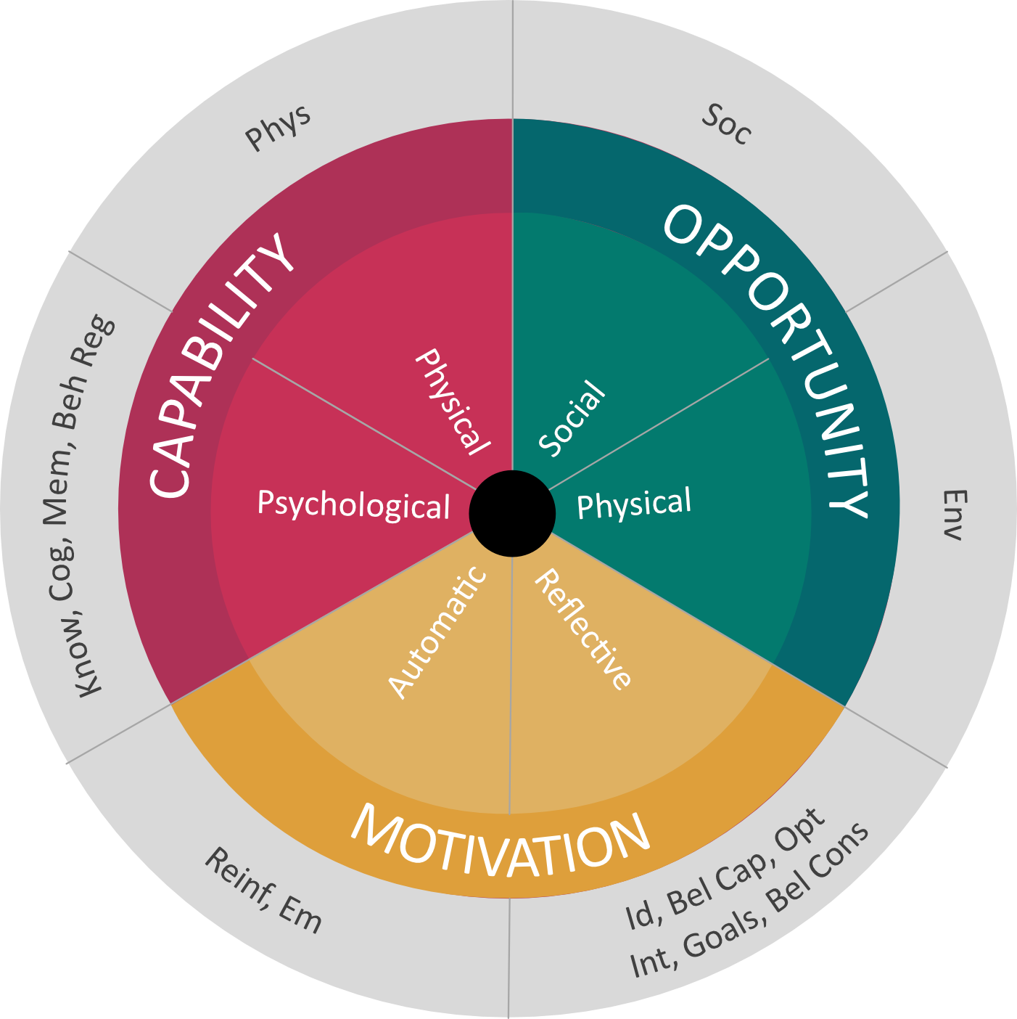

Sources of behavior

TDF Domains

**Soc** – Social influences  
**Env** – Environmental context and resources  
**Id** – Social/professional role and identity

**Bel Cap** – Beliefs about capabilities

**Opt** – Optimism

**Int** – Intentions

**Goals** – Goals

**Bel Cons** – Beliefs about consequences

**Reinf** – Reinforcement

**Em** – Emotion

**Know** – Knowledge

**Cog** – Cognitive and interpersonal skills

**Mem** – Memory, attention and decision processes

**Beh Reg** – Behavioural regulation

**Phys** – Physical skills

The review considered what influencer behaviors AGYW seek throughout the PrEP adoption process. **Once desired behaviors were identified, the review applied the Theoretical Domains Framework (TDF) to understand the enablers and barriers that impact influencer behaviors.** The TDF was developed by a collaboration of behavioral scientists and implementation researchers who identified theories relevant to implementation and grouped constructs from these theories into domains (see Figure 1).[1]

Finally, the review and Action Tank discussions identified interventions that successfully built community acceptance among the primary influencers. Interventions were prioritized if:

* they were implemented between 2011-present
* they were intended to improve health outcomes for youth in Africa
* they included some form of evaluation and focused on HIV prevention, treatment and care, or ‘adjacent’ areas (e.g. reproductive healthcare, gender-based violence prevention).

Eight PrEP-specific interventions were identified, as well as 27 sector-adjacent interventions. Eleven of these interventions were examined in-depth during the Action Tank. Key insights from these interventions were distilled for application in future work with these influencer groups.

Detailed information about the findings presented here can be found in the full report, accessible here.

**Understanding the Influence of the Community**

AGYW seek different types of support from different influencers, at different times in their process of PrEP adoption. The facilitators and barriers to providing this support vary by influencers. (See Table 1 below).

#### Table 1: Understanding the influence of community

|  |  |  |  |  |  |
| --- | --- | --- | --- | --- | --- |
| **Desired Action** | **Awareness** | **Uptake and Evaluation** | **Early Use**  **(0-3 months)** | **Persistence  (>3 mos., pause, restart)** | **Discontinuation** |
| **Male**  **Partners** | * Speak with their male peers in support of PrEP use | * Communicate openly * Actively support use and offer financial support * Speak with their male peers in support of PrEP use | * Emotional support * Adherence support (reminder) * Speak with their male peers in support of PrEP use | * Emotional support * Communicate openly * Financial support * Adherence support * Speak with their male peers in support of PrEP use | * Support method switching |
| **Male partners** were the most frequently mentioned influencer of PrEP decision-making. Fear of disrupting this relationship can limit PrEP use, but supportive male partners play a critical role in facilitating PrEP use  Key **facilitators** of male support of PrEP use were correct knowledge, effective relationship communication, and feeling their actions are supported by their peers. Key **barriers** included incorrect knowledge, belief in negative consequences and social norms | | | | | |
| **Parents/**  **Caregivers** |  | * Voice approval * Give consent * Refer for service | * Voice approval * Consent * Refer for service | * Actively support adherence (reminders, storage) * Communicate openly about support for PrEP use, provide transport, money for services | * Support method switching |
| Despite their strong influence, most AGYW do not actively seek reproductive health information from their **parents/caregivers** for fear of being considered promiscuous  Key **facilitators** to parents/caregiver’s support of PrEP use among AGYW are knowledge about HIV prevention, strong communication skills and social support that facilitates parental support. Key **barriers** are taboos around sex and beliefs in negative consequences of product use | | | | | |
| **Peers** | * Share information * Advocate for PrEP (champion PrEP as a lifestyle option, advocate for supportive policy at the national level) | * Advocate for PrEP * Share information about experience | * Share information about experience * Provide support to facilitate disclosure to parents or partners * Facilitate PrEP delivery at the community level | * Actively encourage adherence (especially via support groups) * Share knowledge and information on experience * Give advice, tips, referrals * Provide support to facilitate disclosure to parents or partners * Facilitate PrEP delivery at the community level | * Remind peers to take PrEP |
| Peers (same-sex friends, same-generation relatives) are a primary source of reproductive health information, and can have significant influence along the PrEP journey  Key **facilitators** for peers to support PrEP use are community social support and personal experience that positively influences peer support. Key **barriers** are stigma and incorrect knowledge | | | | | |

**Promising Interventions to Build Community Acceptance**[2]

Across influencers, there are **several cross-cutting key elements** that underpin successful community engagement. **Engaging influencers** provides “wrap-around support” for AGYW. **Focusing on support** via encouragement, affirmation and social support to cope with challenges can be very helpful. **Primary influencers are all also deeply influenced by their broader community;** this means interventions need to engage policy makers, media and key opinion leaders (especially religious leaders). **Targeted messages and communication channels should be considered to reach primary influencers (vs. AGYW directly).** Finally, **influencer engagement needs investment and resources.**

#### Table 2: Intervention Insights by Influencer

|  |  |
| --- | --- |
| **Male Partner Intervention Insights** | |
| **Core Principles** | |
| * **Adapt!** SRH interventions (such as the Husband Schools) offer significant promise, but will **require adaptation** to align with PrEP target audiences (e.g. younger male partners of AGYW) | |
| **Key Engagement Approaches** | **Building Wrap-Around Support** |
| * **Male support groups show impact across SRH interventions**; support groups offer an opportunity to provide information about PrEP and explore norms around masculinity in a safe space * **Create space to practice/rehearse having difficult conversations** (e.g. support groups, one-on-one conversations, etc.) * **Facilitators of activities for male engagement**,such as male support groups, need to be selected carefully in order to drive transformative discussions, i.e. they should be role models, extensive training, etc.) * **Ensure campaign materials reflect a diversity of partners** (e.g. older men) | * Men need to see **broader community wrap-around support** for social norm change; this may include broader communication campaigns, policy change and engagement of health structures * Men should be engaged **to build knowledge in their own communities**,and become a source of information for their male peers; programmers report that girls want to see their partners speaking about PrEP with their male peers |
| **Parent/Caregiver Intervention Insights** | |
| **Core Principles** | |
| * **Empathy is paramount**;these are difficult conversations * **Focus on adolescence—not sex—**to connect with parents/caregivers; parents do not want to engage first with their daughter’s status as “sexually active” but with their daughters as young people with desires worth supporting * **Root intervention delivery IN the community** by working with local community organizations * **Build a supportive environment** by working closely with community leaders (e.g. traditional or religious leaders) to give parents’ permission to participate in these discussions | |
| **Key Engagement Approaches** | **Building Wrap-Around Support** |
| * **Engage parents directly, but carefully consider how to set parents at ease**;in settings with low social cohesion, one-on-one discussions may be needed * **Create platforms to facilitate parent connection and learning** (e.g. parent support groups such as Mother/Grandmother Prayer Days) * **Make content digestible, relatable, practical and time-bound**,reflecting influencers in materials where possible | * **Engage policy makers to build surrounding support** that can drive norms around promoting open discussions around SRH * **Transform parents into advocates**;mothers/aunties are often the best ones positioned to reach those who play negative roles in young people’s lives regarding PrEP |
| **Peer Intervention Insights** | |
| **Core Principles** | |
| * **Intervention experience underscores the importance of peers** (e.g. peer referrals, and engaging young people to mobilize their own community) * **Peer interventions must be implemented with meaningful youth partnership** (e.g. co-create campaigns; create spaces for feedback) | |
| **Key Engagement Approaches** | **Building Wrap-Around Support** |
| * **Gain framing (vs. risk-based messaging) is particularly important in successful peer engagement** to facilitate positive discussions among peers about how PrEP can make their lives better and strengthen their relationships * **Social media is an important channel for peers** * **Peers can be engaged to support AGYW via a diversity of models** (e.g. support groups, youth clubs, etc.). **Make content digestible, relatable, practical and time-bound**,reflecting influencers in materials where possible | * **Engage with community stakeholders and influencers** to address barriers to ensure that peers have support from their communities; this includes targeting the same social norms that often impact AGYW adoption of PrEP |

1. Atkins, L. Francis, J, Islam, R. et al*.*,“A guide to using the Theoretical Domains Framework of behavior change to investigate implementation problems”, *Implementation Sci* 12, 77, 2017. Available at:[Https://doi.org/10.1186/s13012-017-0605-9](https://doi.org/10.1186/s13012-017-0605-9)
2. **8** **PrEP-specific interventions** were identified as promising (or intended for evaluation); **4** of these were presented for “deep-dive” analysis within the Action Tank; **27** **sector-adjacent interventions** were shortlisted for relevance based on the selection criteria; **13** **sector-adjacent interventions were described via short case studies**; **5** of these interventions were presented for a “deep-dive” analysis within the Action Tank.