About Injectable PrEP (CAB PrEP)

How long-acting injectable cabotegravir for PrEP (CAB PrEP) works

Injectable cabotegravir (CAB PrEP) is one HIV prevention option that participants can choose in CATALYST. It is an antiretroviral (ARV) medication   
that is given as an injection every two months for HIV pre-exposure prophylaxis (PrEP). It can be taken by people without HIV to reduce the chance of getting HIV. Because ARVs circulate throughout the body, CAB PrEP prevents HIV during vaginal, anal and oral sex. CAB PrEP prevents HIV from entering human cells and multiplying itself. If the virus cannot multiply, it simply dies within the body.

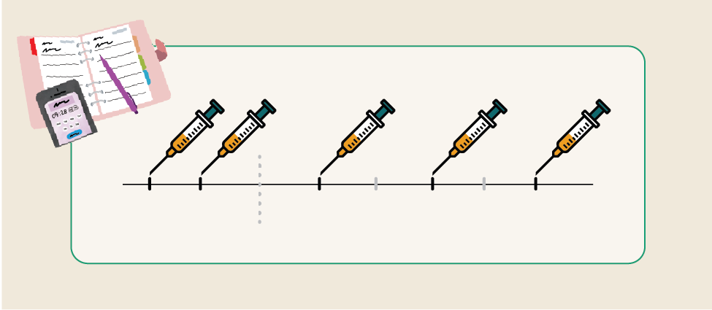

DOSE 1

DOSE 2

After the second dose, receive another dose every 2 months until you choose to stop

CAB PrEP is more than 90% effective, which means it is the most effective PrEP method currently available. CAB PrEP starts preventing HIV for most people about one week after their first dose.

For maximum HIV prevention, it is important to keep regular appointments for injections and use condoms whenever possible.

## Using CAB PrEP successfully

* getting started with injections – injections are given into the muscle of your buttock. An initiation injection is given once a month for the first two months, then follow-up injections are given about every two months thereafter.
* STAY ON SCHEDULE – work closely with your health care provider to schedule your CAB PrEP appointments at times that you are available. People who choose CAB PrEP will take an HIV test before each injection.
* Option to start with Oral CAB – before receiving your first injection, you may have the option to take oral cabotegravir tablets daily for about a month to see how your body tolerates the medication. Your health care provider can counsel you on this option.
* Stay covered – if you miss or plan to miss a scheduled follow-up injection by more than 7 days, inform your health care provider right away to discuss your PrEP options.
* stop CAB safely – if you are going to stop using CAB PrEP, speak with your provider about how to do this safely and continue to prevent HIV.
* Use with other forms of prevention – CAB PrEP does not prevent other STIs or pregnancy. It’s best to use condoms and effective contraception with CAB PrEP.
* CAB PrEP should be stopped immediately if the user has a positive HIV test result.

## Side Effects

* Injection site side effects, such as bruising and tenderness, are very common but usually happen less often over time.
* Common side effects of CAB PrEP include headache, diarrhea, nausea, fatigue, and dizziness.
* Serious side effects such as allergic reactions, liver problems, and depression or mood changes may happen to people who use CAB PrEP. If you have any symptoms of these side effects, speak with your health care provider as soon as possible.
* If a person experiences side effects while using CAB PrEP, a health care provider can advise on how to manage them.

Tips for Using CAB PrEP

Set reminders on your phone or calendar to ensure you attend your regularly scheduled injection appointments.

Communicate with your provider about any scheduling challenges you might have with attending these appointments such as vacation or moving away from the clinic.

Join or start a support group with friends – connect with others who can support each other to use CAB PrEP well. Support groups can be in-person or virtual!

Talk to your health care provider about any questions.



## **In CATALYST, using CAB PrEP is your choice!**

If you want to learn more, contact   
[Insert your contact information here]!