Choosing the Right Method to Prevent

HIV for Yourself and Your Baby

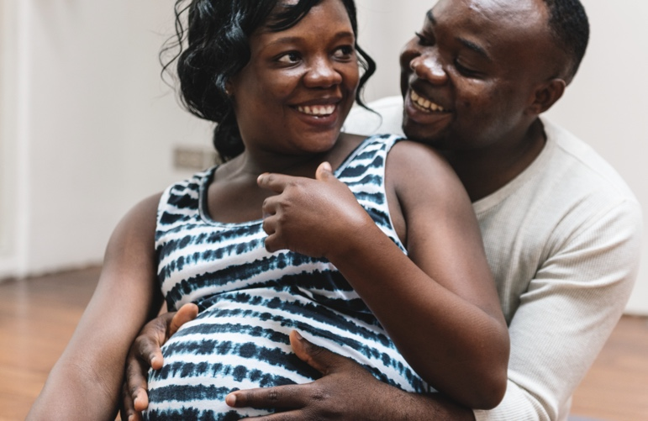
Using oral PrEP or the PrEP ring can help you prevent HIV – and that helps protect your baby too!

People are more likely to get HIV when they are pregnant or during the time after delivery (postpartum), and getting HIV at these times carries a higher risk of passing HIV to babies. For most people who live in places where HIV is common, there are more benefits than risks of using an HIV prevention method during pregnancy and postpartum.

Now, there are more options for you to choose from when preventing HIV during pregnancy and postpartum. Here are some questions and answers about PrEP methods that might help you choose what will work best for you and your baby. Your provider can talk to you about these methods and other ways to prevent HIV.

Make the HIV prevention choice that works best for you and your baby! If you want to learn more, contact [Insert your contact information here]

Frequently Asked Questions
DURING PREGNANCY | ORAL PREP | PREP RING |  | AFTER DELIVERY/WHILE BREASTFEEDING | ORAL PREP | PREP RING

Are there any special considerations for people who are pregnant? | Daily PrEP use may be especially important for HIV prevention if you are pregnant because people have a higher chance of getting HIV at this time. | Consistent ring use may be especially important for HIV prevention if you are pregnant because people have a higher chance of getting HIV at this time.  Take out your PrEP ring if you have vaginal bleeding or if your water breaks. |  | Are there any special considerations for people who are postpartum or who experience a pregnancy loss? | No. You can use oral PrEP just as you would normally postpartum or after a pregnancy loss. | Wait until 6 weeks after delivery to resume or start PrEP ring.  Talk to your provider about PrEP ring resumption after a pregnancy loss.
Is it safe to use during pregnancy? | Yes, several studies have shown that oral PrEP use is safe for the pregnant person and their baby. | Research is more limited, but so far, no problems have been seen for the pregnant person and their baby. |  | Is it safe to use during breastfeeding? | Yes, several studies have shown that oral PrEP use is safe for breastfeeding people and their babies. | Research is more limited, but so far, PrEP ring use has been very safe for breastfeeding people and their babies.
What does the available research show about safety? | PrEP does not increase the risk of birth defects, miscarriage, or other complications during pregnancy, birth, or after the birth. PrEP will not cause babies to be too big or too small. |  |  | Does it affect milk production or the taste of the milk? | No. PrEP does not affect milk production or the taste of the milk.
Is it safe to use with medications and supplements commonly prescribed in pregnancy? | Yes. Always talk to your health care provider about any medications you are using. |  |  | Is it safe to use with medications and supplements commonly prescribed postpartum and while breastfeeding? | Yes. Always talk to your health care provider about any medications you are using.
Are PrEP side effects any different when used during pregnancy? | Side effects are usually mild and no different for those who are pregnant. |  |  | Are PrEP side effects any different when used during breastfeeding? | Side effects are usually mild and no different for those who are breastfeeding.
What do I do when it is time to deliver the baby? | Keep taking oral PrEP at the same time every day. If you stop taking PrEP around the time that you have the baby, you should follow your PrEP provider’s advice for restarting it after delivery. | Take out your PrEP ring if it is time to go the facility to have the baby (active labor) or when your water breaks.  After your delivery, follow your PrEP provider’s advice for when to restart PrEP ring or another PrEP method. |  | Is it safe to use together with family planning methods? | Oral PrEP is safe to use together with all family planning methods. | PrEP ring is safe to use with most family planning methods.  Some countries may have rings available for family planning. You shouldn’t try to use two rings at once (the PrEP ring plus a family planning ring).
Will it affect my ability to get pregnant again in the future? | No. There is no evidence that PrEP impacts fertility. |  |  | What do I do when I have finished breastfeeding? Can I keep using it? | Yes, you can continue this method or switch to a new method.

