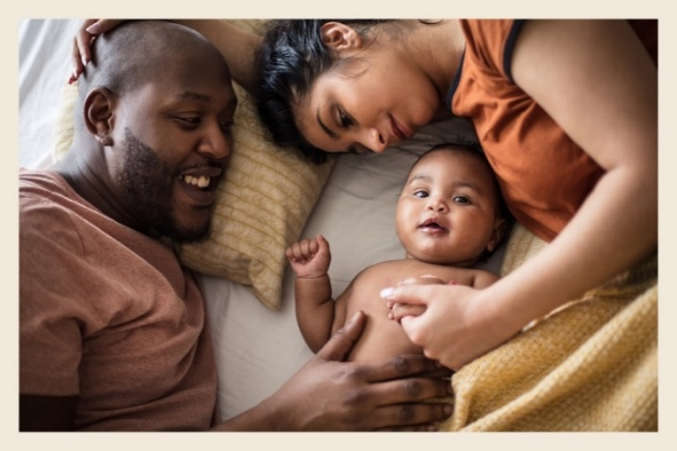
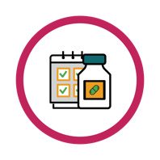
Key facts about oral PrEP

Oral PrEP

Choosing to Prevent HIV During

Pregnancy and Postpartum:

Why should I use an HIV prevention method when
I am pregnant or after delivery?
Oral PrEP is safe to use
with medications and supplements commonly prescribed during pregnancy and breastfeeding.

Oral PrEP does not
increase the risk of birth defects, miscarriage, or other complications
during pregnancy, postpartum, or while breastfeeding.

People are more likely to get HIV when they are pregnant or during the time after delivery (postpartum), and getting HIV during these times carries a higher risk for passing HIV to babies. Getting HIV can greatly impact you and your baby’s health. For most people who live in places where HIV is common, the benefits of using a HIV prevention method during pregnancy and postpartum outweigh the potential risks.
Oral PrEP does not affect breastmilk production.
Oral PrEP does not impact your ability to become pregnant in the future.
Oral PrEP will not
cause babies to be too
big or small.

Is oral PrEP safe for me to use during pregnancy and postpartum? What about during breastfeeding?
Oral PrEP is safe to use with all family planning methods.
Yes, oral PrEP has been shown to be safe during pregnancy, postpartum, and while breastfeeding.
Make the HIV prevention
choice that works best for
you and your baby!
If you want to learn more, contact [Insert contact information here]

Choosing oral PrEP can protect me and my baby from getting HIV!
Oral PrEP is a pill taken daily to prevent HIV. When taken daily, oral PrEP is highly effective at preventing HIV. Protecting yourself from HIV can protect your baby as well. More information on how to use oral PrEP, possible side effects, and other options for HIV prevention are available from your health provider.

