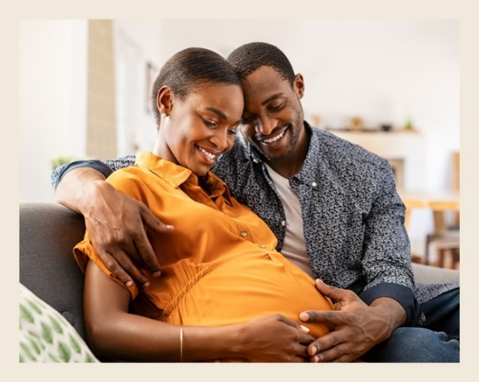
Why should I use a
HIV prevention method when I’m pregnant or after delivery?
Key Facts about the PrEP Ring
The PrEP ring does not increase the risk of birth defects, miscarriage, or other complications during pregnancy or while breastfeeding.

Talk to your provider about resuming ring use after delivery or following a pregnancy loss.
The PrEP ring is safe to use with medications and supplements commonly prescribed during pregnancy and breastfeeding.

The PrEP ring will not cause babies to be too big or small.
The PrEP ring does not impact the ability to become pregnant in the future.
The PrEP ring does not affect breastmilk production.
PrEP ring is safe to use with most family planning methods.

Some countries may have rings available for family planning. You shouldn’t try to use two rings at once (the PrEP ring plus a family planning ring).

Choosing to Prevent HIV During

Pregnancy and Postpartum: PrEP Ring
People are more likely to get HIV when they are pregnant or during the time after delivery (postpartum) and getting HIV at these times carries a higher risk of passing HIV to babies. Getting HIV can greatly impact you and your baby’s health. For most people who live in places where HIV is common, the benefits of using a HIV prevention method during pregnancy and postpartum outweigh the potential risks.

Is the PrEP ring safe for me to use during pregnancy
and postpartum? What about during breastfeeding?
While researchers continue to study safety of the PrEP ring during pregnancy and breastfeeding, no harmful effects have been seen so far. However, it is recommended that individuals wait until 6 weeks after delivery to resume or start PrEP ring use and vaginal sex.

Choosing the PrEP ring can prevent HIV for me and my baby!
Make the HIV prevention
choice that works best for
you and your baby!
If you want to learn more, contact [Insert contact information here]

The PrEP ring is inserted into the vagina and kept in place until replaced each month with a new ring.
Protecting yourself from HIV protects your baby as well. The PrEP ring should also be removed when labour
starts or your water breaks. People experiencing complications in their current pregnancy like vaginal bleeding
should not use the ring. More information on how to use the PrEP ring, possible side effects, and other options
for HIV prevention are available from your health provider.

