About the PrEP Ring

Factsheet

DRAFT

## How the PrEP ring works

The PrEP ring is one HIV prevention option that participants can choose in CATALYST. It is a flexible silicone ring inserted in the vagina containing the antiretroviral (ARV) medication dapivirine. It slowly releases dapivirine into the vagina over one month. Dapivirine works by preventing HIV from making copies of itself inside the vagina. If the virus can’t make copies of itself, it simply dies within the body.

The PrEP ring can reduce the chance of getting HIV through vaginal sex by about 50% or more when kept in place for a whole month. The ring must be in place for 24 hours before it provides maximum HIV prevention. For maximum HIV prevention, it is important to use PrEP ring in combination with condoms whenever possible.



* INSERT A NEW PREP RING EACH MONTH – the ring can be inserted and removed by the user or with help from a provider.
* LIVE DAILY LIFE AS NORMAL – the PrEP ring sits high and snug in the vagina. It is not usually felt in daily activities or by partners during sex if inserted correctly. Any discomfort can usually be resolved by pushing it further into the vagina with a finger.
* THE RING SHOULD ONLY BE INSERTED VAGINALLY.
* KEEP THE RING IN ALL THE TIME FOR THE BEST PREVENTION – no need to remove for sex, bathing or menses (period). The ring does not need to be taken out to be cleaned.
* USE WITH OTHER FORMS OF PREVENTION – the PrEP ring does not prevent HIV during anal sex or injection drug use. The ring also does not prevent other STIs or pregnancy. It is best to use condoms and effective contraception with the ring.
* GET NEW RINGS ON TIME – receive a new set of rings every three months or as prescribed by a provider. An HIV test will need to be done at least once every three months.
* NEVER SHARE THE PREP RING – everyone should see their health care provider to get their own rings.
* THE PREP RING SHOULD BE REMOVED IMMEDIATELY IF THE USER HAS A POSITIVE HIV TEST RESULT.

## Using the PrEP ring successfully

## **Side effects**

* Some users have minor to moderate side effects, which usually go away after a few days without needing to remove the PrEP ring.
* Possible side effects include urinary tract infections, discomfort of the vagina and/or area outside the vagina (vulva), changes in vaginal wetness or odour, increased itching, or pain in the lower part of the belly. Remove immediately if an allergy to the ring is suspected.
* If a person experiences side effects while using the PrEP ring, a health care provider can advise on how to manage them.

## **How to store and dispose of the PrEP ring**

* Unused rings should be kept in the original packaging in a cool, dry place, away from children.
* Used rings should be placed in the empty foil wrapper or tissue/toilet paper and disposed in the trash/rubbish bin that is kept away from children and animals.
* DO NOT throw rings in a flushing toilet or burn them.

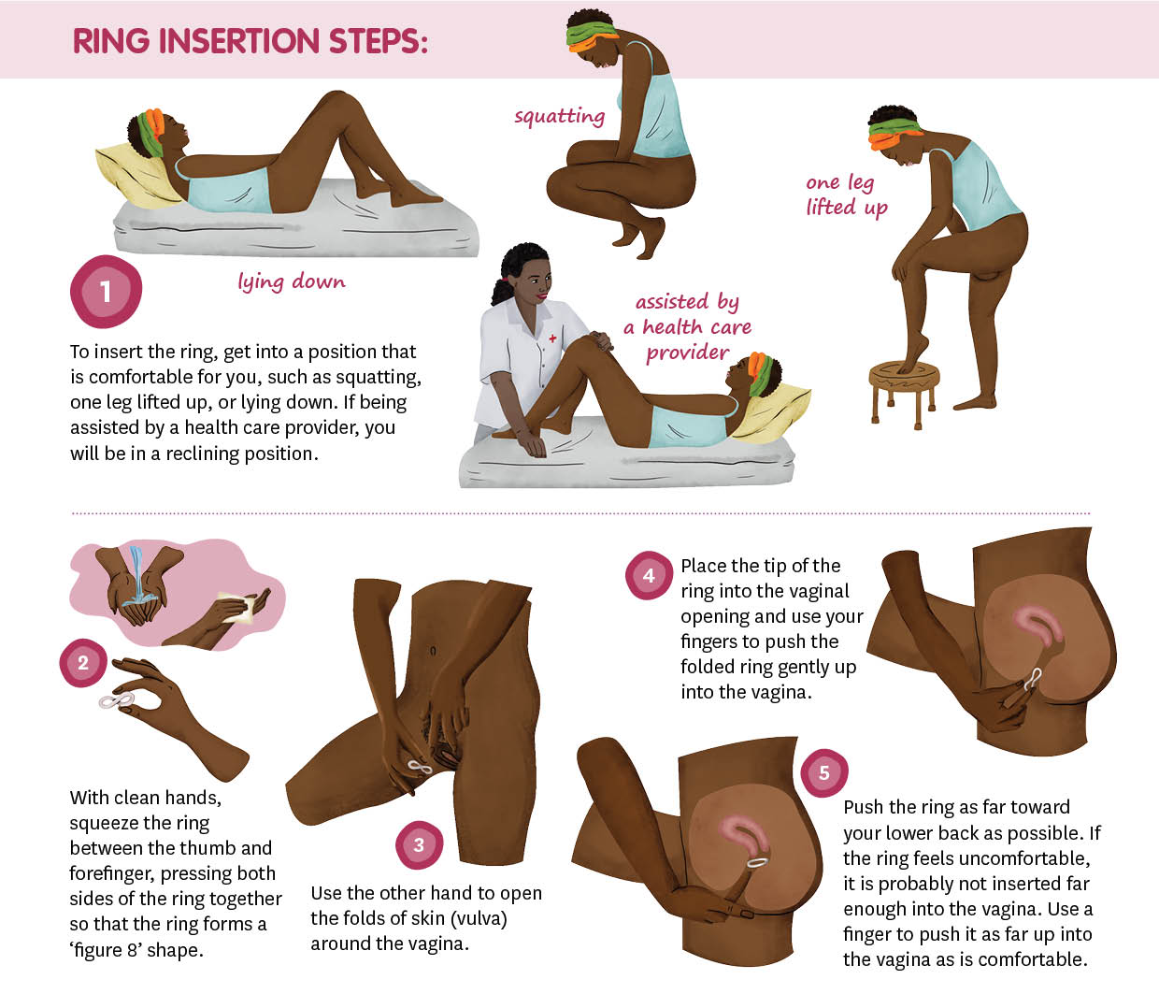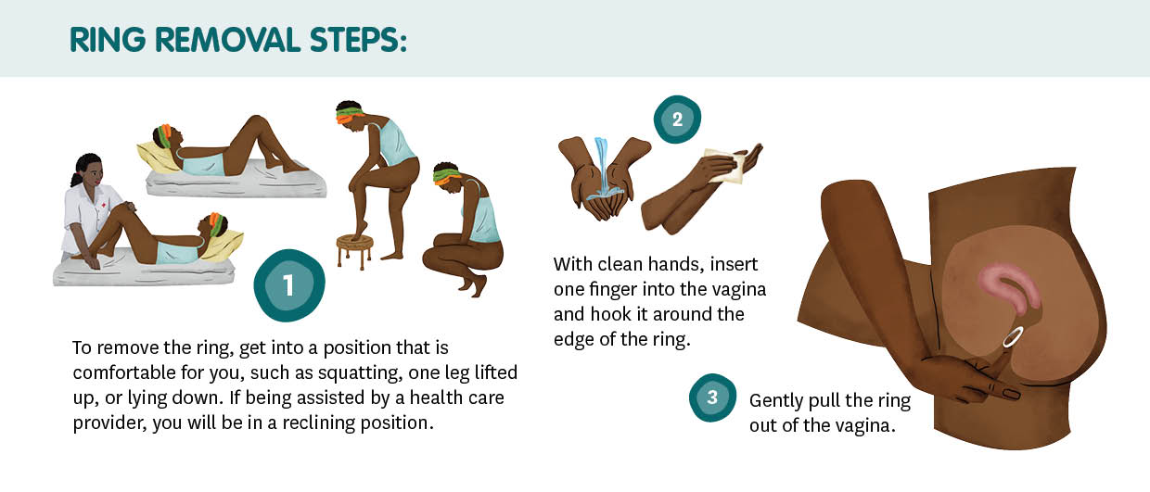

Hear young women’s first-hand experience on using the ring



Learn more about how to use the ring





## **In CATALYST, using the PrEP ring is your choice!**

If you want to learn more, contact

[Insert your contact information here]!

Tips for Using the PrEP ring

Set a reminder to replace the ring each month.

Get comfortable with inserting and removing the ring.

Join or start a support group with friends – connect with others who can support each other to use the PrEP ring well. Support groups can be in-person or virtual!

Talk to your health care provider about any questions.

