Catalyzing Access to New Prevention Products to Stop HIV

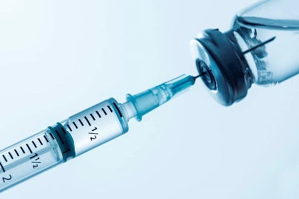

**Oral PrEP**

A pill taken daily. Oral PrEP has been approved and in use in many countries for several years.

**PrEP ring**

A flexible silicone ring inserted in the vagina   
and worn continuously   
for one month.

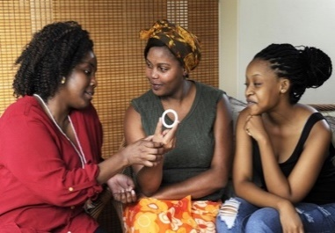

HEAR FIRST-HAND EXPERIENCE ON USING ORAL PreP

HEAR FIRST-HAND EXPERIENCE ON USING THE RING



**CAB PrEP**

An injection given once a month for the first two months, then every 2 months.

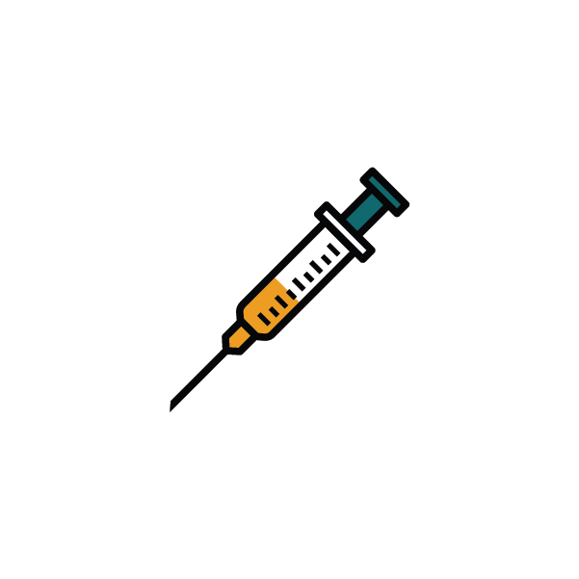

The PrEP ring and CAB PrEP are new

and recently approved for use.

### What is the study design?

Cohort participants will be followed for 1–3 years to collect information about how they choose, use, and like the offered PrEP methods.

The study will also evaluate how service providers can best offer PrEP choice and deliver new PrEP methods, including the cost. The study will also assess how people in the community feel about PrEP.

### What will participants who join CATALYST be asked to do?

Participants in the study will be counseled on detailed information on each PrEP method to support them to choose the best method for their lifestyle.

Participants will be scheduled to come for visits every 1–3 months to refill, stop or switch PrEP. Visits will include HIV testing and pregnancy testing as well as other standard of care procedures required of the PrEP method they are using.

Participants will answer short surveys at each visit about their PrEP use and sexual behaviors, and allow access to their PrEP records.

The CATALYST study offers HIV prevention product choice and gives communities a say in how these options known as pre-exposure prophylaxis (PrEP) will be rolled out.

### What is PrEP?

PrEP is a type of HIV prevention method that contains antiretrovirals (ARVs). People without HIV can use PrEP to prevent HIV before they are exposed. The study will offer three methods to protect against HIV: **Oral PrEP, PrEP ring, and CAB PrEP (injectable)**.

### Why is having options for PrEP important?

People have different HIV prevention needs and preferences that can change over their life. Having options gives people the ability to choose the method that works best for them at any given time.

### Who will participate in CATALYST?

A group, or cohort, of about 11,000 women without HIV who are motivated to learn about HIV prevention in Kenya, Lesotho, South Africa, Uganda, Zimbabwe will participate. This includes adolescent girls, young women, people assigned female at birth of any gender identity, or people assigned male at birth who identify as women.

PrEP health care providers and people in the community will also be engaged in the study to learn about their perspectives on PrEP options and service delivery.

### What happens if a participant **gets** HIV while in CATALYST?

Being in the study will not cause HIV. However, if a participant gets HIV while in this study, they will be referred for treatment and other services. These participants will be asked to provide blood to conduct HIV drug resistance testing and PrEP drug level testing.

### Does it cost anything to **be** in CATALYST?

Being in the study does not cost anything. Participants will have their choice of HIV prevention method, standard of care testing, and study-related testing for free.

What are the risks?

* Participants may experience side effects from the PrEP methods
* Participants may feel discomfort from having blood tests or worry about getting test results
* Participants might feel uncomfortable answering questions about their personal life
* Others may find out about being in the study and may treat participants poorly or unfairly

The health care providers will provide counseling and support for problems   
or side effects that happen during the study. Staff will keep all participant information private.

### What are the benefits?

Participants will have the opportunity to be among the first to learn about   
and try new PrEP methods along with their peers. Participants will also have   
a chance to make their voices heard in how PrEP is rolled out in their communities. We hope the information gained will help others have more options for PrEP and receive better PrEP services.

### Protecting choices

Clients are free to make their own choice about joining the study and may leave at any time. Participants are encouraged to ask questions and involve their partner(s), parent(s), or other individuals who are important to them in their decision-making. Staff can provide study information to share with loved ones or invite them to the clinic to learn more.

**For more information about CATAYST, go to: *<MyPrEP study page>* CATALYST is supported by the [*country, health department/ministry*] and reviewed by *[relevant IRB*].**

CATALYST is made possible by the generous support of the American people through the U.S. President's Emergency Plan for AIDS Relief (PEPFAR) and the U.S. Agency for International Development (USAID). The contents are the responsibility of the MOSAIC project and do not necessarily reflect the views of PEPFAR, USAID, or the U.S. Government. MOSAIC is a global cooperative agreement (Cooperative Agreement 7200AA21CA00011) led by FHI 360, with core partners Jhpiego, LVCT Health, Pangaea Zimbabwe AIDS Trust, Wits Reproductive Health and HIV Institute, and AVAC.



Joining CATALYST is your choice!   
If you want to learn more, contact   
[insert your contact information here]!